**Introduction**

* 1. **Company Profile:**

**Company Name:** FlakyTech InfoTech .

**Address:** 2/5, Gate No.2, Singapuri Vadi, Opp.Prakash Bakery, Surat.

**Proprietor:** Mr. Junned Rajbhara.

**Business Type:** Software Developer.

**Year of Establish:** 2015

**Contact No:** +91 8347703333

**E-mail ID:** Info@flakytech.com

**1.2 Project Profile:**

* **Definition:**
* Let’s Teach is designed for the students who want to learn a particular topic by reading articles or watching a video about that topic.
* Using this website, a tutor can post article or video on the particular topic.
* **Description:**
* This website designed to bring the tutor and students closer.
* A student can register, read the articles, view the videos, subscribe the channel, search for courses, like the article and chat with a tutor using this website.
* A tutor can register, post an article, post a video, create a channel, manage courses, manage students and chat with students using this website.
* **Front – End Tools:** HTML5, CSS3,
* **Back – End Tools:** MySQL
* **Web Server Tools:** Xamp Server
* **Operating System:** Windows 10
* **Project Category:** Web Base Application
* **Team Members:** 2
* **Duration:** 3 Months
* **External Project Guide:** Mr. Junaid Rajbara
* **Internal Project Guide:** Mrs. Parul Patel And Mr. Dhaval Joshi
* **Submitted By:** Ms. Khushboo Tolat, Ms. Kalyani Samanthula
* **Submitted To:** Veer Narmad South Gujarat University,Surat

**Proposed System**

**2.1. Scope:**

* **Admin**: Admin can manage tutor , student , articles , subject , course , state , city , question and answer .
* **Student:** Student can search courses , articles , can give like , comments to article , can give review of course and ask question to tutor.
* **Tutor:** Tutor can manage course , articles and videos , give answer to students.

**2.2. Objectives:**

* The main aim of this website is to make tutor and students to closer.
* Provides the system administrator with easy interface for different administrative tasks such as searching, addition and updating of different entities.
* The system administrator will be able to manage tutor, student, articles, courses and subjects.
* The system should properly maintain user privilege i.e., it should only allow registered users to access certain features, which it should not allow for unregistered users.
* Only registered students will be able to search tutor, review the courses and like articles.
* The tutor will have the platform to post his/her courses and articles.
* Only administrator will have all privileges.

**2.3. Advantages:**

* User-friendly interface.
* Allows the student to clear their doubts.
* 24/7 availability.
* Students can easily find courses.
* Students can view the subject according to various courses.
* Students can see notifications.
* Students can report the unwanted articles or videos.
* Easy and fast communication between tutor and students.

**2.4. Limitations:**

* Students/Tutor cannot change the design or any functionality of the application.

**2.5. Disadvantages:**

* Article can be wrong or malicious.
* Anyone can register to the website. So, some users may post some inappropriate content.

**Environment Specification**

**3.1. Hardware Requirements:**

* **Processor**: Intel(R)Core(TM) i5-4210M CPU @ 2.60GHz 2.60GHz
* **Ram**: 4GB
* **HDD**: 500GB

**3.2. Software Requirements:**

* XAMPP 3.2.2
* Google Chrome 67.0.3396
* Apache Version : 2.2.21

**System Planning**

**4.1. Feasibility Study:**

Feasibility study involves research relating to different aspects that go into developing software. Feasibility study of the problem definition or requirement was done to determine if the requirement can be solved effectively given the budgetary, operational & technical and scheduled constraints in place. The aim of feasibility study is to identify the best solution under the circumstances by identifying the effects of this solution on the organisation. The feasibility of our project has been judged on the basis of time, technology, resources available, behavioural feasibility & cost of development.

* **Duration Feasibility**
* Project initiated with pre-stated deadlines.
* The duration is allotted keeping in mind the entire task & is practically feasible.
* **Implementation Feasibility**
* A proper implementation is essential to provide a reliable system to meet requirements of the organization.
* Implementation is the stage in the project where the theoretical design is turned into a working system.
* The most critical stage in achieving a new successful system is to improve the performance of the existing system and to deliver system effective application.
* **Operational Feasibility**
* It will help in time saving and fast processing and dispersal.
* From the Admin perspective our application requires basic knowledge about policies of Cyber World.
* **Technical Feasibility**
* Minimum system required for admin, user and doctor is computer connected with internet with compatible browser.
* The system is suitable for multi user operations. With the available resources robust system with data security can be developed. It uses PHP which has been tested & approved to be sufficiently robust, scalable & efficient to develop such an application. Hence technically there is no limitation for development of the system.
* **Resource Feasibility**
* The system requires well trained software developers. Besides that network connectivity, MySQL servers are needed. Tools for documentation & editing are required.
* These resources are available and feasible.
* **Behavioural Feasibility**
* Benefits of proposed system were assessed. Having realized the benefit of new system the users’ response was studied before the inception of system development. They reacted positively towards the proposal.
* Since all the users involved in project development are familiar with internet no explicit training will be required to learn the usage of new system. Simple guidance would suffice.
* **Economic Feasibility**
* The cost of software and hardware required for system including storage of bulk of data server.
* No budgetary constraints were imposed on the system. More importantly since all free software were used only hardware, usage & internet costs were to be considered.
* These were quite limited & well within feasibility.
* Based on above study it can be stated that designing & developing this system is certainly feasible if executed well within stated guidelines. So based on these positive results, the new system was approved for development.

**4.2. Software Engineering Model:**

* We followed Iterative Waterfall Model for software development do we can add new functionalities as per requirement.

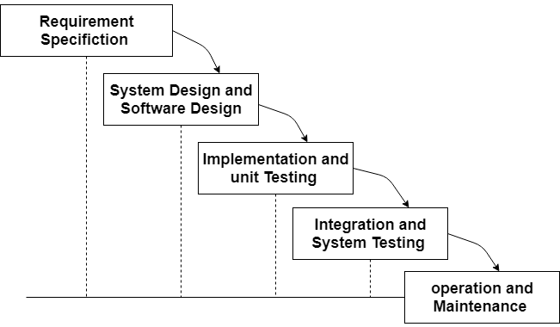

**4.3. Task Dependency:**

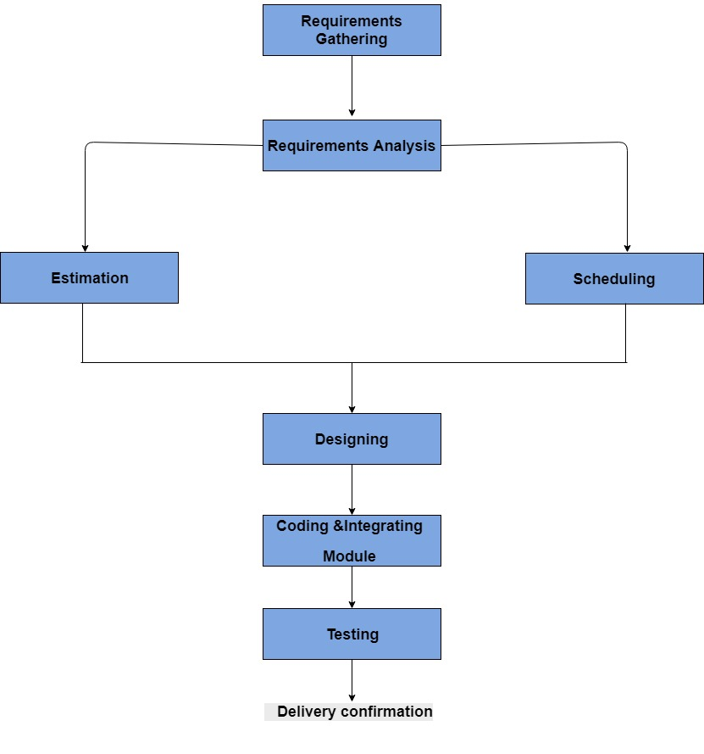

**System Analysis**

**5.1. Software Requirement Specification:**

* **Requirement Gathering:**
* We went through many websites with a similar concept.
* We went through pros and cons of the system and avoided the cons as possible.
* We deeply discussed this topic with our guide.
* **Requirement Analysis:**
* **Functional Requirements:**
* Courses
* Articles
* Videos
* Subscribe Tutors
* Search Courses/Tutors
* Like Article/Video
* Comments
* Chats
* QnA
* Report Students
* Report Articles
* Report Video
* **Non Functional Requirements:**
* Login/Logout
* Registration
* Validation

**5.2. UML Diagrams:**

**5.2.1. Use Case Diagram:**

**Admin:**

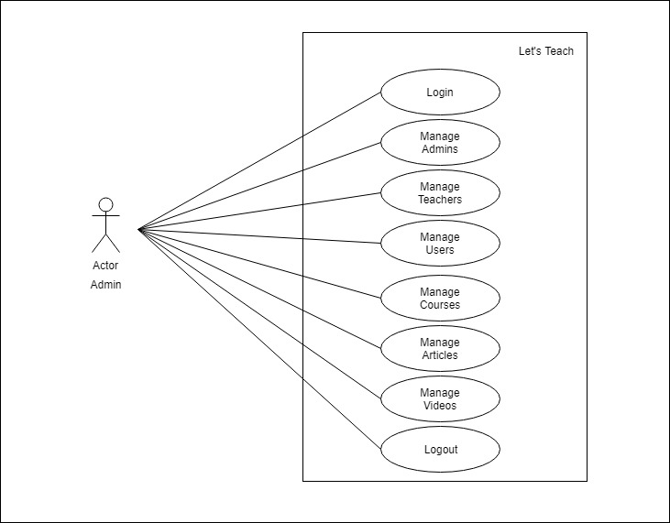

**Tutor:**

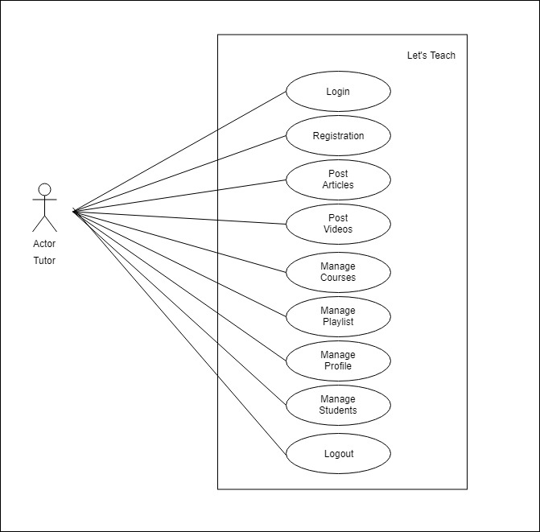

**Student:**

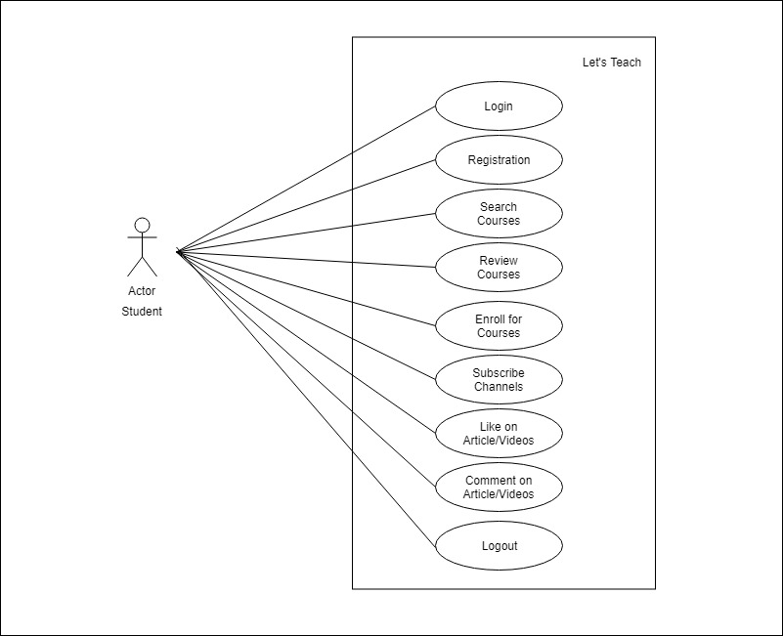

**5.2.2. Data Flow Diagrams:**

**1. Context Level:**

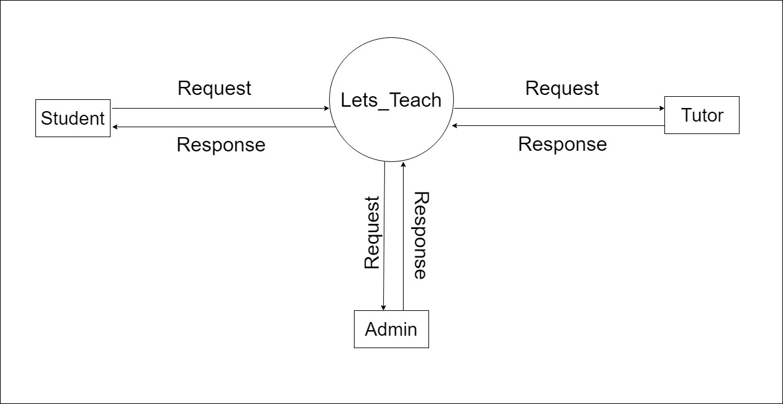

**2. First Level:**

**Admin**

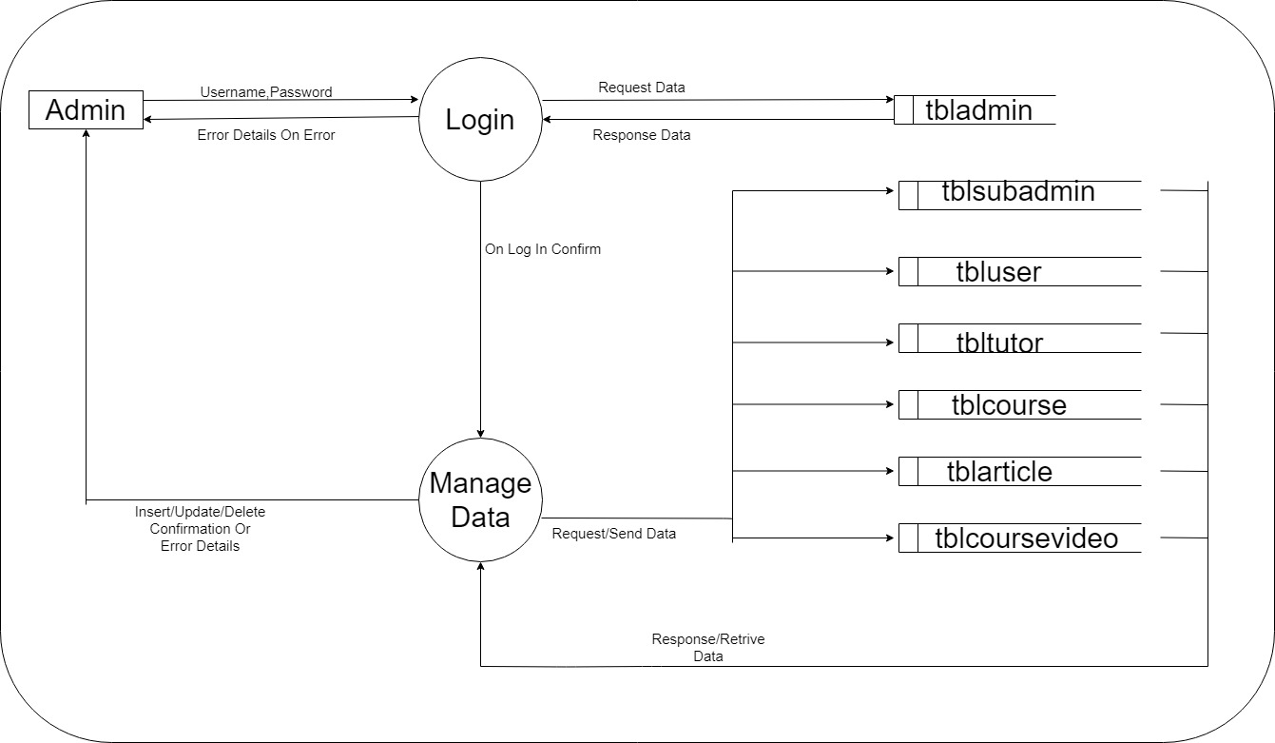

**Tutor**

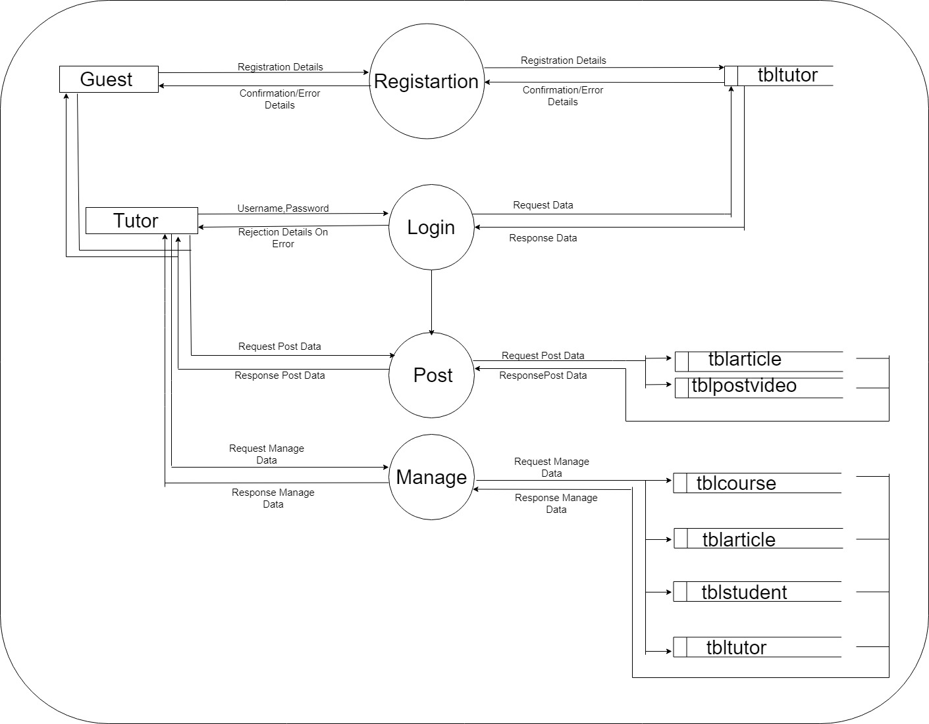

**Student**

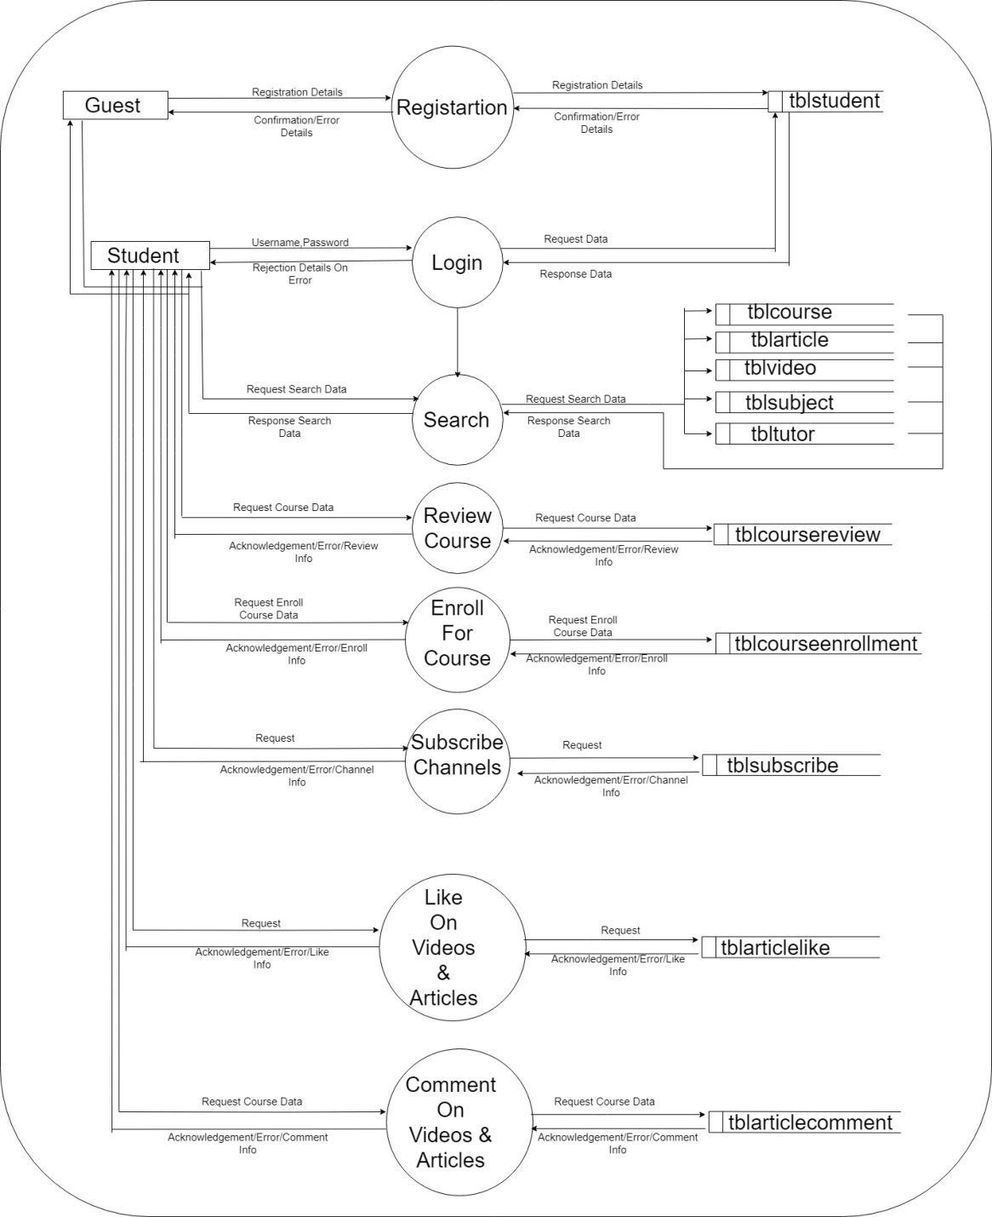

**3. Second Level:**

**Admin**

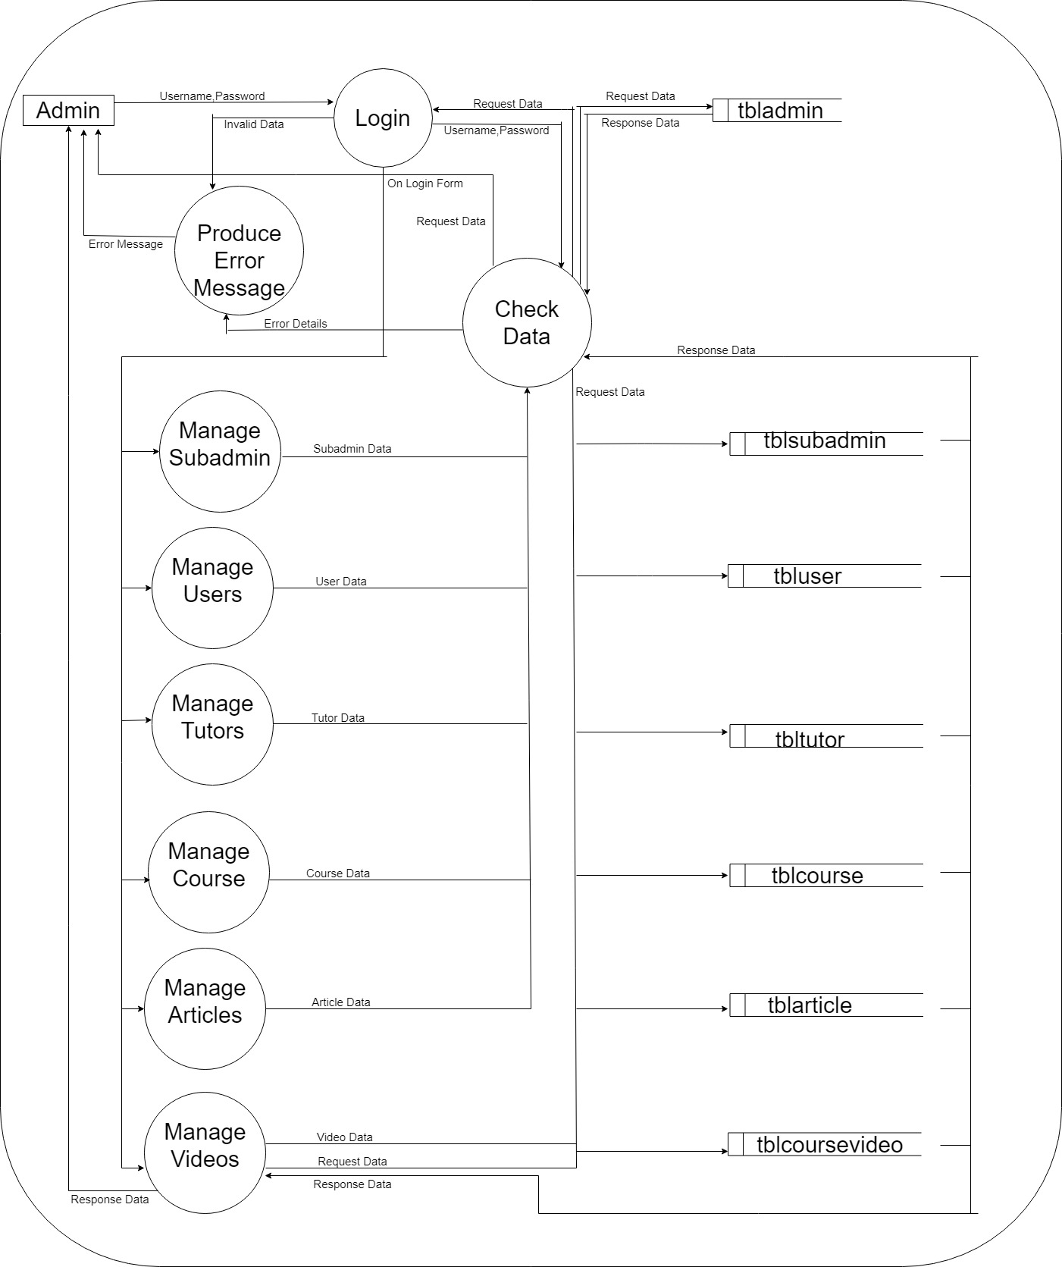

**Student**

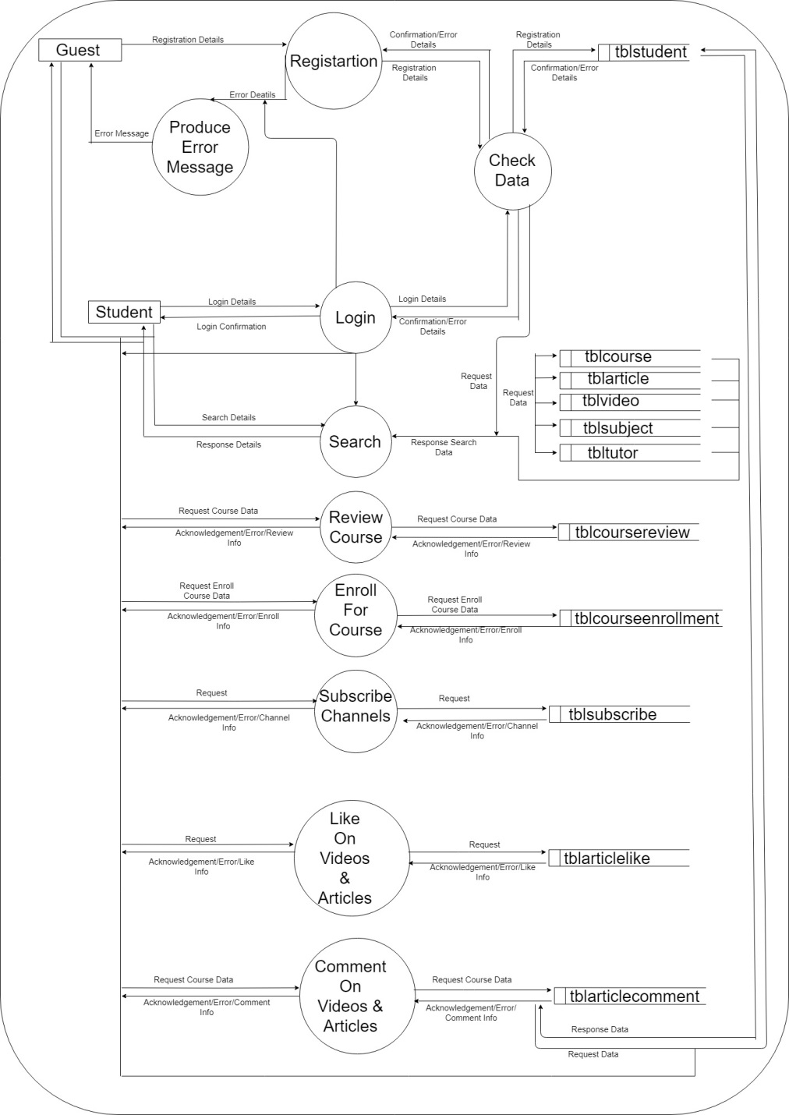

**Tutor**

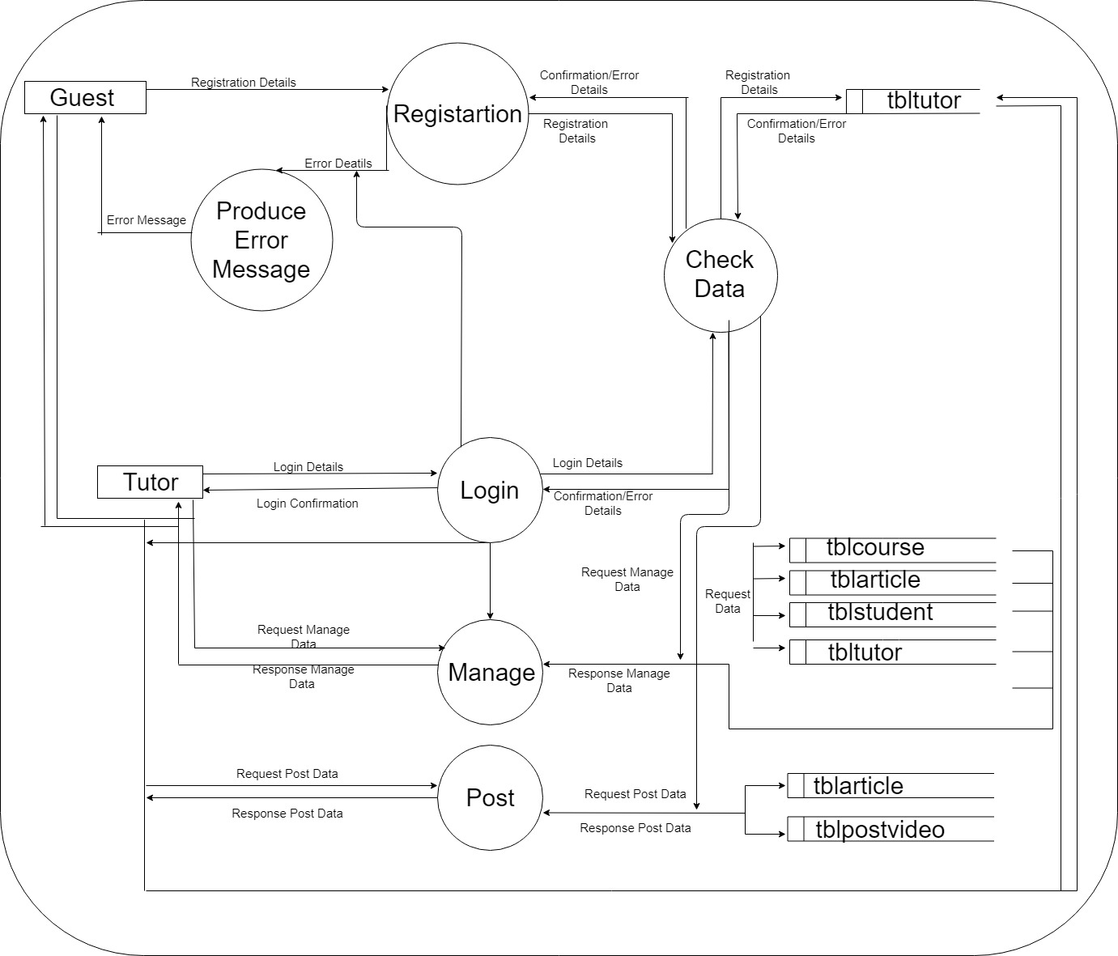

**5.2.3. Class Diagram:**

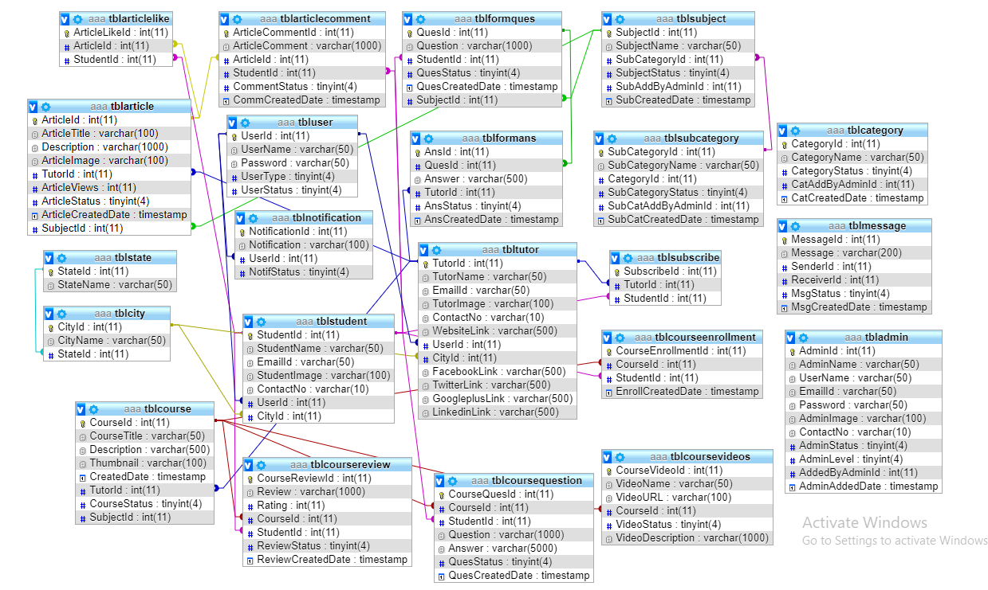

**5.2.4. Activity Diagram:**

**ADMIN**

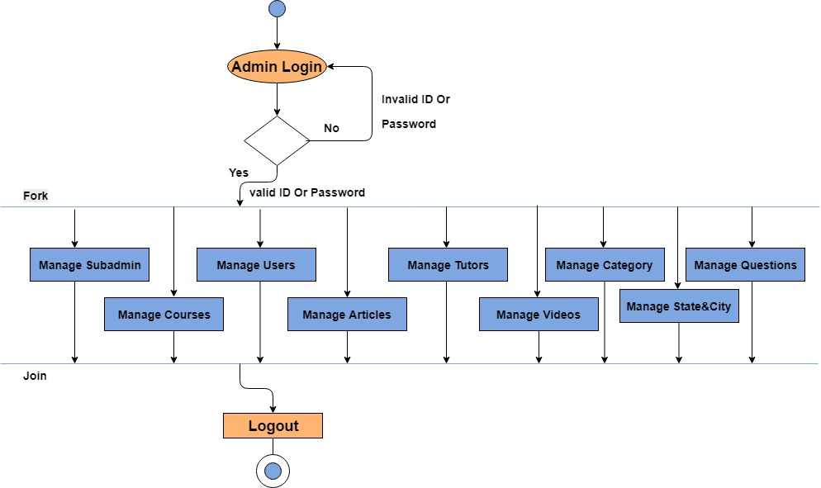

**STUDENT**

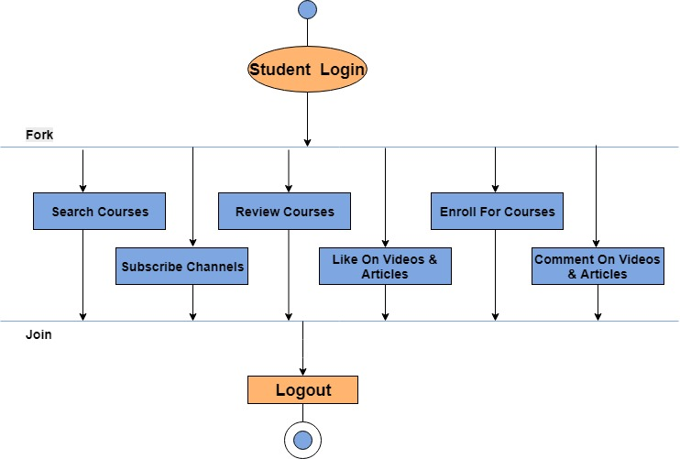

**TUTOR**

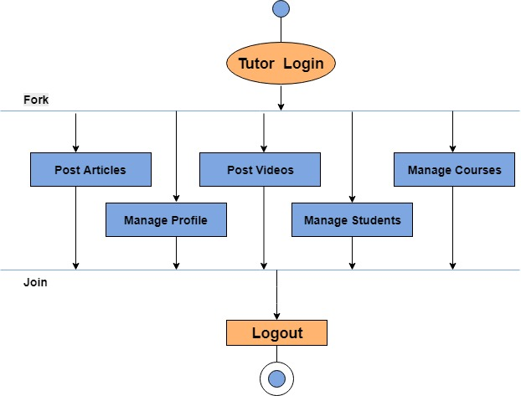

**5.3. E-R Diagram:**

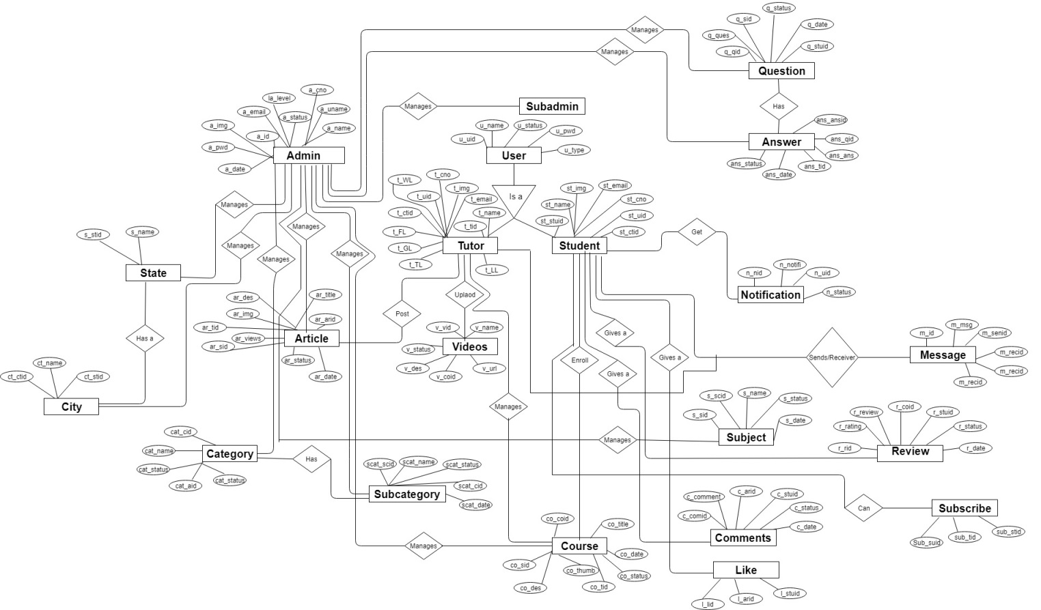

**5.4. Process Specification:**

* **Admin Side:**

**Process**: - 1

**Process Name**: - Login Process

**Description**: -

This process will take login information as input from admin and will compare that information with data stored in admin table. If provided data is correct then system will create a session else will show an error.

**Process**: - 2

**Process Name**: - Manage User

**Description**: -

This process will help admin manage the registered users of its web application. It will allow admin to block user or even delete the user.

**Process**: - 3

**Process Name**: - Manage Sub admin

**Description**: -

This process will help admin manage the sub admin of its web application. It will allow admin to block sub admin or even delete the sub admin.

**Process**: - 4

**Process Name**: - Manage Tutors

**Description**: -

This process will help admin manage the tutors of its web application. It will allow block tutors.

**Process**: - 5

**Process Name**: - Manage Courses

**Description**: -

This process will help admin manage the courses of its web application.

**Process**: - 6

**Process Name**: - Manage Articles

**Description**: -

This process will help admin manage the articles which are displayed over its web application. It will allow admin to insert, update, view and even delete a data of various articles like.

**Process**: - 7

**Process Name**: - Manage Extra

**Description**: -

This process will help admin manage the extras which are displayed over its web application. It will allow admin to insert, update, view & even delete a data of various extra items like ‘Question’, ‘Answer’.

**Process**: - 8

**Process Name**: - Logout Process

**Description**: -

This process will logout the admin i.e. it will unset the current session.

* **Student Side:**

**Process**: - 1

**Process Name**: - Login Process

**Description**: -

This process will take login information as input from Student and will compare that information with data stored in Student table. If provided data is correct then system will create a session else will show an error.

**Process**: - 2

**Process Name**: - Registration Process

**Description**: -

This process will allow a guest user to register themselves as a registered user by inserting required data. The inserted data is stored in database in form of data in student table.

**Process**: - 3

**Process Name**: - Searching

**Description**: -

This process will take search text as input from user and will display relevant data. Search results differ from page to page. It will allow user to view and search data of various extra items like ‘Tutors’, ‘Articles’, ’Questions’, ‘Answers’ and ‘Reviews’.

**Process**: - 4

**Process Name**: - Edit Profile Data

**Description**: -

This process will allow logged in users to change their data which is stored in database.

**Process**: - 5

**Process Name**: - Subscribe Tutor

**Description**: -

This process will allow student to subscribe to tutor.

**Process**: - 5

**Process Name**: - Comment/Like

**Description**: -

This process will allow students to like/comment on the articles.

**Process**: - 6

**Process Name**: - Review

**Description**: -

This process will allow students to give/write review on courses.

**Process**: - 7

**Process Name**: - Logout Process

**Description**: -

This process logs out the user i.e. it will destroy the current session of User.

* **Tutor Side:**

**Process**: - 1

**Process Name**: - Login Process

**Description**: -

This process will take login information as input from Tutor and will compare that information with data stored in Tutor table. If provided data is correct then system will create a session else will show an error.

**Process**: - 2

**Process Name**: - Registration Process

**Description**: -

This process will allow a guest tutor to register themselves as a registered tutor by inserting required data. The inserted data is stored in database in form of data in tutor table.

**Process**: -3

**Process Name**: - Post Articles

**Description**: -

This process will allow registered tutor to post new articles. And edit existing articles posted by the tutor.

**Process**: -4

**Process Name**: - Post Videos

**Description**: -

This process will allow registered tutor to post new videos. And edit detail existing video posted by the tutor.

**Process**: -5

**Process Name**: - Manage Courses

**Description**: -

This process will allow registered tutor to add new course. And edit existing course added by the tutor.

**Process**: -6

**Process Name**: - Edit Profile Data

**Description**: -

This process will allow logged in users to change their data which is stored in database.

**Process**: -7

**Process Name**: - Logout Process

**Description**: -

This process logs out the Tutor i.e. it will destroy the current session.

**Software Design**

**6.1. Database Design:**

**Table:** Table Admin

**Data:** admin username & password.

**Where & how used:** manages admin username, password and its profile image.

**Columns:**

|  |  |  |  |  |
| --- | --- | --- | --- | --- |
| Sr.no | Field | Type | Constraints | Description |
| 1. | AdminId | int(11) | PK |  |
| 2. | AdminName | varchar(50) |  |  |
| 3. | UserName | varchar(50) |  |  |
| 4. | EmailId | varchar(50) |  |  |
| 5. | Password | varchar(50) |  |  |
| 6. | AdminImage | varchar(100) |  |  |
| 7. | ContactNo | varchar(10) |  |  |
| 8. | AdminStatus | tinyint(4) |  | Describe weather the admin is active or blocked |
| 9. | AdminLevel | tinyint(4) |  | Describe the level of  Admin weather the admin is super admin or sub admin |
| 10. | AddedByAdminId | int(11) |  |  |
| 11. | AdminAddedDate | timestamp |  | The date and time at which the admin was added |

**Table:** Table Article

**Data:** Data about article of Tutors.

**Where & how used:** To show various article of tutors.

**Columns:**

|  |  |  |  |  |
| --- | --- | --- | --- | --- |
| Sr.no | Field | Type | Constraints | Description |
| 1. | ArticleId | int(11) | PK |  |
| 2. | ArticleTitle | varchar(100) |  |  |
| 3. | Description | varchar(1000) |  |  |
| 4. | ArticleImage | varchar(100) |  |  |
| 5. | TutorId | int(11) | FK(tbltutor) |  |
| 6. | ArticleViews | int(11) |  |  |
| 7. | ArticleStatus | tinyint(4) |  | Describe weather the article status is active or blocked |
| 8. | ArticleCreatedDate | timestamp |  | The date and time at which the admin was added |
| 9. | SubjectId | int(11) |  |  |

**Table:** Table Article Comment

**Data:** Data about how many users comment on articles.

**Where & how used:** To show various comments of articles.

**Columns:**

|  |  |  |  |  |
| --- | --- | --- | --- | --- |
| Sr.no | Field | Type | Constraints | Description |
| 1. | ArticleCommentId | int(11) | PK |  |
| 2. | ArticleComment | varchar(1000) |  |  |
| 3. | ArticleId | int(11) | FK(tblarticle) |  |
| 4. | StudentId | int(11) | FK(tblstudent) |  |
| 5. | CommentStatus | int(11) |  | Describe weather the comment status is active or blocked |
| 6. | CommCreatedDate | int(11) |  |  |

**Table:** Table Article Like

**Data:** Data about how many users like on articles.

**Where & how used:** To show various like of articles.

**Columns:**

|  |  |  |  |  |
| --- | --- | --- | --- | --- |
| Sr.no | Field | Type | Constraints | Description |
| 1. | ArticlelikeId | int(11) | PK |  |
| 2. | ArticleId | int(11) | FK(tblarticle) |  |
| 3. | StudentId | int(11) | FK(tblstudent) |  |

**Table:** Table Category

**Data:** Data about category of admin.

**Where & how used:** To show various categories of admin.

**Columns:**

|  |  |  |  |  |
| --- | --- | --- | --- | --- |
| Sr.no | Field | Type | Constraints | Description |
| 1. | CategoryId | int(11) | PK |  |
| 2. | CategoryName | varchar(50) |  |  |
| 3. | CategoryStatus | tinyint(4) |  | Describe weather the category Status is active or blocked |
| 4. | CatAddedByAdminId | int(11) |  |  |
| 5. | CatCreatedDate | timestamp |  |  |

**Table:** Table City

**Data:** Data about city.

**Where & how used:** To show the state of city .

**Columns:**

|  |  |  |  |  |
| --- | --- | --- | --- | --- |
| Sr.no | Field | Type | Constraints | Description |
| 1. | CityId | int(11) | PK |  |
| 2. | CityName | varchar(50) |  |  |
| 3. | StateId | int(11) |  |  |

**Table:** Table Course

**Data:** Data about course.

**Where & how used:** To show course of tutors.

**Columns:**

|  |  |  |  |  |
| --- | --- | --- | --- | --- |
| Sr.no | Field | Type | Constraints | Description |
| 1. | CourseId | int(11) | PK |  |
| 2. | CourseTitle | varchar(50) |  |  |
| 3. | SubjectId | int(11) | Fk(tblsubject) |  |
| 4. | Description | varchar(500) |  |  |
| 5. | Thumbnail | varchar(100) |  |  |
| 5. | CreatedDate | timestamp |  |  |
| 6. | TutorId | int(11) | FK(tbltutor) |  |
| 7. | CourseStatus | tinyint(4) |  | Describe weather the course Status is active or blocked |

**Table:** Table Course Enrollment

**Data:** Data about course enrollment.

**Where & how used:** To show data of course enrollment.

**Columns:**

|  |  |  |  |  |
| --- | --- | --- | --- | --- |
| Sr.no | Field | Type | Constraints | Description |
| 1. | CourseEnrollmentId | int(11) | PK |  |
| 2. | CourseId | int(11) | FK(tblcourse) |  |
| 3. | StudentId | int(11) | FK(tblstudent) |  |
| 4. | EnrollCreatedDate | timestamp |  |  |

**Table:** Table Course Questions

**Data:** Data about questions of user.

**Where & how used:** To show various types of questions.

**Columns:**

|  |  |  |  |  |
| --- | --- | --- | --- | --- |
| Sr.no | Field | Type | Constraints | Description |
| 1. | CourseQuesId | int(11) | PK |  |
| 2. | CourseId | int(11) | FK(tblcourse) |  |
| 3. | StudentId | int(11) | FK(tblstudent) |  |
| 4. | Question | varchar(1000) |  |  |
| 5. | Answer | varchar(5000) |  |  |
| 6. | QuesStatus | tinyint(4) |  | Describe weather the question Status is active or blocked |
| 7. | QuesCreatedDate | timestamp |  |  |

**Table:** Table Course View

**Data:** Data about review of user.

**Where & how used:** To show various review of course.

**Columns:**

|  |  |  |  |  |
| --- | --- | --- | --- | --- |
| Sr.no | Field | Type | Constraints | Description |
| 1. | CourseReviewId | int(11) | PK |  |
| 2. | Review | varchar(1000) |  |  |
| 3. | Rating | int(11) |  |  |
| 4. | CourseId | int(11) | FK(tblcourse) |  |
| 5. | StudentId | int(11) | FK(tblstudent) |  |
| 6. | ReviewStatus | tinyint(4) |  | Describe weather the review Status is active or blocked |
| 7. | ReviewCreatedDate | timestamp |  |  |

**Table:** Table Course Videos

**Data:** Data about videos.

**Where & how used:** To show various videos of course.

**Columns:**

|  |  |  |  |  |
| --- | --- | --- | --- | --- |
| Sr.no | Field | Type | Constraints | Description |
| 1. | CourseVideoId | int(11) | PK |  |
| 2. | VideoName | varchar(50) |  |  |
| 3. | VideoUrl | varchar(1000) |  |  |
| 4. | CourseId | int(11) | FK(tblcourse) |  |
| 5. | VideoStatus | tinyint(4) |  | Describe weather the video Status is active or blocked |
| 6. | VideoDescription | varchar(1000) |  |  |

**Table:** Table Form Answer

**Data:** Data about answers.

**Where & how used:** To show various of answers.

**Columns:**

|  |  |  |  |  |
| --- | --- | --- | --- | --- |
| Sr.no | Field | Type | Constraints | Description |
| 1. | AnsId | int(11) | PK |  |
| 2. | QuesId | int(11) | FK(tblformques) |  |
| 3. | Answer | varchar(500) |  |  |
| 4. | TutorId | int(11) | FK(tbltutor) |  |
| 5. | AnsStatus | tinyint(4) |  | Describe weather the ans Status is active or blocked |
| 6. | AnsCreatedDate | timestamp |  |  |

**Table:** Table Form Question

**Data:** Data about questions.

**Where & how used:** To show various of questions.

**Columns:**

|  |  |  |  |  |
| --- | --- | --- | --- | --- |
| Sr.no | Field | Type | Constraints | Description |
| 1. | QuesId | int(11) | PK |  |
| 2. | Question | varchar(50) |  |  |
| 3. | StudentId | int(11) | FK(tblstudent) |  |
| 4. | QuesStatus | tinyint(4) |  | Describe weather the video Status is active or blocked |
| 5. | QuesCreatedDate | timestamp |  |  |
| 6. | SubjectId | int(11) | FK(tblsubject) |  |

**Table:** Table Message

**Data:** Data about message.

**Where & how used:** To show various of messages.

**Columns:**

|  |  |  |  |  |
| --- | --- | --- | --- | --- |
| Sr.no | Field | Type | Constraints | Description |
| 1. | MessageId | int(11) | PK |  |
| 2. | Message | varchar(500) |  |  |
| 3. | SenderId | int(11) |  |  |
| 4. | ReceiverId | int(11) |  |  |
| 5. | MsgStatus | tinyint(4) |  |  |
| 6. | MsgCreatedDate | timestamp |  |  |

**Table:** Table Notification

**Data:** Data about notification.

**Where & how used:** To show notification of user.

**Columns:**

|  |  |  |  |  |
| --- | --- | --- | --- | --- |
| Sr.no | Field | Type | Constraints | Description |
| 1. | NotificationId | int(11) | PK |  |
| 2. | Notification | varchar(100) |  |  |
| 3. | TutorId | int(11) |  |  |
| 4. | StudentId | int(11) |  |  |
| 6. | UserType | tinyint(4) |  |  |
| 5. | NotifStatus | tinyint(4) |  |  |

**Table:** Table State

**Data:** Data about state.

**Where & how used:** To show the state.

**Columns:**

|  |  |  |  |  |
| --- | --- | --- | --- | --- |
| Sr.no | Field | Type | Constraints | Description |
| 1. | StateId | int(11) | PK |  |
| 2. | StateName | varchar(50) |  |  |

**Table:** Table Student

**Data:** Data about student.

**Where & how used:** To show various data of students.

**Columns:**

|  |  |  |  |  |
| --- | --- | --- | --- | --- |
| Sr.no | Field | Type | Constraints | Description |
| 1. | StudentId | int(11) | PK |  |
| 2. | StudentName | varchar(50) |  |  |
| 3. | EmailId | varchar(50) |  |  |
| 4. | StudentImage | varchar(100) |  |  |
| 5. | ContactNo | varchar(10) |  |  |
| 6. | UserId | int(11) | FK(tbluser) |  |
| 7.. | CityId | int(11) | FK(tblcity) |  |

**Table:** Table Subcategory

**Data:** Data about subcategory of admin.

**Where & how used:** To show various subcategories.

**Columns:**

|  |  |  |  |  |
| --- | --- | --- | --- | --- |
| Sr.no | Field | Type | Constraints | Description |
| 1. | SubCategoryId | int(11) | PK |  |
| 2. | SubCategoryName | varchar(50) |  |  |
| 3. | CategoryId | int(11) | FK(tblcategory) |  |
| 4. | SubCategoryStatus | tinyint(4) |  |  |
| 5. | SubCatAddByAdminId | int(11) |  |  |
| 6. | SubCatCreatedDate | timestamp |  |  |

**Table:** Table Subject

**Data:** Data about subject.

**Where & how used:** To show various course of subject.

**Columns:**

|  |  |  |  |  |
| --- | --- | --- | --- | --- |
| Sr.no | Field | Type | Constraints | Description |
| 1. | SubjectId | int(11) | PK |  |
| 2. | SubjectName | varchar(50) |  |  |
| 3. | SubcategoryId | int(11) | FK(tblsubcategory) |  |
| 4. | SubjectStatus | tinyint(4) |  |  |
| 5. | SubAddByAdminId | int(11) |  |  |
| 6. | SubCreatedDate | timestamp |  |  |

**Table:** Table Subscribe

**Data:** Data about subscribe of user.

**Where & how used:** To show various of subscribes.

**Columns:**

|  |  |  |  |  |
| --- | --- | --- | --- | --- |
| Sr.no | Field | Type | Constraints | Description |
| 1. | SubscribeId | int(11) | PK |  |
| 2. | TutorId | int(11) | FK(tbltutor) |  |
| 3. | StudentId | int(11) | FK(tblstudent) |  |

**Table:** Table Tutor

**Data:** Data about tutor.

**Where & how used:** To show various of tutors.

**Columns:**

|  |  |  |  |  |
| --- | --- | --- | --- | --- |
| Sr.no | Field | Type | Constraints | Description |
| 1. | TutorId | int(11) | PK |  |
| 2. | TutorName | varchar(50) | FK(tbltutor) |  |
| 3. | EmailId | varchar(50) | FK(tblstudent) |  |
| 4. | TutorImage | varchar(100) |  |  |
| 5. | ContactNo | varchar(10) |  |  |
| 6. | WebsiteLink | varchar(100) |  |  |
| 7. | UserId | int(11) | FK(tbluser) |  |
| 8. | CityId | int(11) | FK(tblcity) |  |
| 9. | FacebookLink | varchar(500) |  |  |
| 10. | TwitterLink | varchar(500) |  |  |
| 11. | GoogleplusLink | varchar(500) |  |  |
| 12. | LinkedinLink | varchar(500) |  |  |

**Table:** Table User

**Data:** Data about users of web application.

**Where & how used:** To store data of various users.

**Columns:**

|  |  |  |  |  |
| --- | --- | --- | --- | --- |
| Sr.no | Field | Type | Constraints | Description |
| 1. | UserId | int(11) | PK |  |
| 2. | UserName | varchar(50) |  |  |
| 3. | Password | varchar(50) |  |  |
| 4. | UserType | tinyint(4) |  |  |
| 5. | UserStatus | tinyint(4) |  |  |

**6.2. Data Dictionary:**

* **tbladmin**

|  |  |
| --- | --- |
| **Name:** | **AdminId** |
| Alias: | None |
| Where / How used: | - To identify unique admin.  - Change Profile picture  - Change Password |
| Description: | Auto incremented number for uniquely identify admin |
| Format: | Numeric Data |

|  |  |
| --- | --- |
| **Name:** | **AdminName** |
| Alias: | None |
| Where / How used: | Login process |
| Description: | Store Admin name for authentication process |
| Format: | Alphanumeric Data |

|  |  |
| --- | --- |
| **Name:** | **UserName** |
| Alias: | None |
| Where / How used: | Login process |
| Description: | Store Admin of user name for authentication process |
| Format: | Alphanumeric Data |

|  |  |
| --- | --- |
| **Name:** | **EmailId** |
| Alias: | None |
| Where / How used: | Login process |
| Description: | Store Email id for authentication process |
| Format: | Alphanumeric Data |

|  |  |
| --- | --- |
| **Name:** | **Password** |
| Alias: | None |
| Where / How used: | Login process |
| Description: | Store Encrypted Password for authentication process |
| Format: | Alphanumeric Data |

|  |  |
| --- | --- |
| **Name:** | **AdminImage** |
| Alias: | None |
| Where / How used: | Display profile picture |
| Description: | Store Image Name for profile picture |
| Format: | Alphanumeric Data |

|  |  |
| --- | --- |
| **Name:** | **Contactno** |
| Alias: | Phone number |
| Where / How used: | Display contactno |
| Description: | Store contactno of admin |
| Format: | Numeric data |

* **tblarticle**

|  |  |
| --- | --- |
| **Name:** | **ArticleId** |
| Alias: | None |
| Where / How used: | - To identify unique Id. |
| Description: | Auto incremented number for uniquely identify admin |
| Format: | Numeric Data |

|  |  |
| --- | --- |
| **Name:** | **ArticleTitle** |
| Alias: | None |
| Where / How used: | Display the Article Title |
| Description: | Store Article title for authentication process |
| Format: | Alphanumeric Data |

|  |  |
| --- | --- |
| **Name:** | **Description** |
| Alias: | None |
| Where / How used: | Display the description of article title |
| Description: | Store Admin of user name for authentication process |
| Format: | Alphanumeric Data |

|  |  |
| --- | --- |
| **Name:** | **ArticleImage** |
| Alias: | None |
| Where / How used: | Display article image |
| Description: | Store Image Name for article image |
| Format: | Alphanumeric Data |

|  |  |
| --- | --- |
| **Name:** | **ArticleViews** |
| Alias: | None |
| Where / How used: | Display the view of article |
| Description: | Store article view of admin |
| Format: | Alphanumeric Data |

* **tblarticlecomment**

|  |  |
| --- | --- |
| **Name:** | **ArticleCommentId** |
| Alias: | None |
| Where / How used: | To identify unique Id. |
| Description: | Auto incremented number for uniquely identified. |
| Format: | Numeric Data |

|  |  |
| --- | --- |
| **Name:** | **ArticleComment** |
| Alias: | None |
| Where / How used: | Display the Article Comment |
| Description: | Store Article comment for authentication process |
| Format: | Alphanumeric Data |

* **tblarticlelike**

|  |  |
| --- | --- |
| **Name:** | **ArticleLikeId** |
| Alias: | None |
| Where / How used: | To identify unique Id. |
| Description: | Auto incremented number for uniquely identified . |
| Format: | Numeric Data |

* **tblcategory**

|  |  |
| --- | --- |
| **Name:** | **CategoryId** |
| Alias: | None |
| Where / How used: | To identify unique Id. |
| Description: | Auto incremented number for uniquely identified. |
| Format: | Numeric Data |

|  |  |
| --- | --- |
| **Name:** | **CategoryName** |
| Alias: | None |
| Where / How used: | Display the category name |
| Description: | Store category name for authentication process |
| Format: | Alphanumeric Data |

* **tblcity**

|  |  |
| --- | --- |
| **Name:** | **CityId** |
| Alias: | None |
| Where / How used: | To identify unique Id. |
| Description: | Auto incremented number for uniquely identified. |
| Format: | Numeric Data |

|  |  |
| --- | --- |
| **Name:** | **CityName** |
| Alias: | None |
| Where / How used: | Display the city name |
| Description: | Store city name for authentication process |
| Format: | Alphanumeric Data |

* **tblcourse**

|  |  |
| --- | --- |
| **Name:** | **CourseId** |
| Alias: | None |
| Where / How used: | - To identify unique Id. |
| Description: | Auto incremented number for uniquely identify admin |
| Format: | Numeric Data |

|  |  |
| --- | --- |
| **Name:** | **CourseTitle** |
| Alias: | None |
| Where / How used: | Display the Course Title |
| Description: | Store Course title for authentication process |
| Format: | Alphanumeric Data |

|  |  |
| --- | --- |
| **Name:** | **Description** |
| Alias: | None |
| Where / How used: | Display the description of course title |
| Description: | Store Admin of user name for authentication process |
| Format: | Alphanumeric Data |

|  |  |
| --- | --- |
| **Name:** | **Thumbnail** |
| Alias: | None |
| Where / How used: | Display image of course title |
| Description: | Store Image Name for thumbnail |
| Format: | Alphanumeric Data |

* **tblcourseenrollment**

|  |  |
| --- | --- |
| **Name:** | **CourseEnrollmentId** |
| Alias: | None |
| Where / How used: | - To identify unique Id. |
| Description: | Auto incremented number for uniquely identify admin |
| Format: | Numeric Data |

* **tblcoursequestion**

|  |  |
| --- | --- |
| **Name:** | **CourseQuesId** |
| Alias: | None |
| Where / How used: | - To identify unique Id. |
| Description: | Auto incremented number for uniquely identify admin |
| Format: | Numeric Data |

|  |  |
| --- | --- |
| **Name:** | **Question** |
| Alias: | None |
| Where / How used: | Display the Question. |
| Description: | Store Question for authentication process |
| Format: | Alphanumeric Data |

|  |  |
| --- | --- |
| **Name:** | **Answer** |
| Alias: | None |
| Where / How used: | Display the Answer. |
| Description: | Store Answer for authentication process |
| Format: | Alphanumeric Data |

* **tblcoursereview**

|  |  |
| --- | --- |
| **Name:** | **CourseReviewId** |
| Alias: | None |
| Where / How used: | - To identify unique Id. |
| Description: | Auto incremented number for uniquely identify admin |
| Format: | Numeric Data |

|  |  |
| --- | --- |
| **Name:** | **Review** |
| Alias: | None |
| Where / How used: | Display the Review. |
| Description: | Store Review for authentication process |
| Format: | Alphanumeric Data |

|  |  |
| --- | --- |
| **Name:** | **Rating** |
| Alias: | None |
| Where / How used: | Display the Rating. |
| Description: | Store Rating for authentication process |
| Format: | Numeric Data |

* **tblcoursevideos**

|  |  |
| --- | --- |
| **Name:** | **CourseVideoId** |
| Alias: | None |
| Where / How used: | - To identify unique Id. |
| Description: | Auto incremented number for uniquely identify admin |
| Format: | Numeric Data |

|  |  |
| --- | --- |
| **Name:** | **VideoName** |
| Alias: | None |
| Where / How used: | Display the Video Name |
| Description: | Store video name for authentication process |
| Format: | Alphanumeric Data |

|  |  |
| --- | --- |
| **Name:** | **VideoURL** |
| Alias: | None |
| Where / How used: | Display the URL of video |
| Description: | Store URL of video for authentication process |
| Format: | Alphanumeric Data |

|  |  |
| --- | --- |
| **Name:** | **VideoDescription** |
| Alias: | None |
| Where / How used: | Display description of video |
| Description: | Store the video of description. |
| Format: | Alphanumeric Data |

* **tblfromans**

|  |  |
| --- | --- |
| **Name:** | **AnsId** |
| Alias: | None |
| Where / How used: | - To identify unique Id. |
| Description: | Auto incremented number for uniquely identify admin |
| Format: | Numeric Data |

* **tblquesans**

|  |  |
| --- | --- |
| **Name:** | **QuesId** |
| Alias: | None |
| Where / How used: | - To identify unique Id. |
| Description: | Auto incremented number for uniquely identify admin |
| Format: | Numeric Data |

* **tblmessage**

|  |  |
| --- | --- |
| **Name:** | **MessageId** |
| Alias: | None |
| Where / How used: | - To identify unique Id. |
| Description: | Auto incremented number for uniquely identify admin |
| Format: | Numeric Data |

|  |  |
| --- | --- |
| **Name:** | **Message** |
| Alias: | None |
| Where / How used: | Display message |
| Description: | Store message for authentication process |
| Format: | Alphanumeric Data |

* **tblnotification**

|  |  |
| --- | --- |
| **Name:** | **NotificationId** |
| Alias: | None |
| Where / How used: | - To identify unique Id. |
| Description: | Auto incremented number for uniquely identify admin |
| Format: | Numeric Data |

|  |  |
| --- | --- |
| **Name:** | **Notification** |
| Alias: | None |
| Where / How used: | Display notification |
| Description: | Store notification for authentication process |
| Format: | Alphanumeric Data |

* **tblstate**

|  |  |
| --- | --- |
| **Name:** | **StateId** |
| Alias: | None |
| Where / How used: | To identify unique Id. |
| Description: | Auto incremented number for uniquely identified. |
| Format: | Numeric Data |

|  |  |
| --- | --- |
| **Name:** | **StateName** |
| Alias: | None |
| Where / How used: | Display the State name |
| Description: | Store city state for authentication process |
| Format: | Alphanumeric Data |

* **tblstudent**

|  |  |
| --- | --- |
| **Name:** | **StudentId** |
| Alias: | None |
| Where / How used: | - To identify unique admin. |
| Description: | Auto incremented number for uniquely identify admin |
| Format: | Numeric Data |

|  |  |
| --- | --- |
| **Name:** | **StudentName** |
| Alias: | None |
| Where / How used: | Login process |
| Description: | Store student name for authentication process |
| Format: | Alphanumeric Data |

|  |  |
| --- | --- |
| **Name:** | **EmailId** |
| Alias: | None |
| Where / How used: | Login process |
| Description: | Store Email id for authentication process |
| Format: | Alphanumeric Data |

|  |  |
| --- | --- |
| **Name:** | **StudentImage** |
| Alias: | None |
| Where / How used: | Display student image |
| Description: | Store Image as student |
| Format: | Alphanumeric Data |

|  |  |
| --- | --- |
| **Name:** | **Contactno** |
| Alias: | Phone number |
| Where / How used: | Display contactno |
| Description: | Store contactno of student |
| Format: | Numeric data |

* **tblsubcategory**

|  |  |
| --- | --- |
| **Name:** | **SubCategoryId** |
| Alias: | None |
| Where / How used: | To identify unique Id. |
| Description: | Auto incremented number for uniquely identified. |
| Format: | Numeric Data |

|  |  |
| --- | --- |
| **Name:** | **SubCategoryName** |
| Alias: | None |
| Where / How used: | Display the subcategory name |
| Description: | Store subcategory name for authentication process |
| Format: | Alphanumeric Data |

* **tblsubject**

|  |  |
| --- | --- |
| **Name:** | **SubjectId** |
| Alias: | None |
| Where / How used: | To identify unique Id. |
| Description: | Auto incremented number for uniquely identified. |
| Format: | Numeric Data |

|  |  |
| --- | --- |
| **Name:** | **SubjectName** |
| Alias: | None |
| Where / How used: | Display the subject name |
| Description: | Store subject name for authentication process |
| Format: | Alphanumeric Data |

* **tblsubscribe**

|  |  |
| --- | --- |
| **Name:** | **SubscribeId** |
| Alias: | None |
| Where / How used: | To identify unique Id. |
| Description: | Auto incremented number for uniquely identified. |
| Format: | Numeric Data |

* **tbltutor**

|  |  |
| --- | --- |
| **Name:** | **TutorId** |
| Alias: | None |
| Where / How used: | - To identify unique admin. |
| Description: | Auto incremented number for uniquely identify admin |
| Format: | Numeric Data |

|  |  |
| --- | --- |
| **Name:** | **TutorName** |
| Alias: | None |
| Where / How used: | Login process |
| Description: | Store tutor name for authentication process |
| Format: | Alphanumeric Data |

|  |  |
| --- | --- |
| **Name:** | **EmailId** |
| Alias: | None |
| Where / How used: | Login process |
| Description: | Store Email id of the tutor |
| Format: | Alphanumeric Data |

|  |  |
| --- | --- |
| **Name:** | **TutorImage** |
| Alias: | None |
| Where / How used: | Display Tutor image |
| Description: | Store Image as tutor |
| Format: | Alphanumeric Data |

|  |  |
| --- | --- |
| **Name:** | **Contactno** |
| Alias: | Phone number |
| Where / How used: | Display contactno |
| Description: | Store contactno of tutor |
| Format: | Numeric data |

|  |  |
| --- | --- |
| **Name:** | **WebsiteLink** |
| Alias: | None |
| Where / How used: | Display website link |
| Description: | Store website link of tutor |
| Format: | Alphanumeric data |

|  |  |
| --- | --- |
| **Name:** | **FacebookLink** |
| Alias: | None |
| Where / How used: | Display Facebook link |
| Description: | Store Facebook link of tutor |
| Format: | Alphanumeric data |

|  |  |
| --- | --- |
| **Name:** | **TwitterLink** |
| Alias: | None |
| Where / How used: | Display Twitter link |
| Description: | Store Twitter link of tutor |
| Format: | Alphanumeric data |

|  |  |
| --- | --- |
| **Name:** | **GoogleplusLink** |
| Alias: | None |
| Where / How used: | Display Googleplus link |
| Description: | Store Googleplus link of tutor |
| Format: | Alphanumeric data |

|  |  |
| --- | --- |
| **Name:** | **LinkedinLink** |
| Alias: | None |
| Where / How used: | Display Linkedin link |
| Description: | Store Linkedin link of tutor |
| Format: | Alphanumeric data |

* **tbluser**

|  |  |
| --- | --- |
| **Name:** | **UserId** |
| Alias: | None |
| Where / How used: | - To identify unique admin.  - Change Profile picture  - Change Password |
| Description: | Auto incremented number for uniquely identify admin |
| Format: | Numeric Data |

|  |  |
| --- | --- |
| **Name:** | **UserName** |
| Alias: | None |
| Where / How used: | Login process |
| Description: | Store User name for authentication process |
| Format: | Alphanumeric Data |

|  |  |
| --- | --- |
| **Name:** | **Password** |
| Alias: | None |
| Where / How used: | Login process |
| Description: | Store Encrypted Password for authentication process |
| Format: | Alphanumeric Data |

**Screenshots**

* **Tutor Site:**

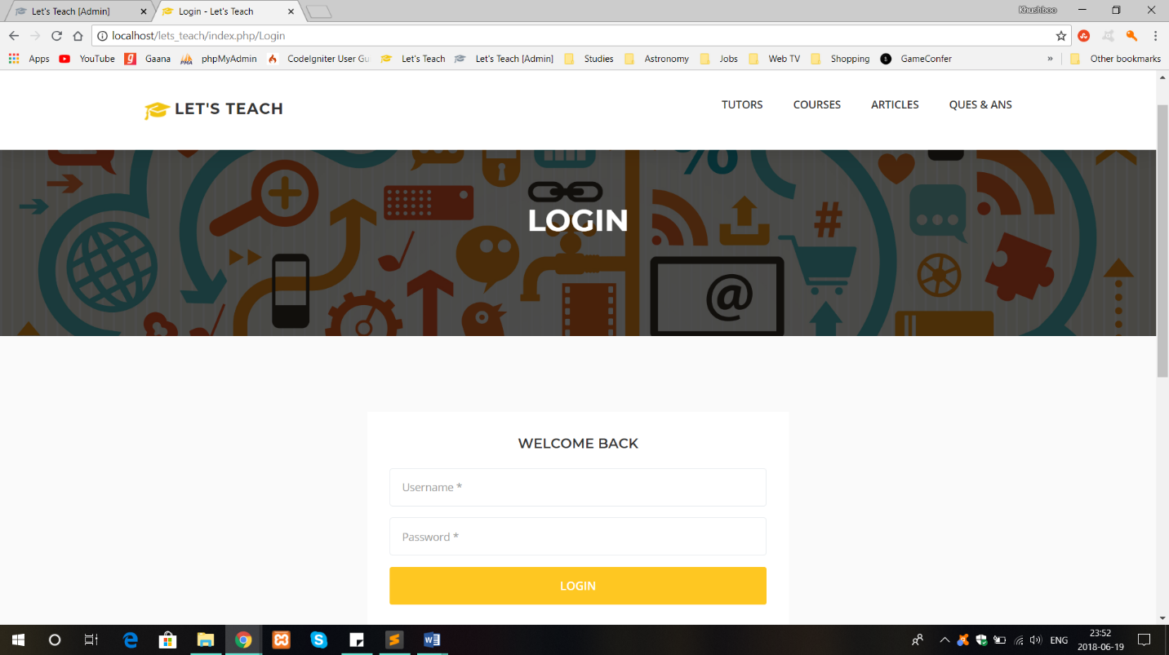

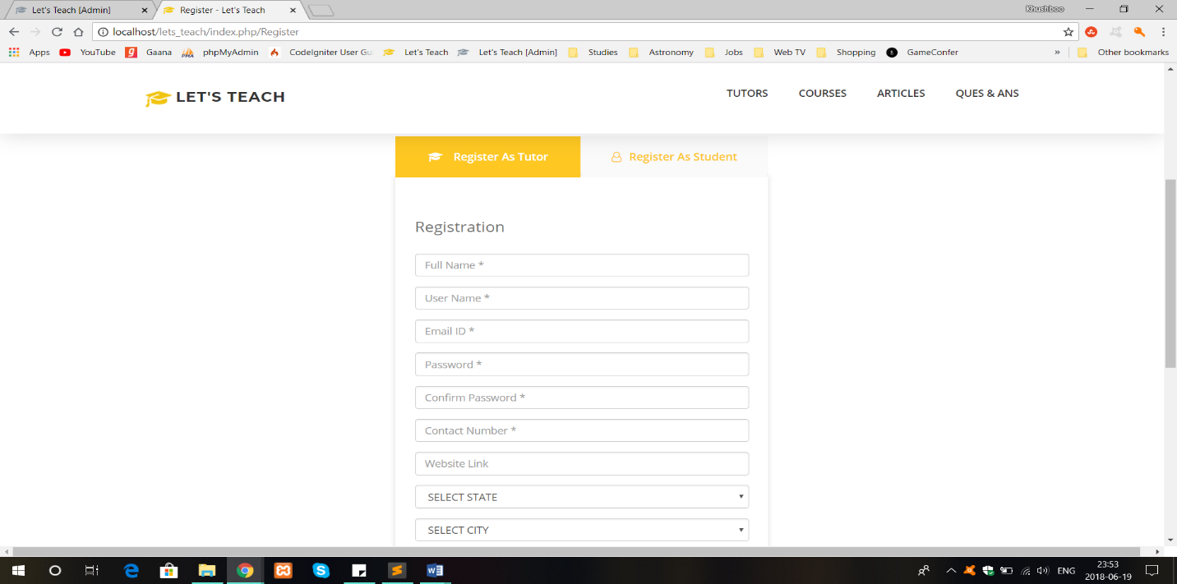

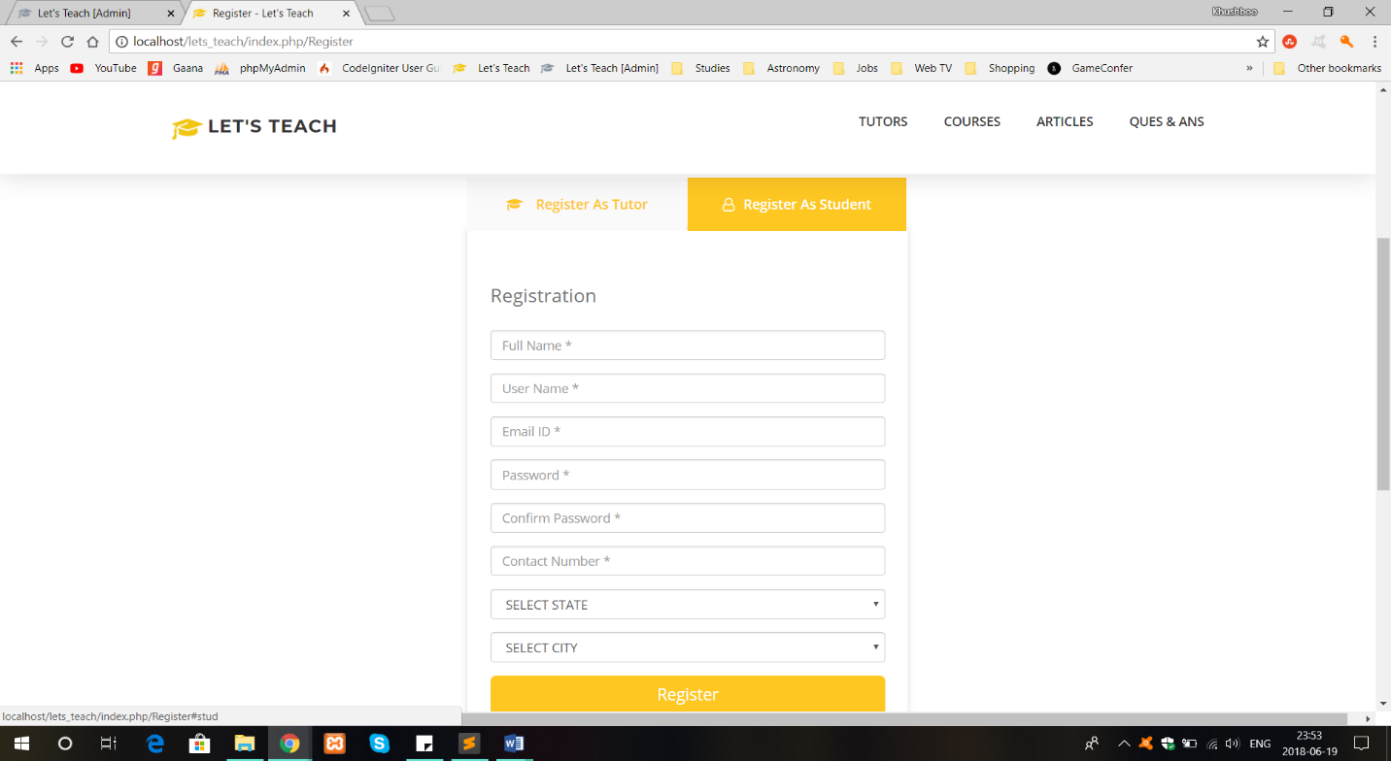



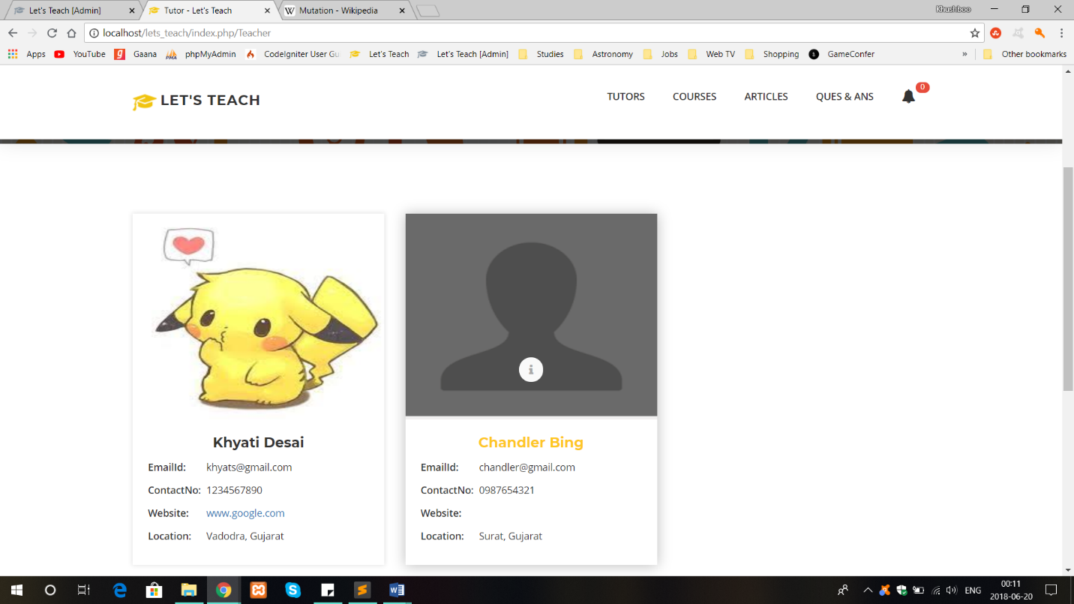

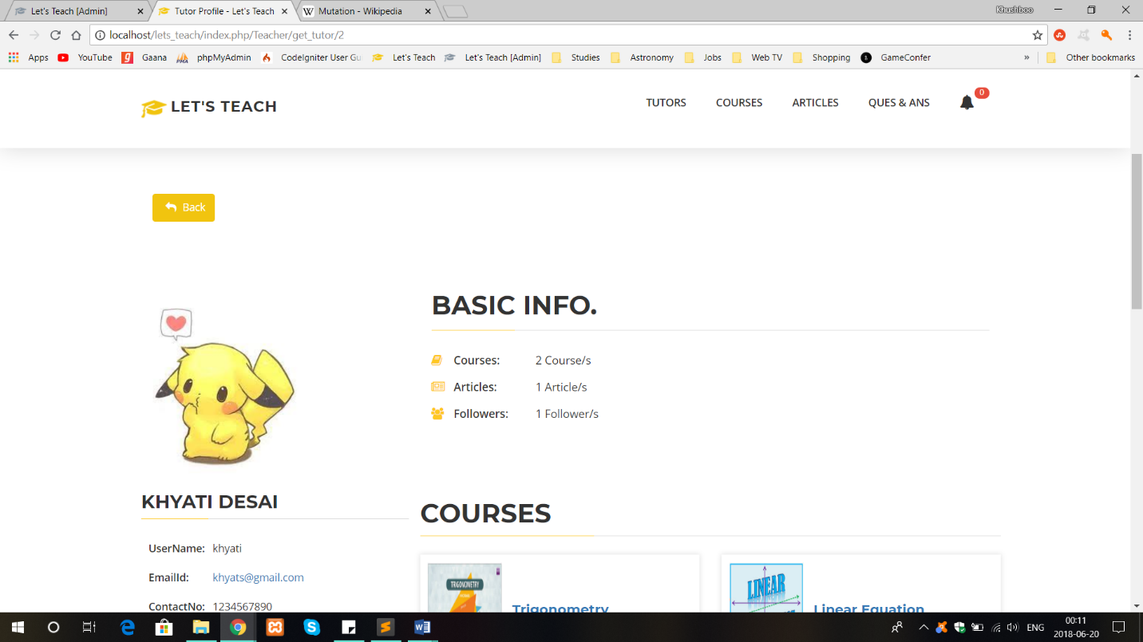

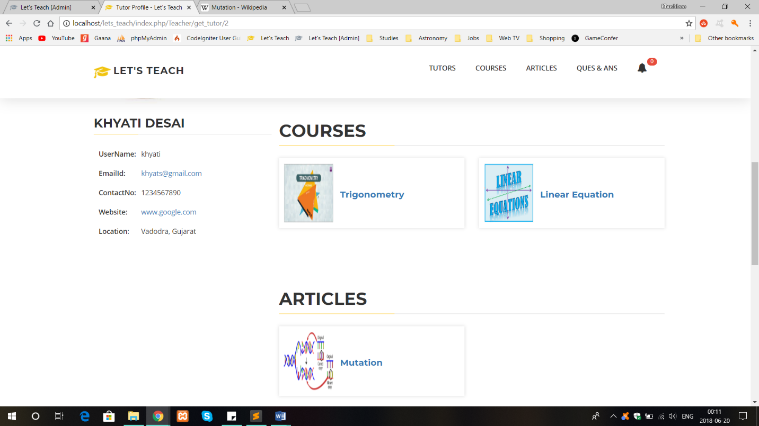

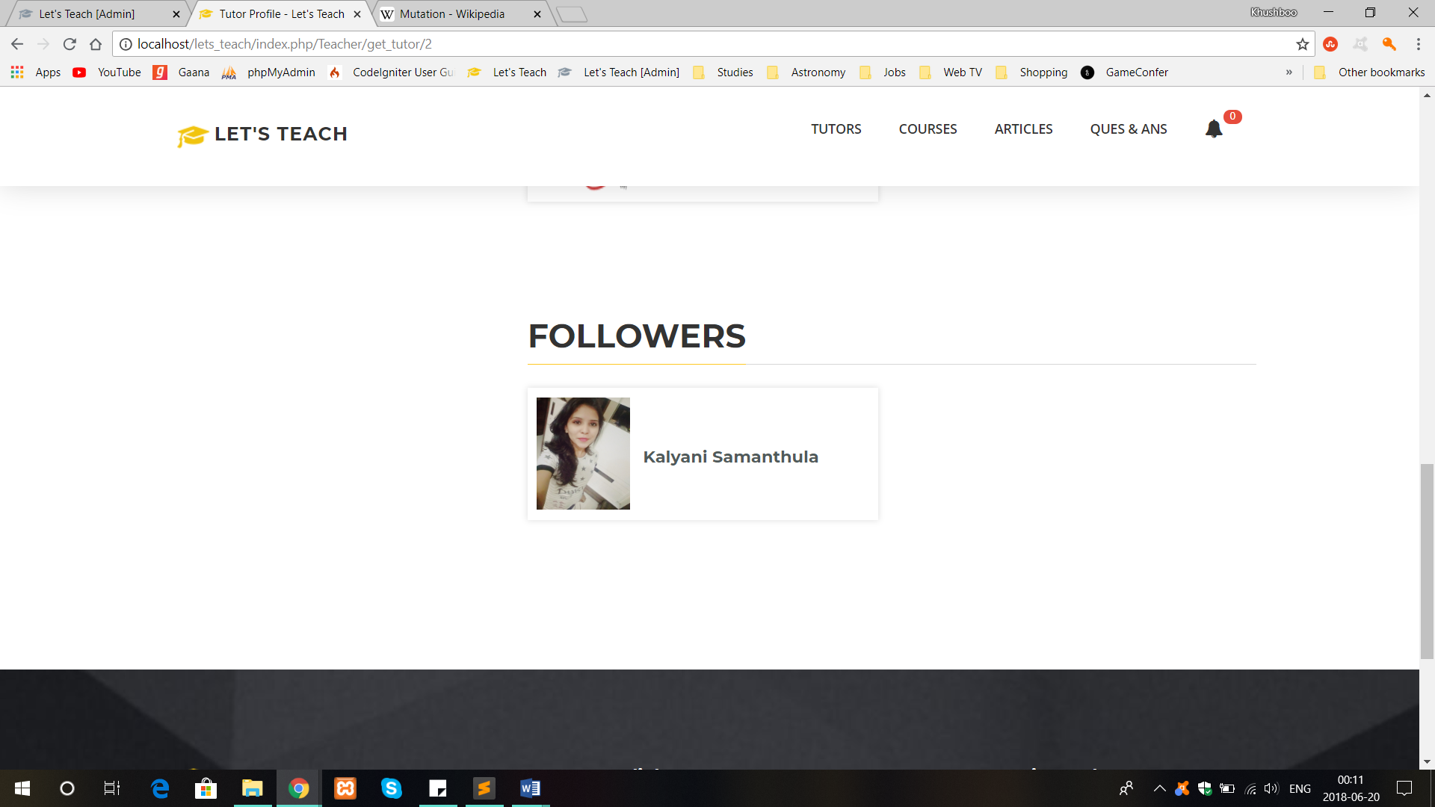

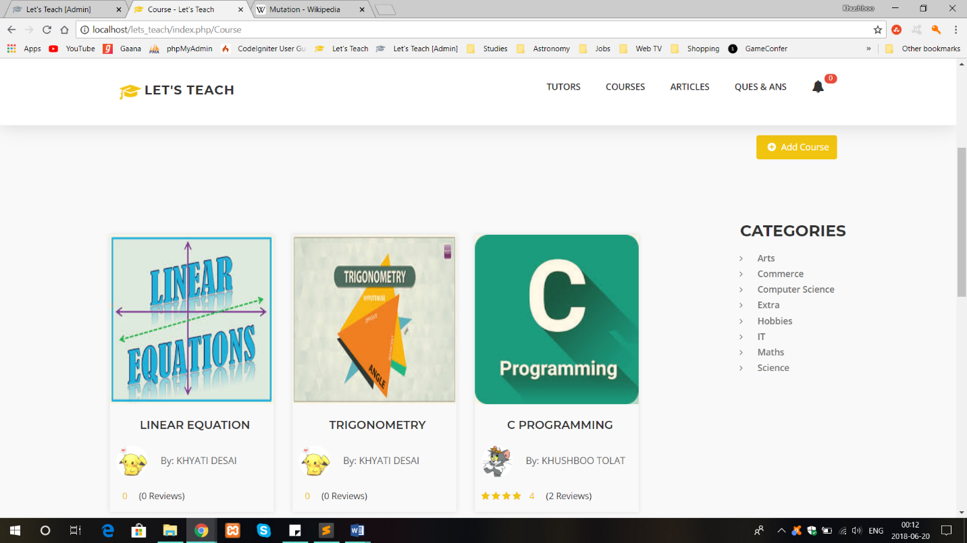

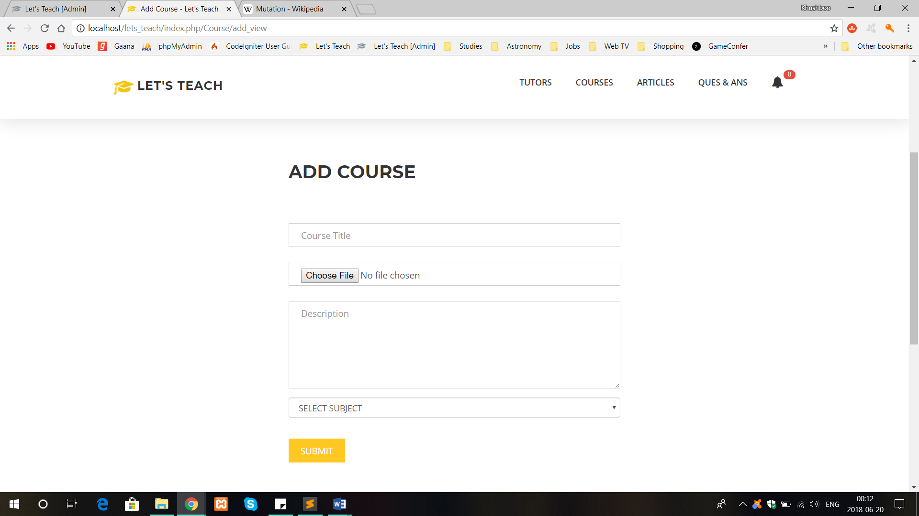

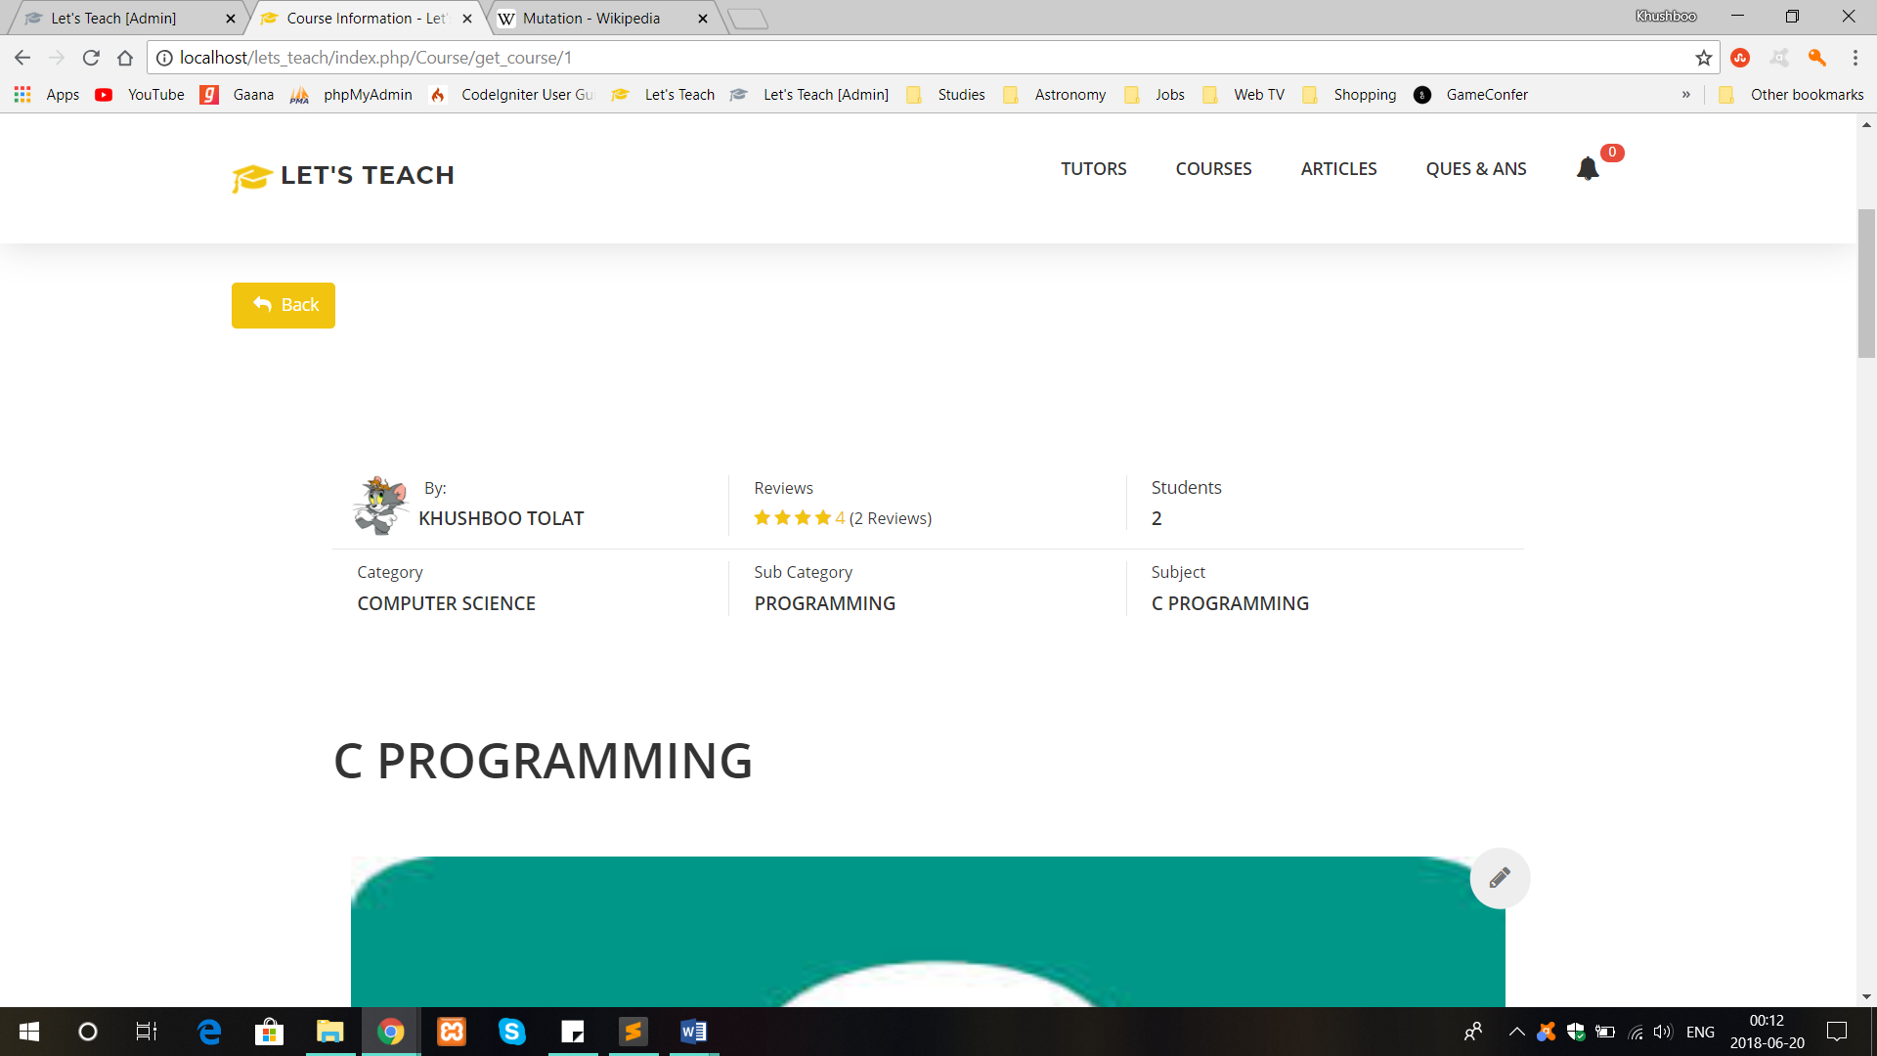

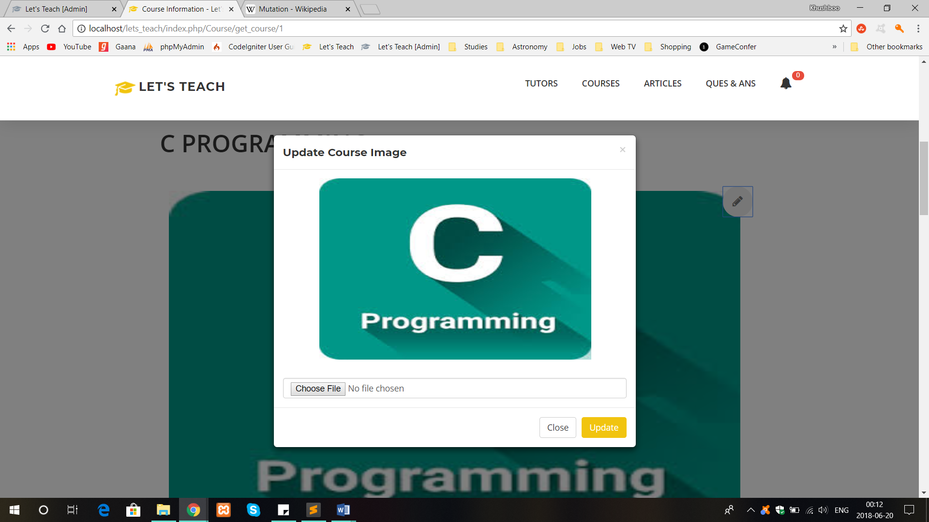

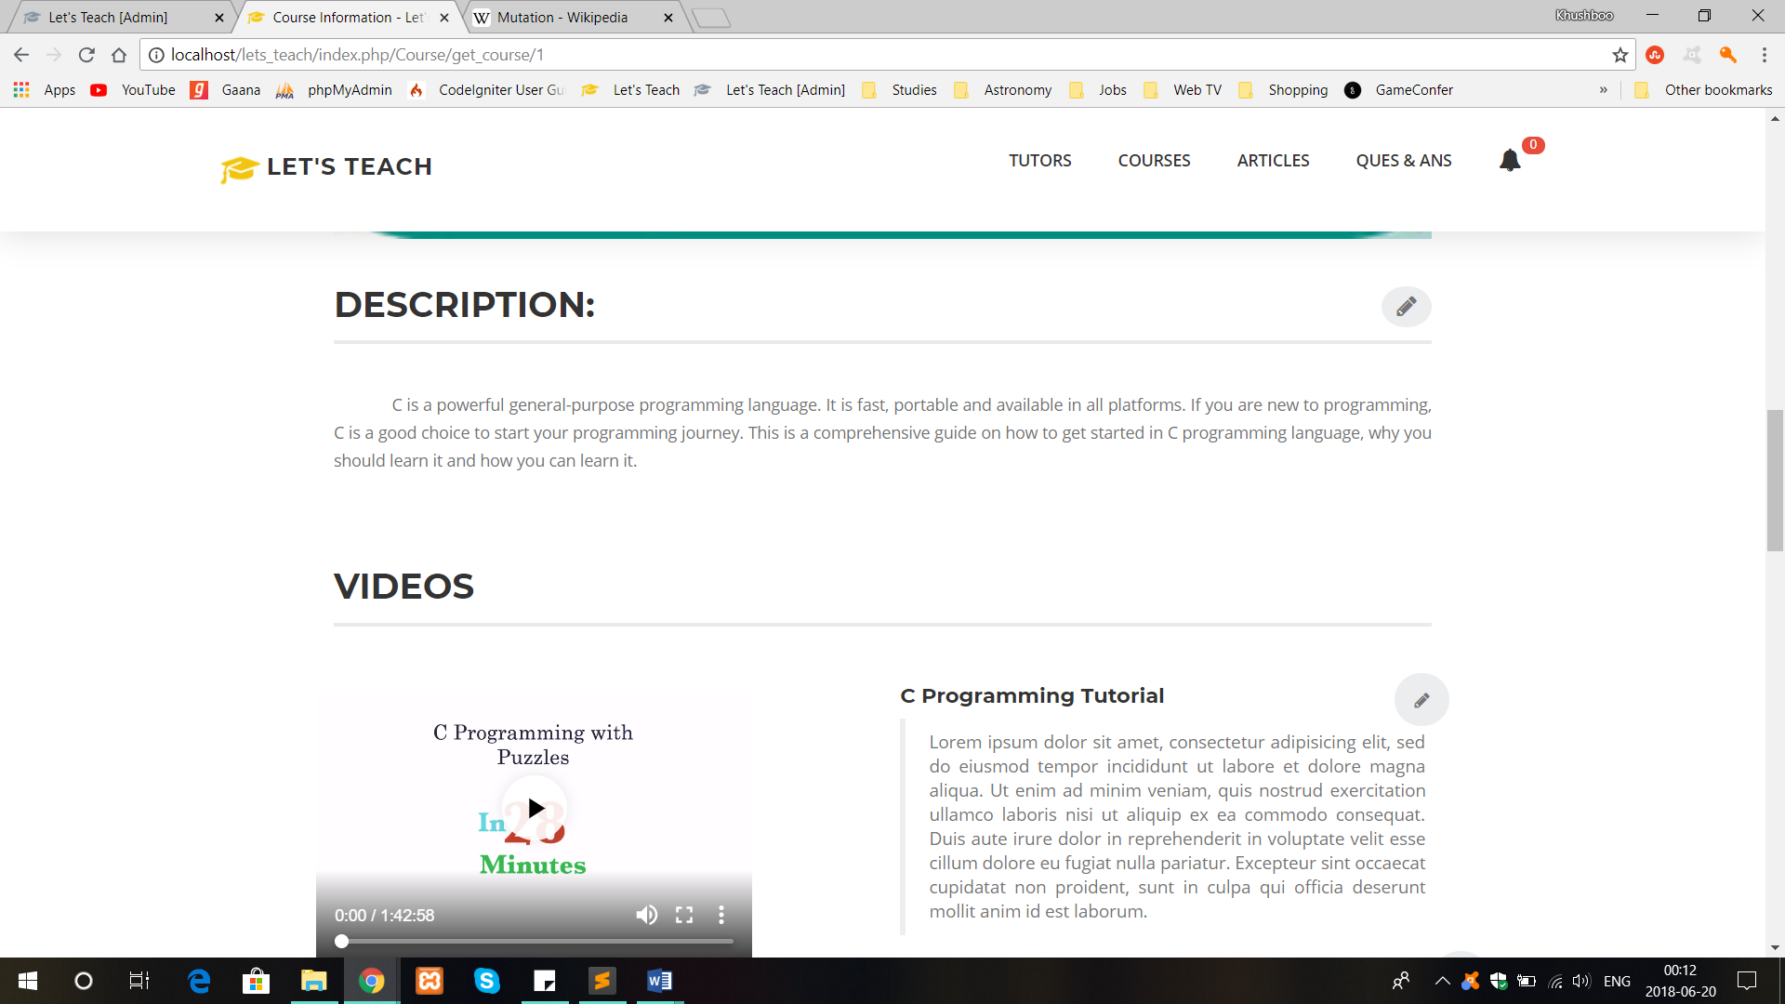

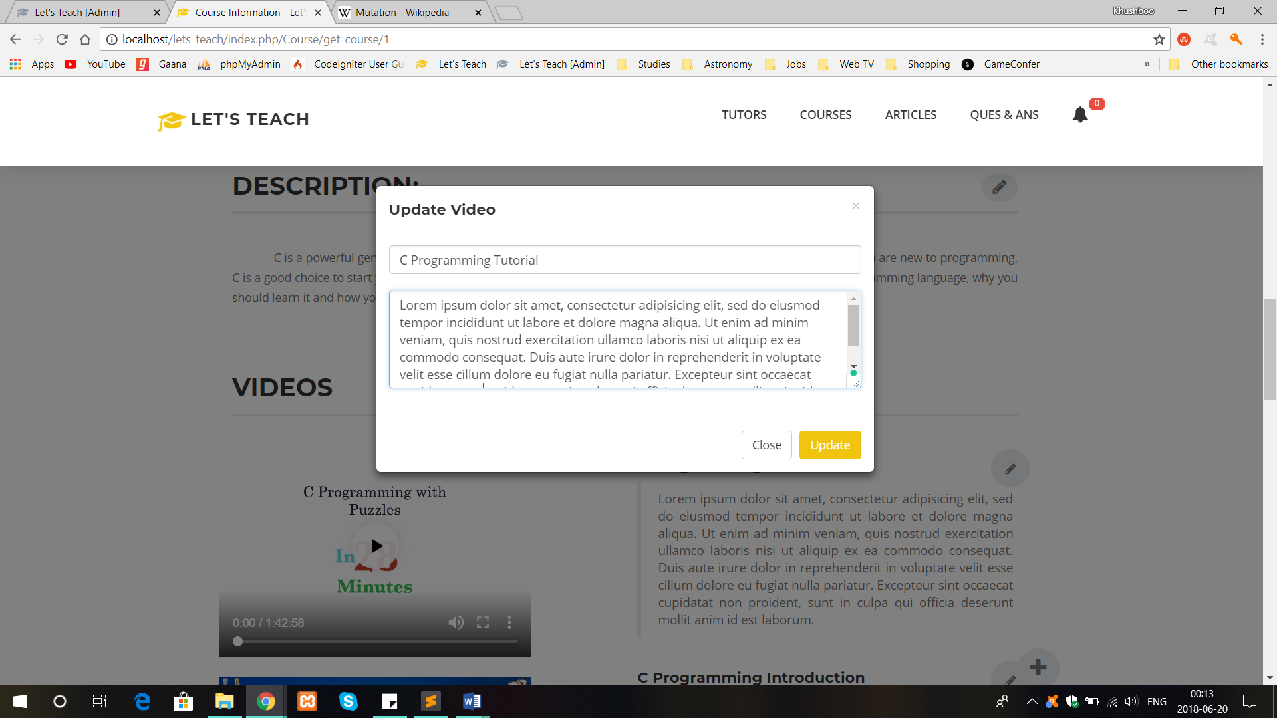

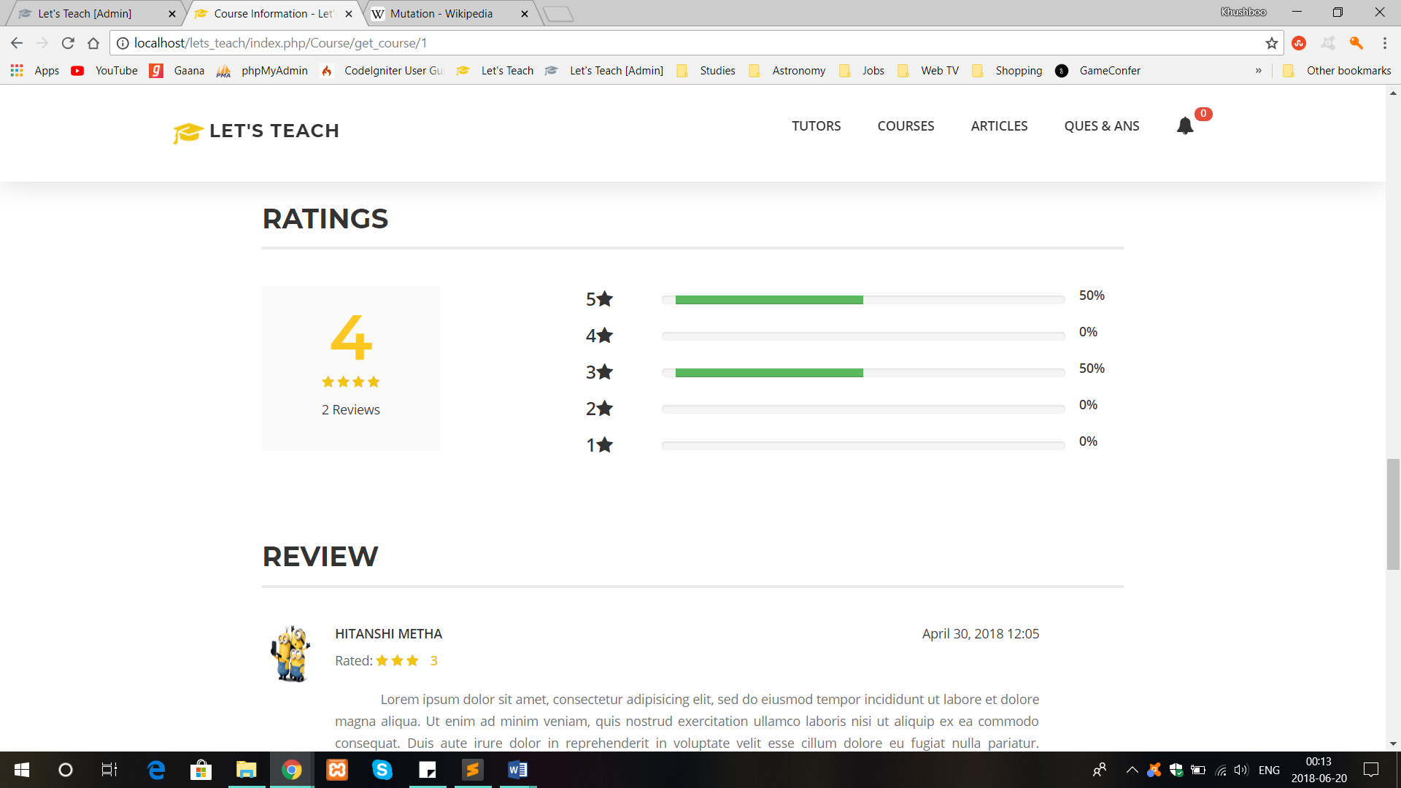

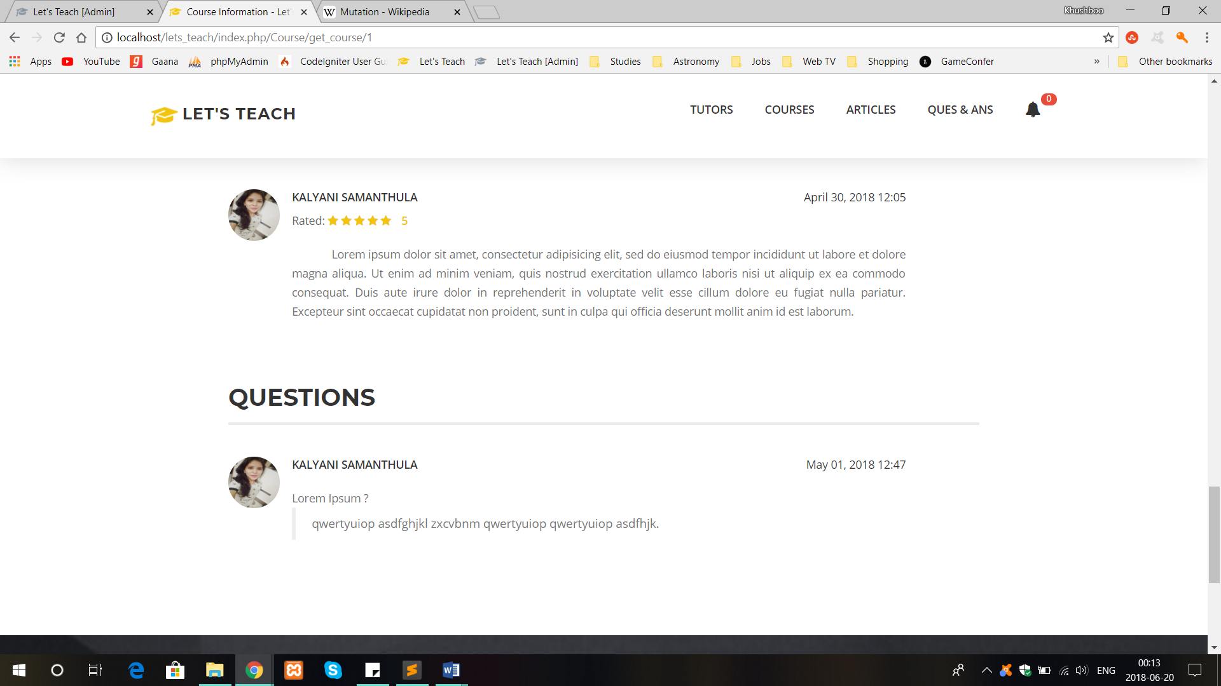

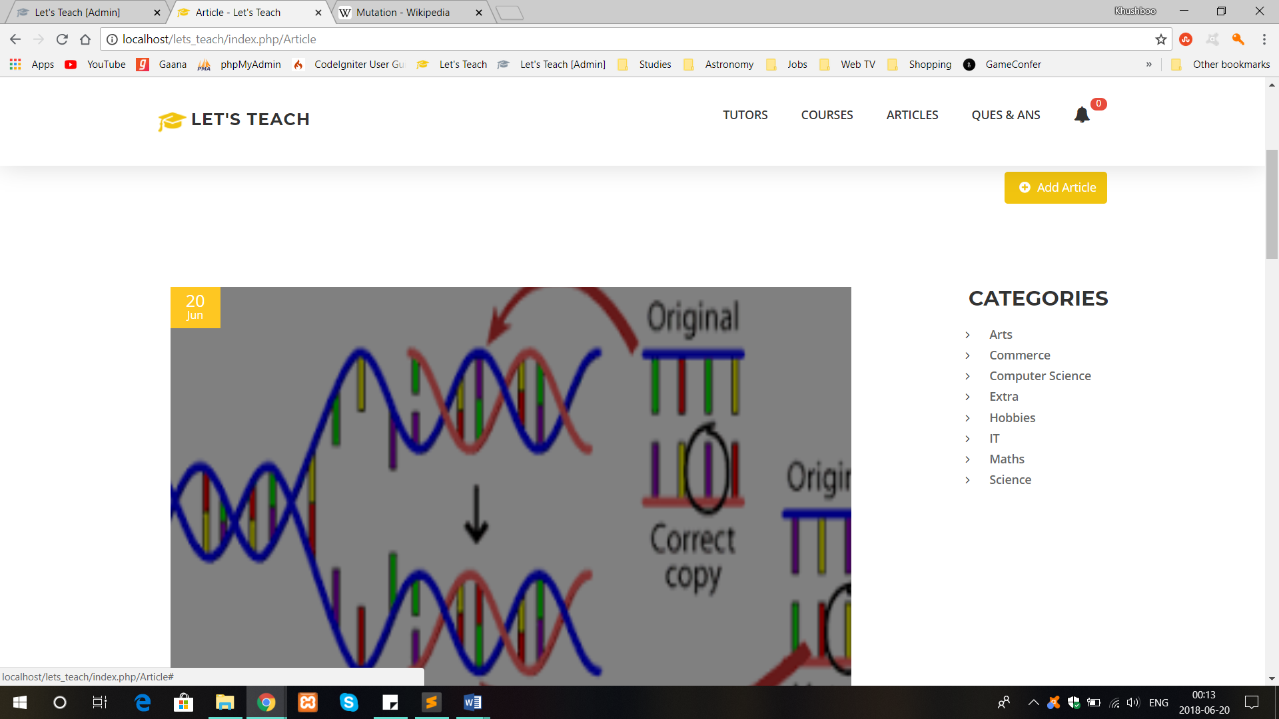

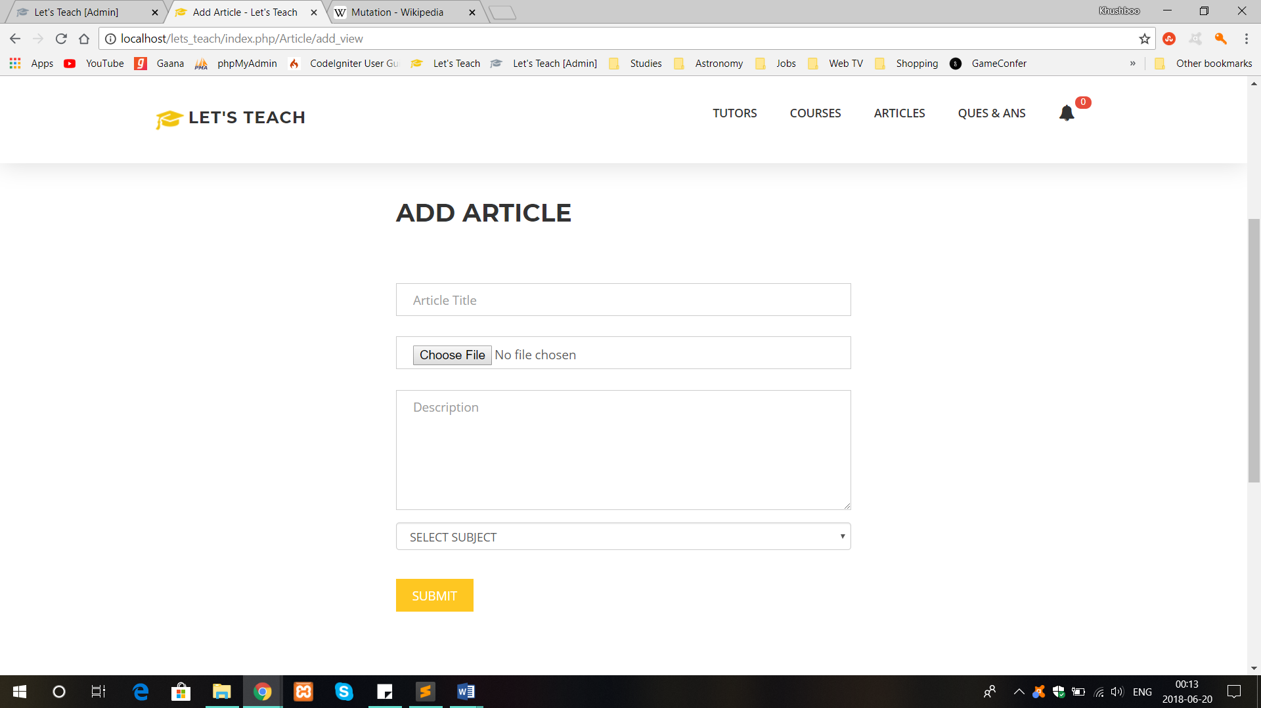

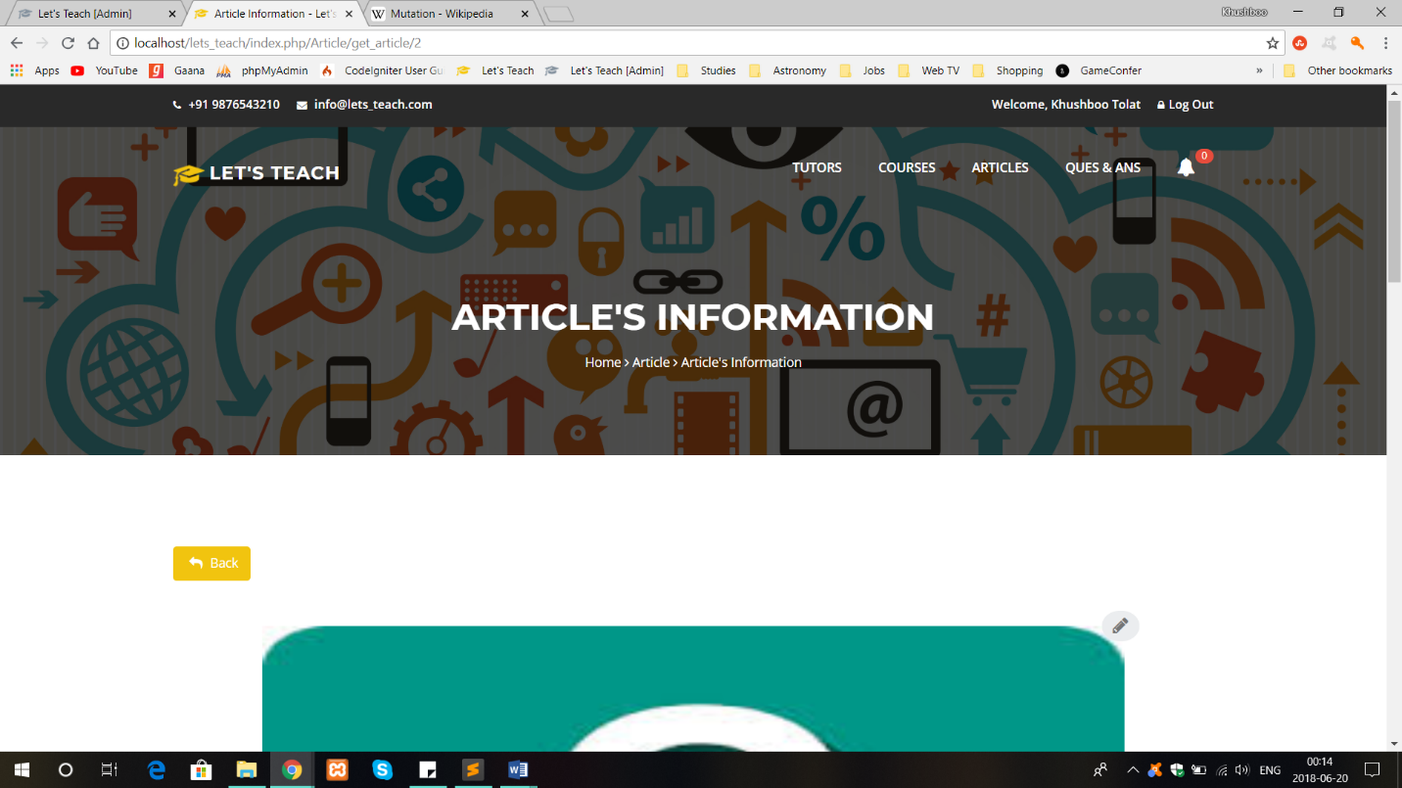

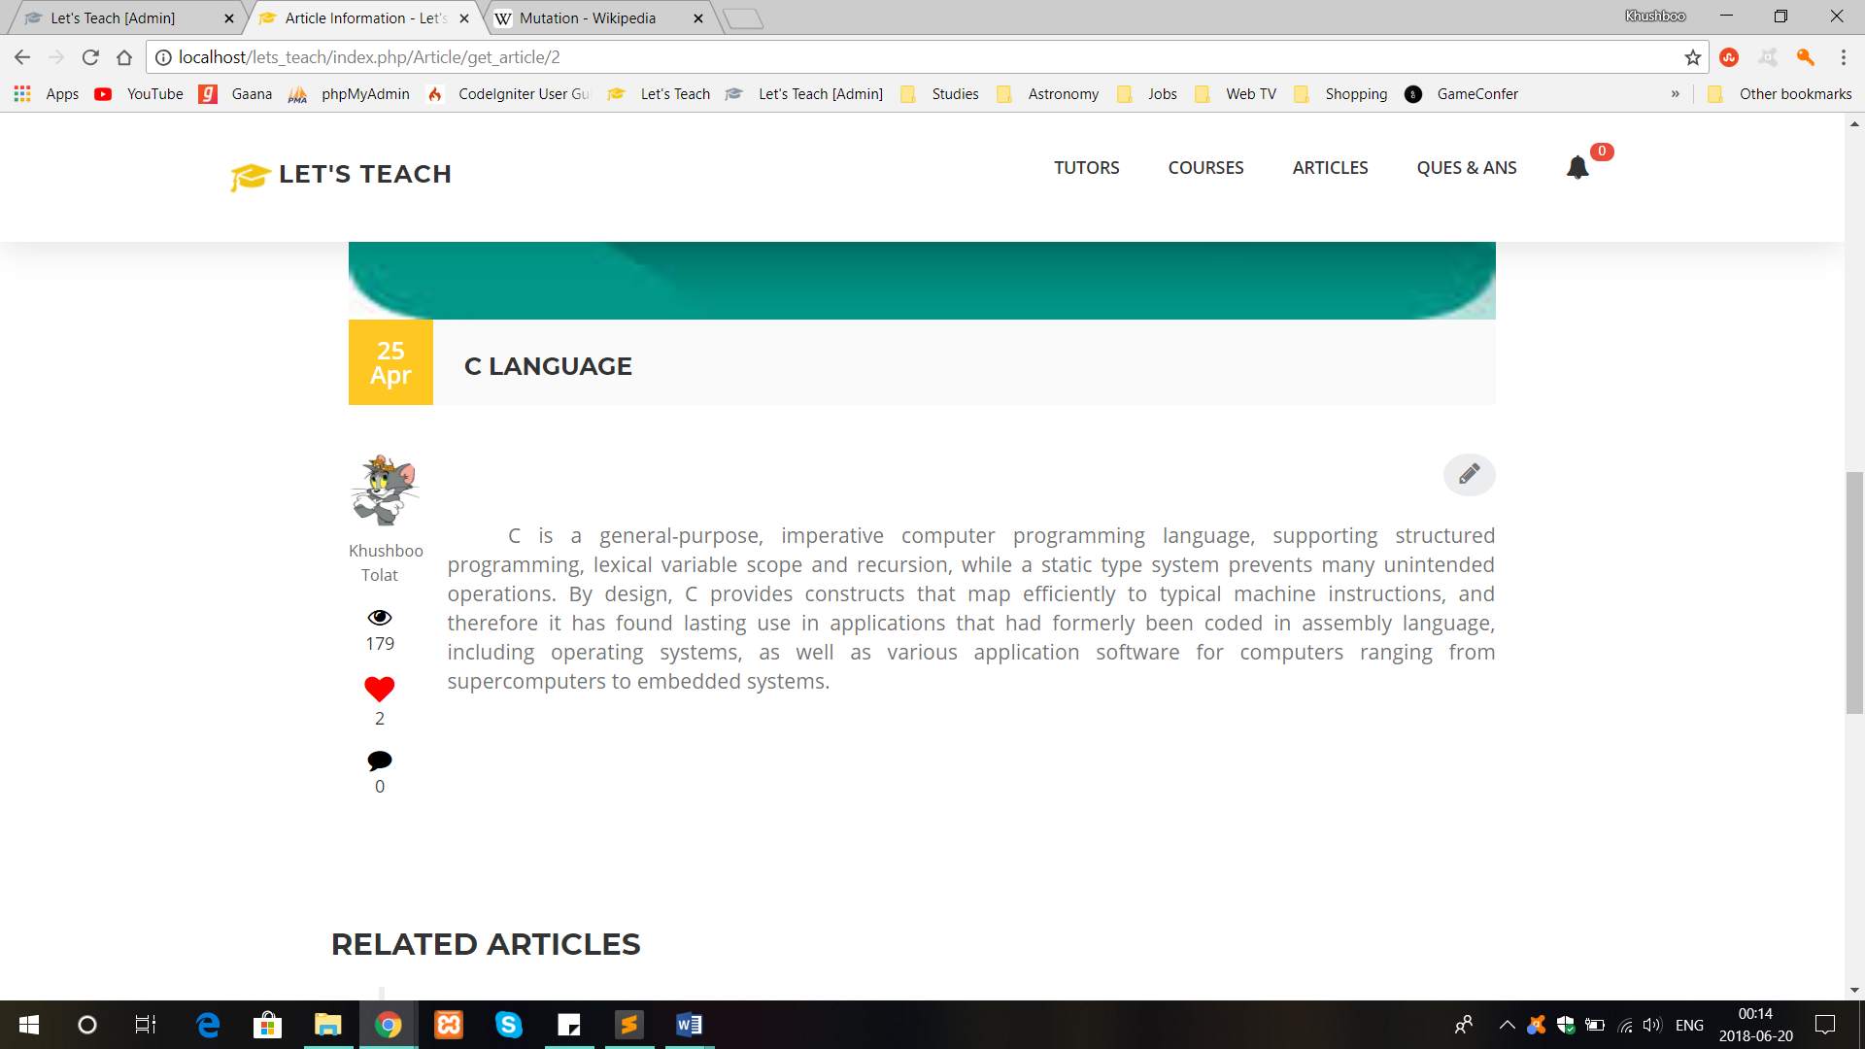

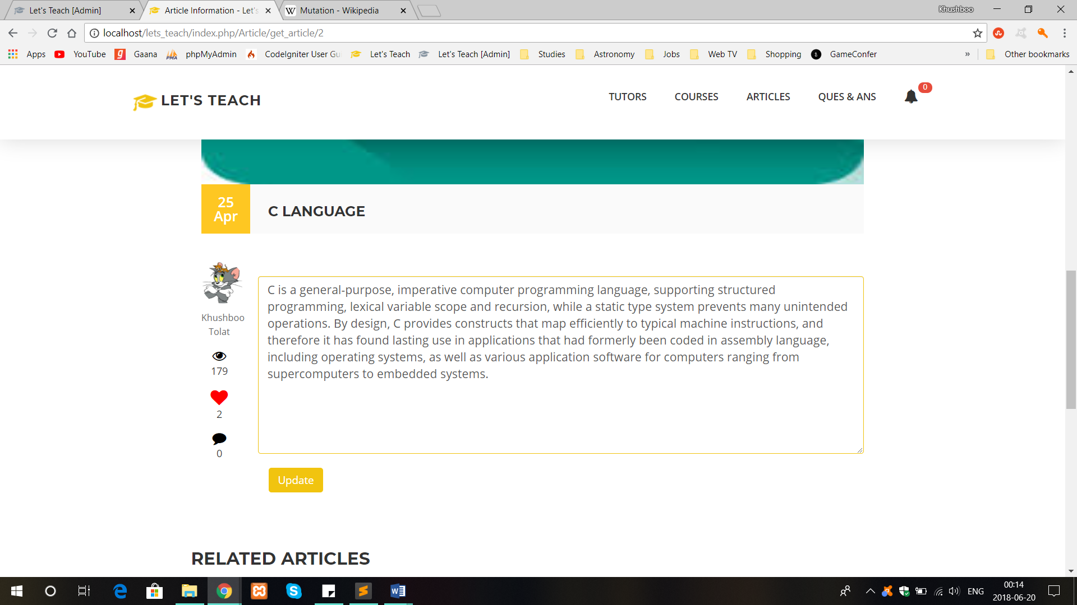

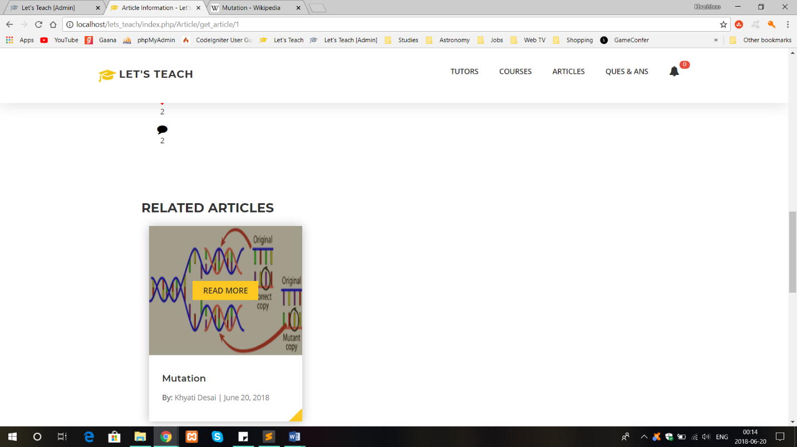

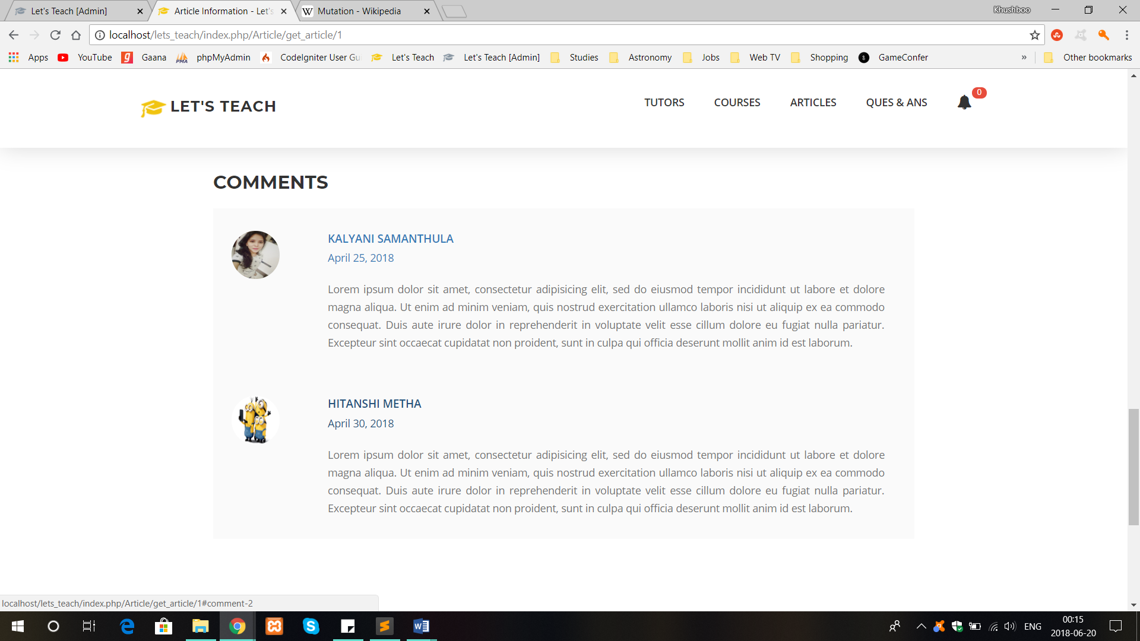

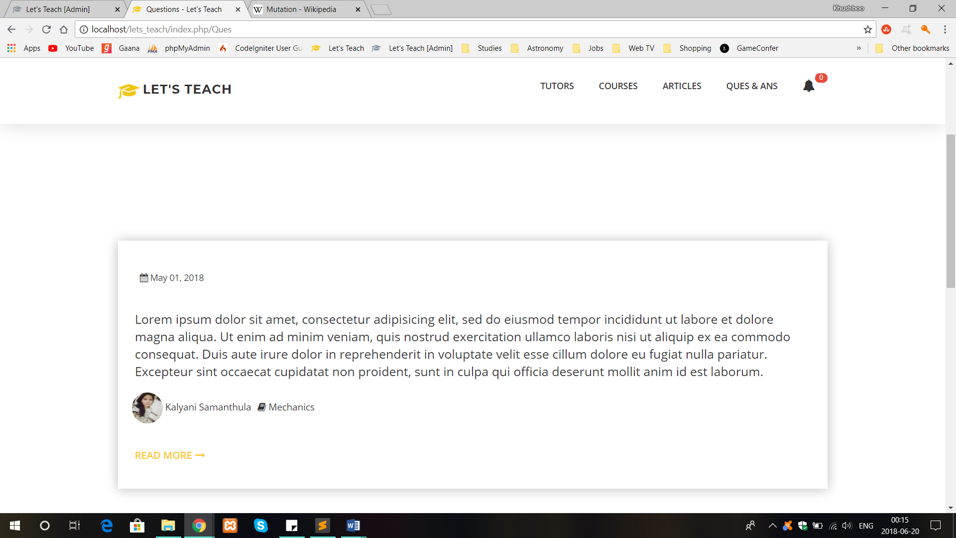

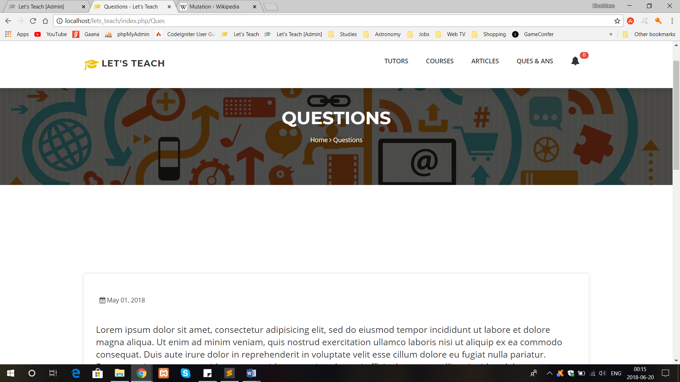

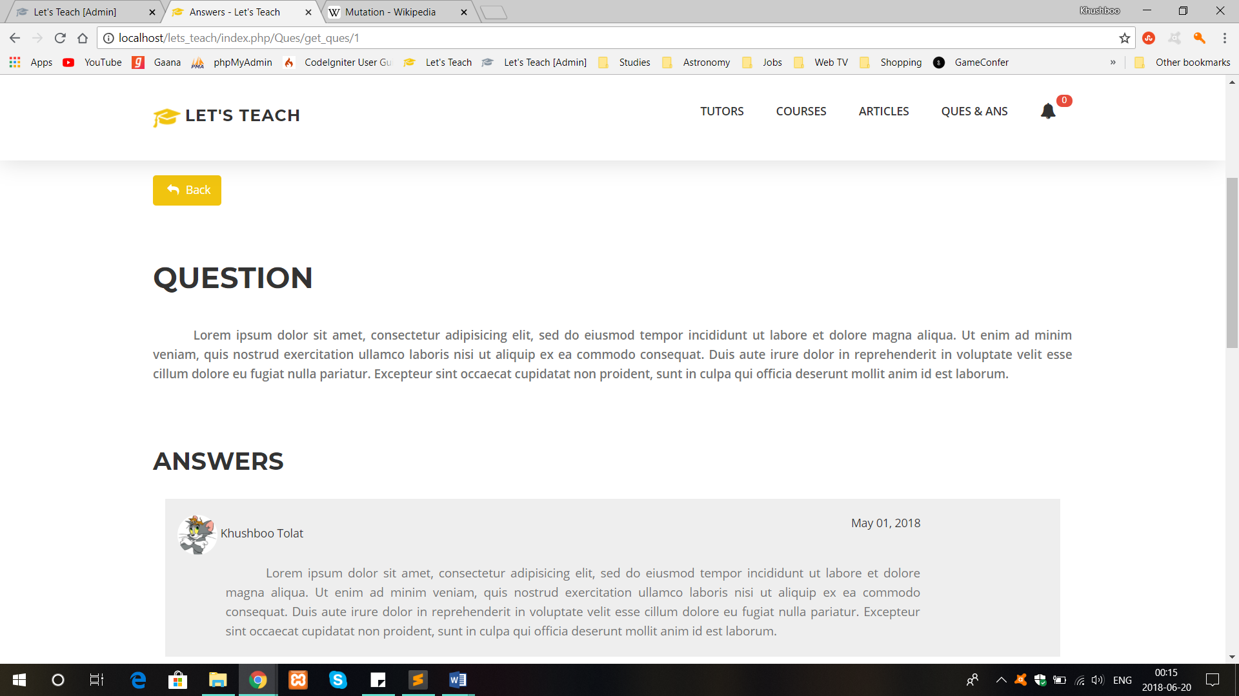

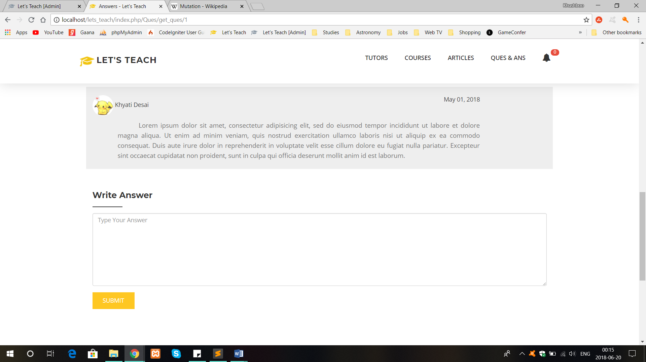



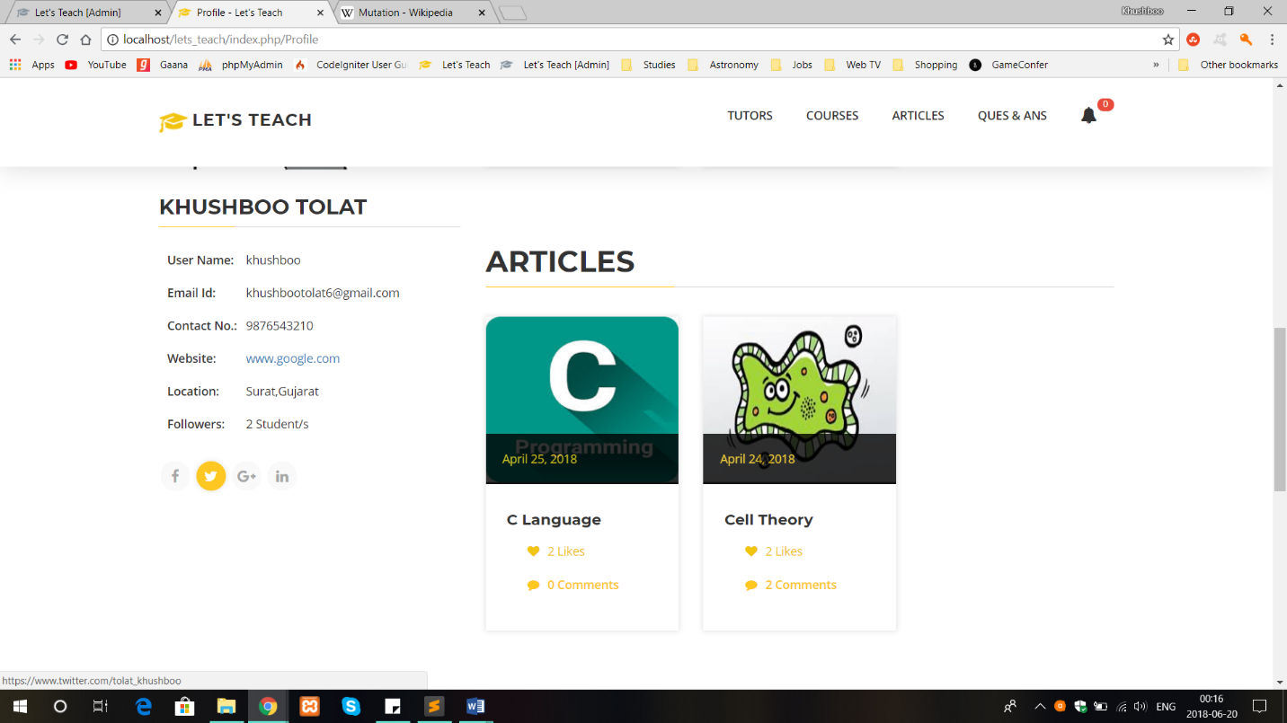

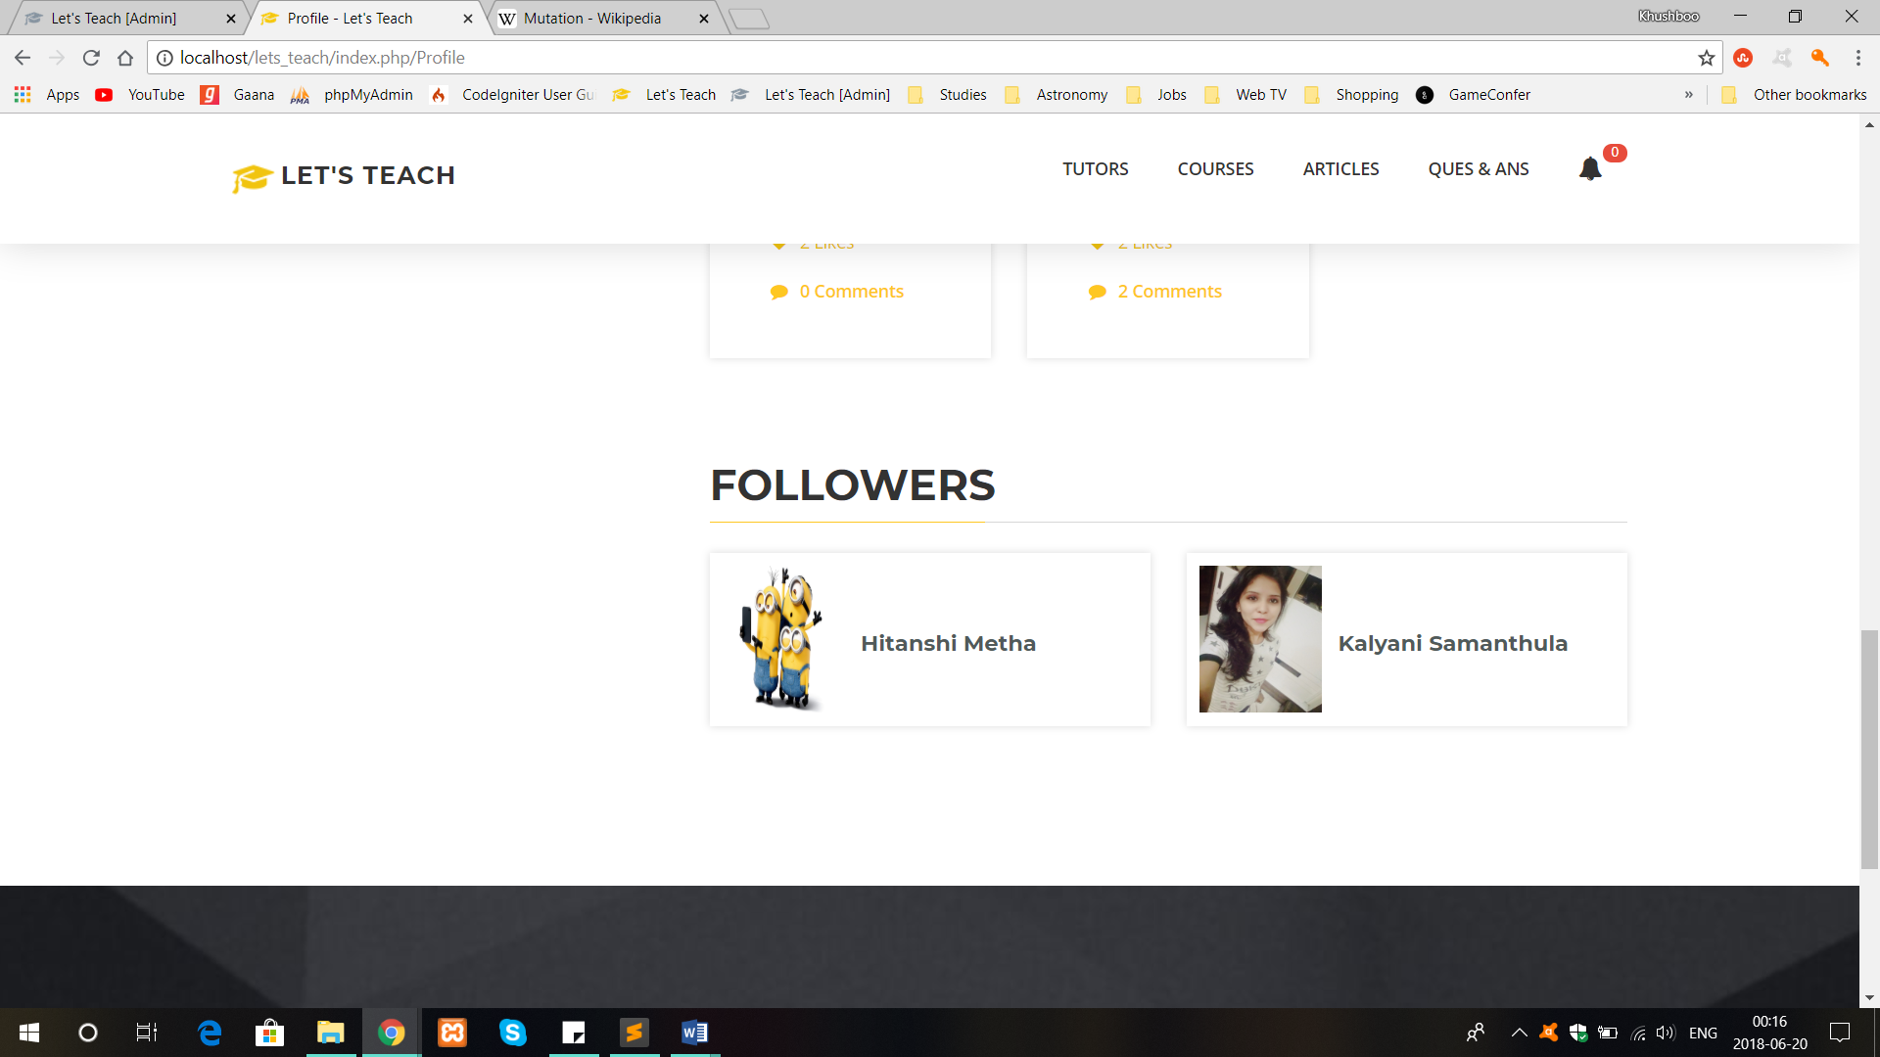

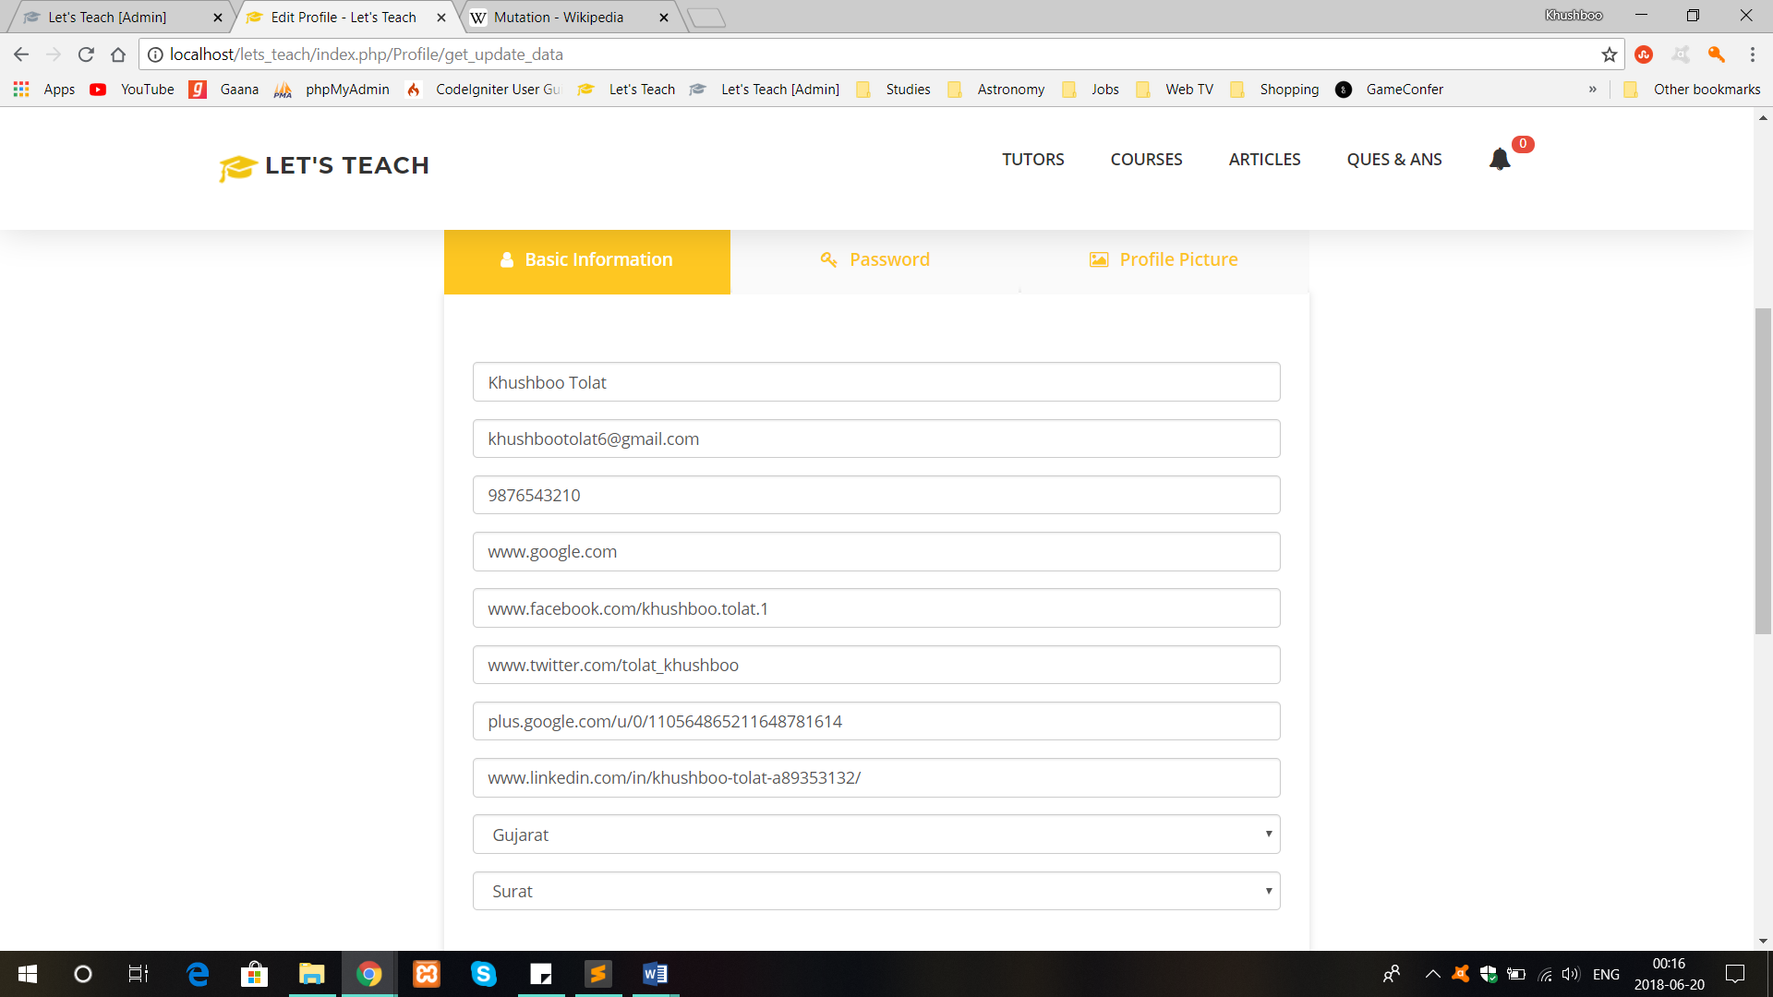

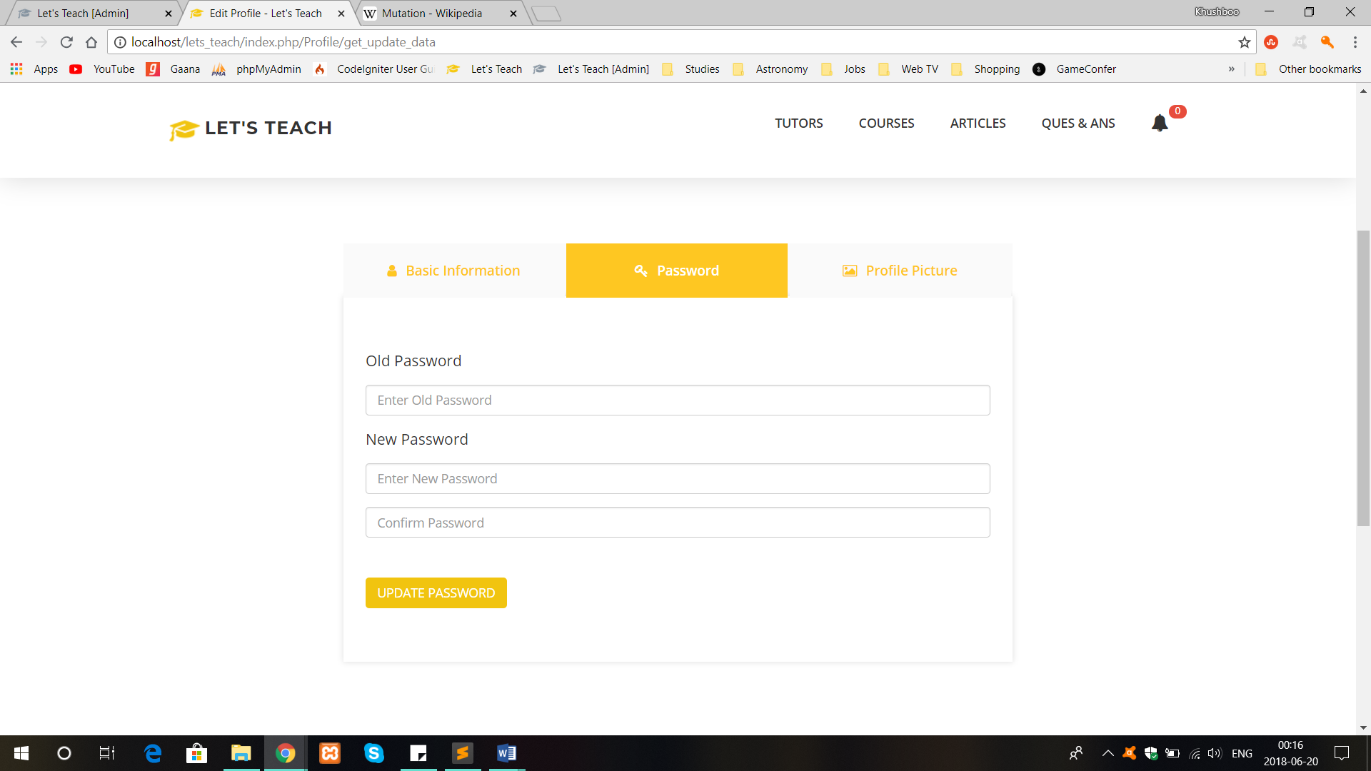

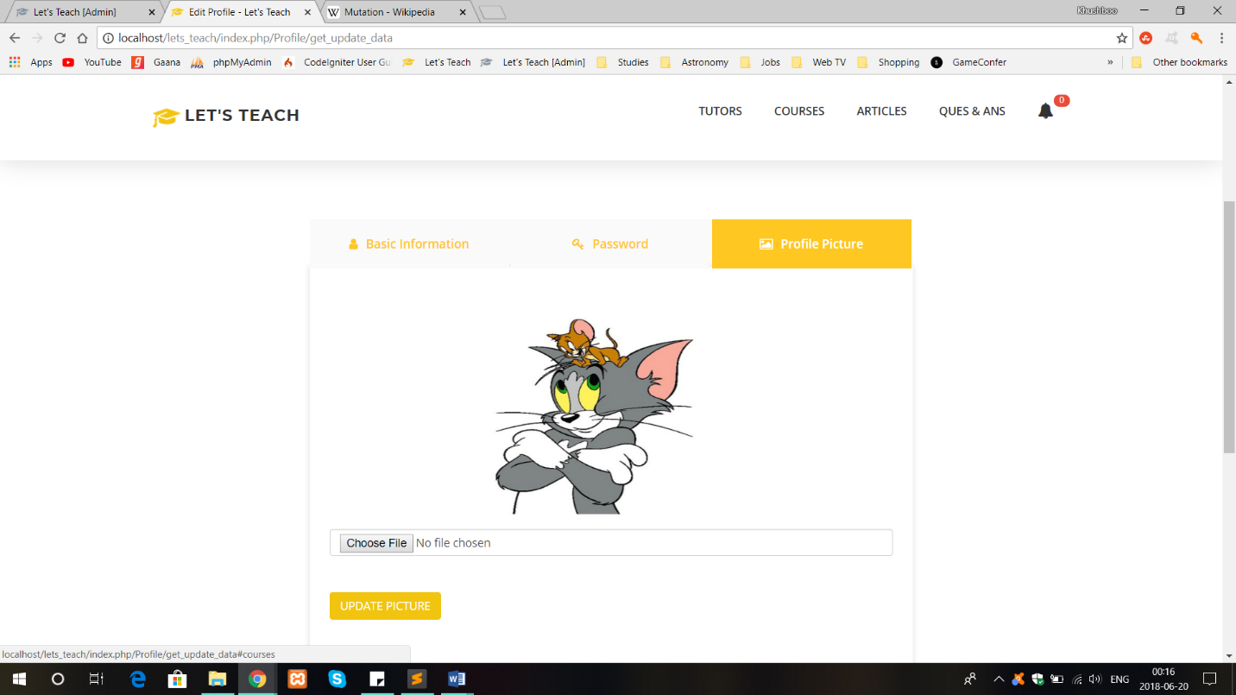

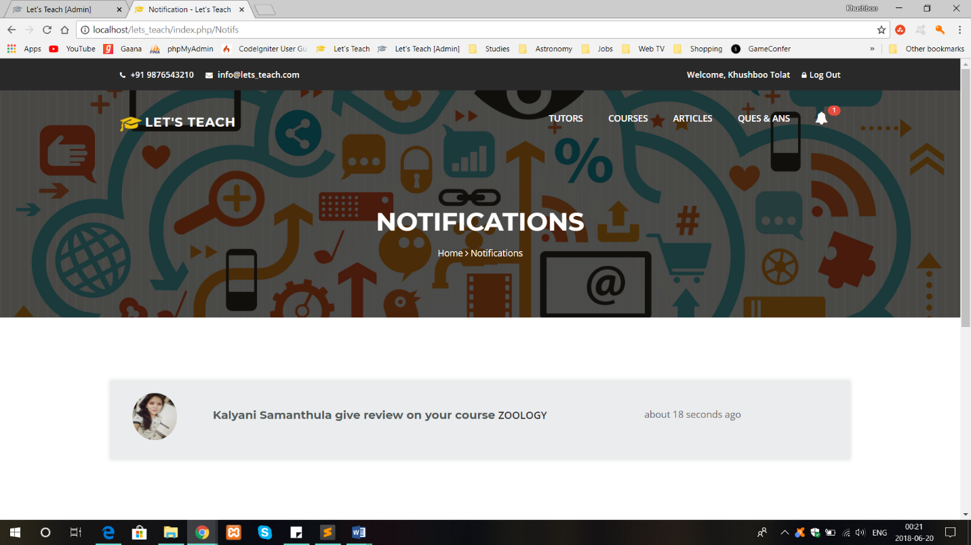

* **Student Site:**



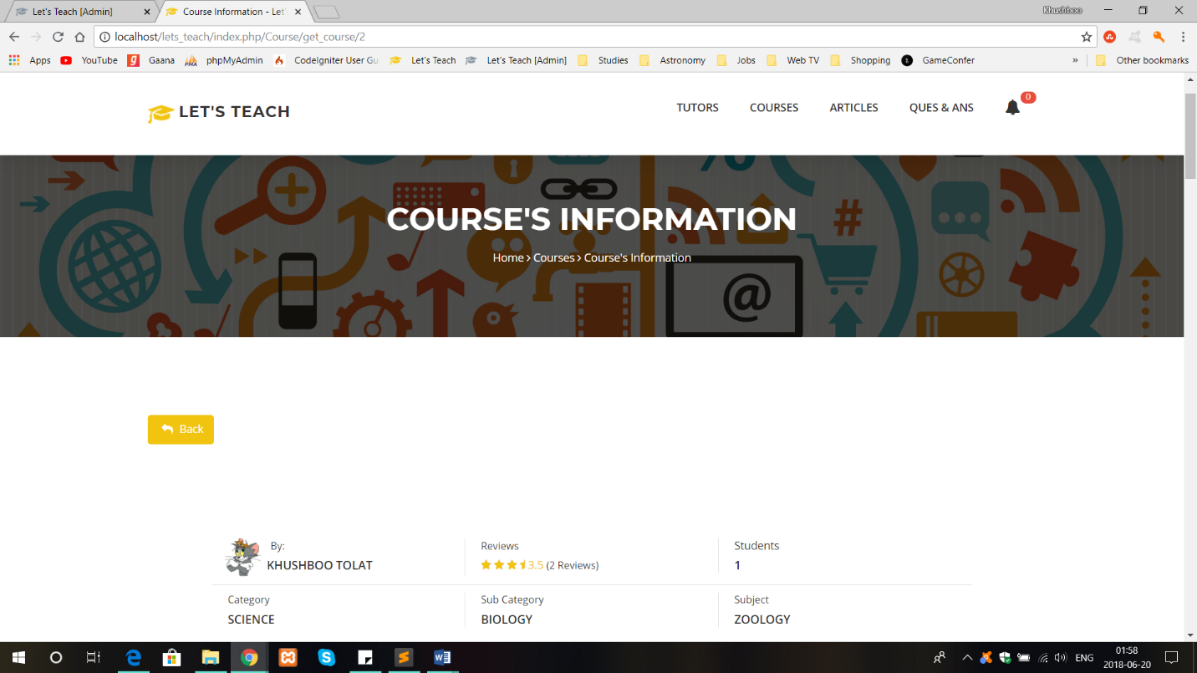



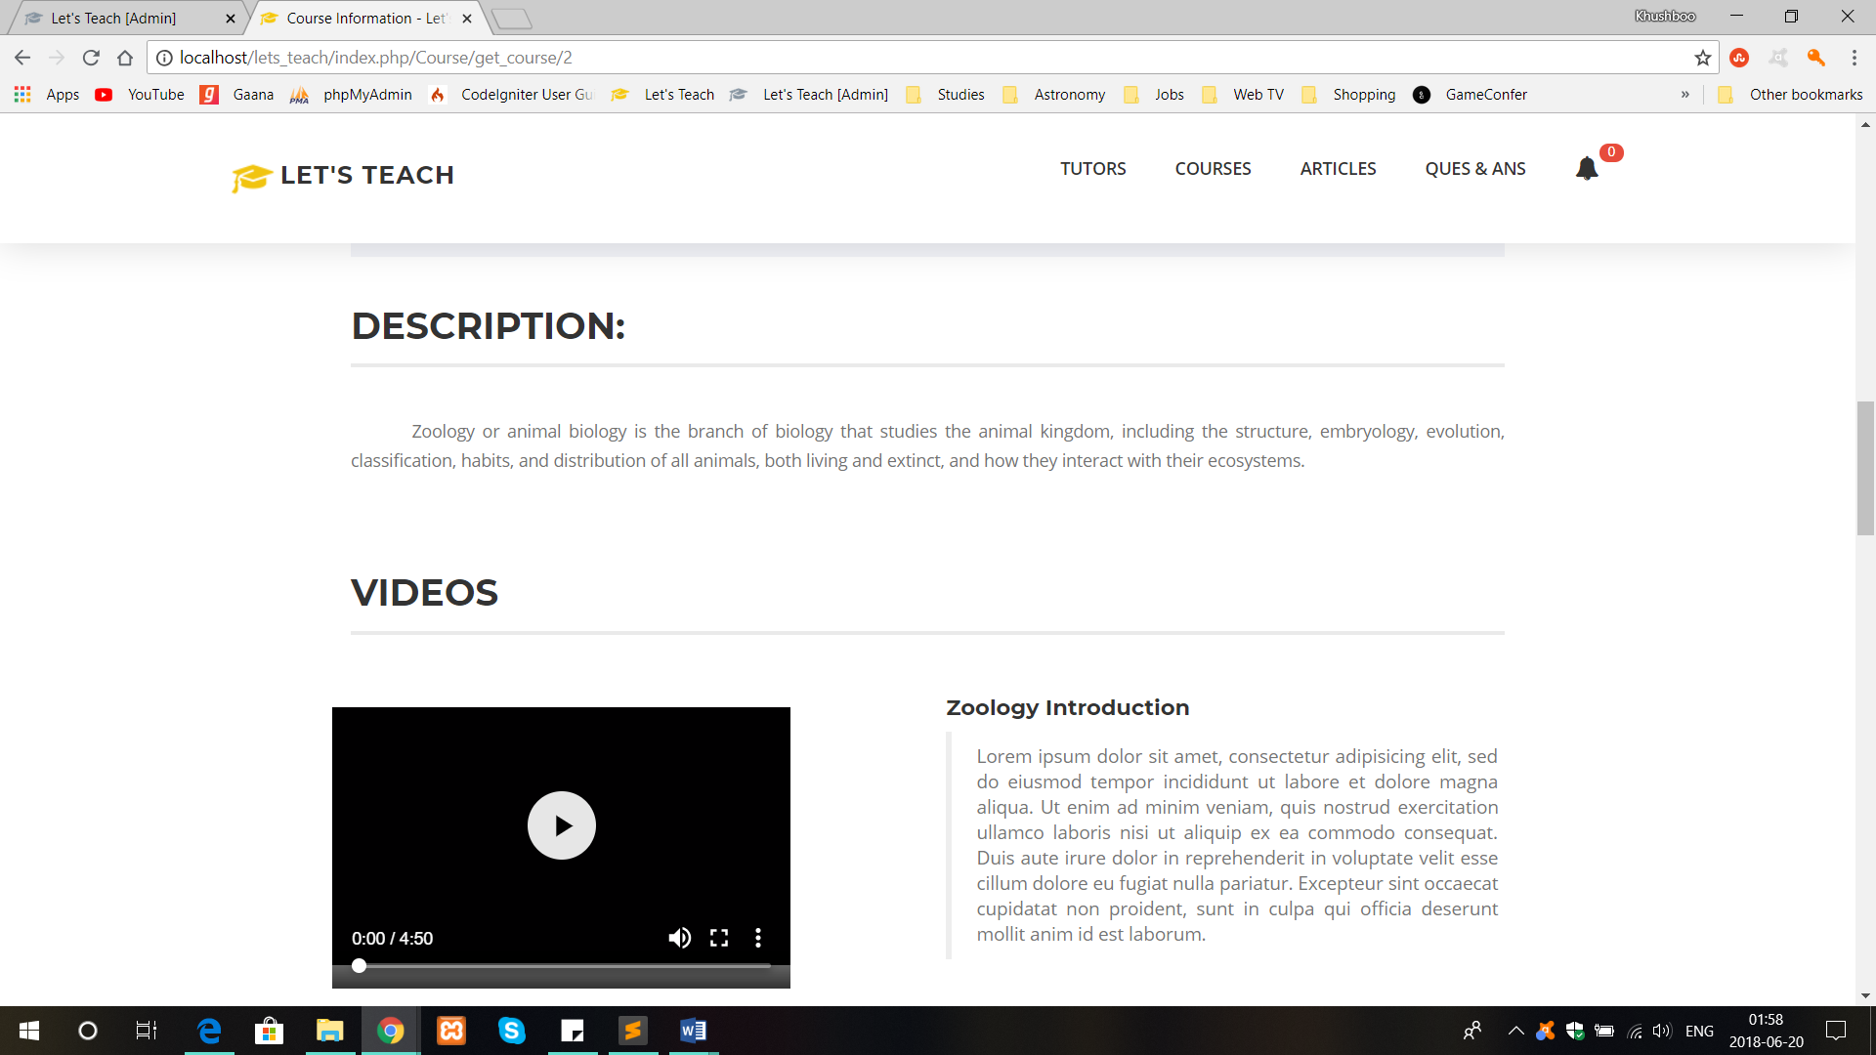

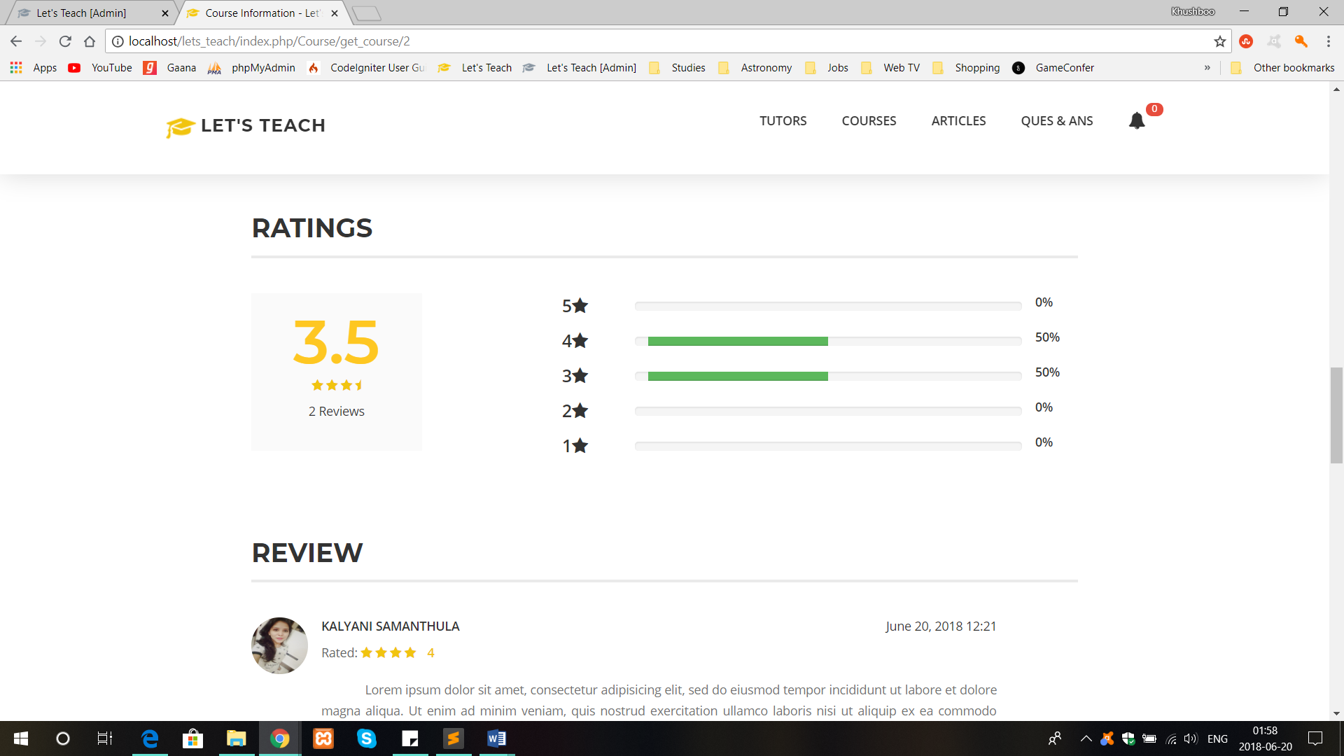

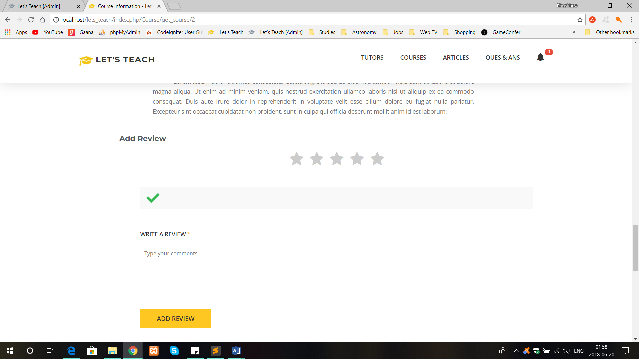

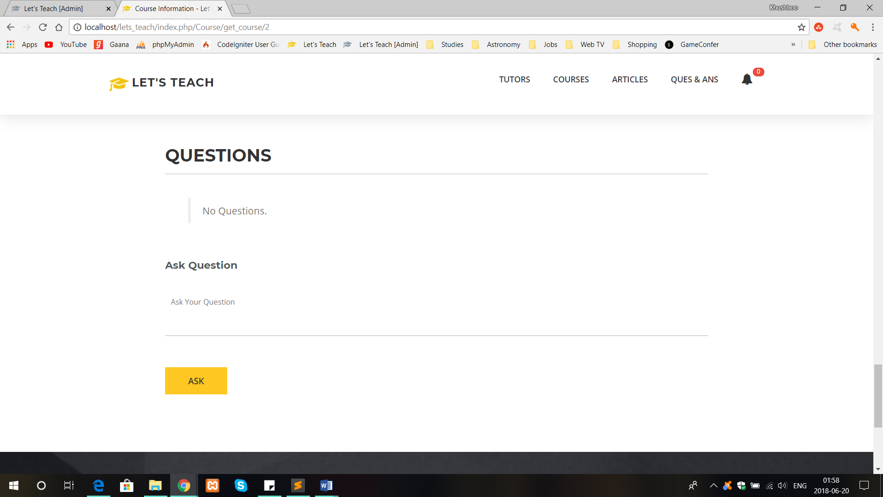





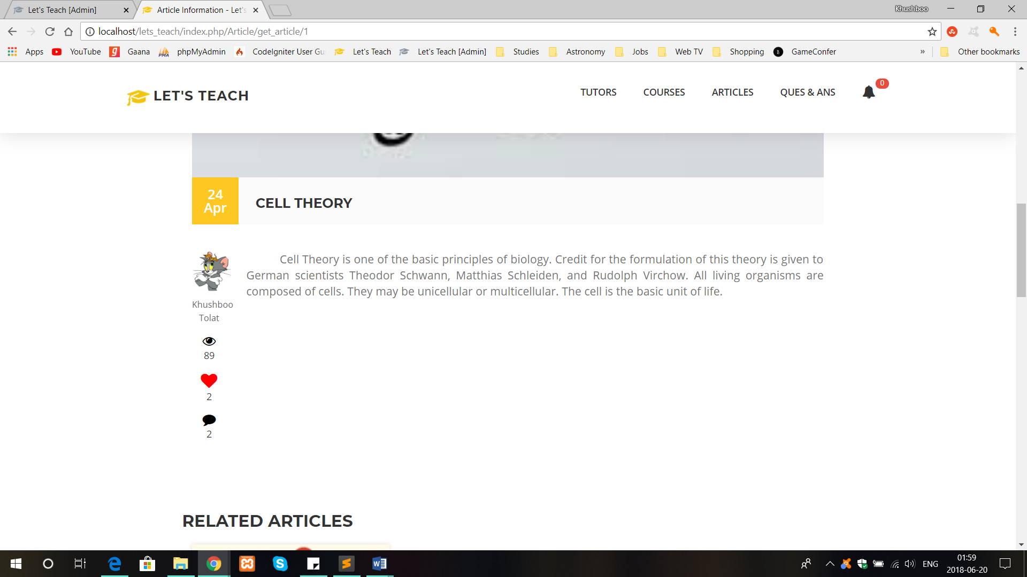

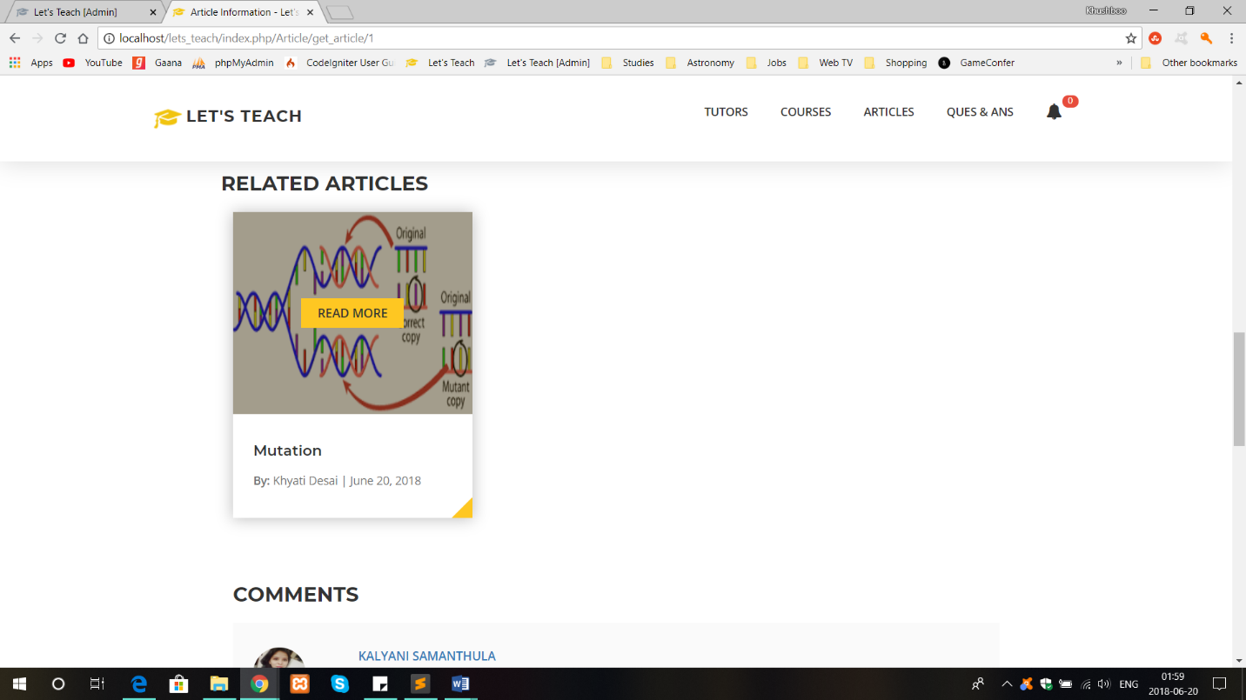

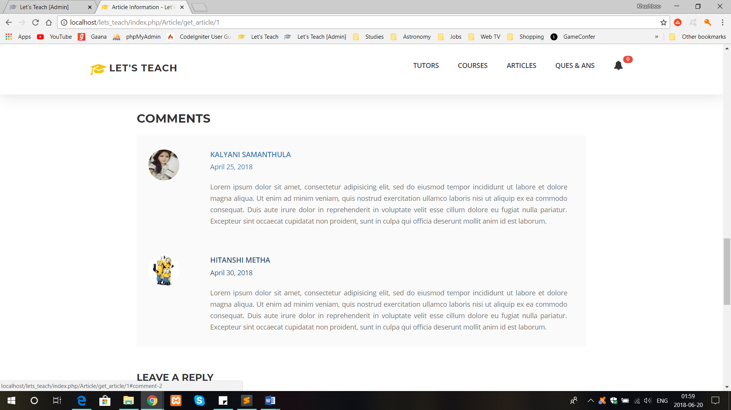

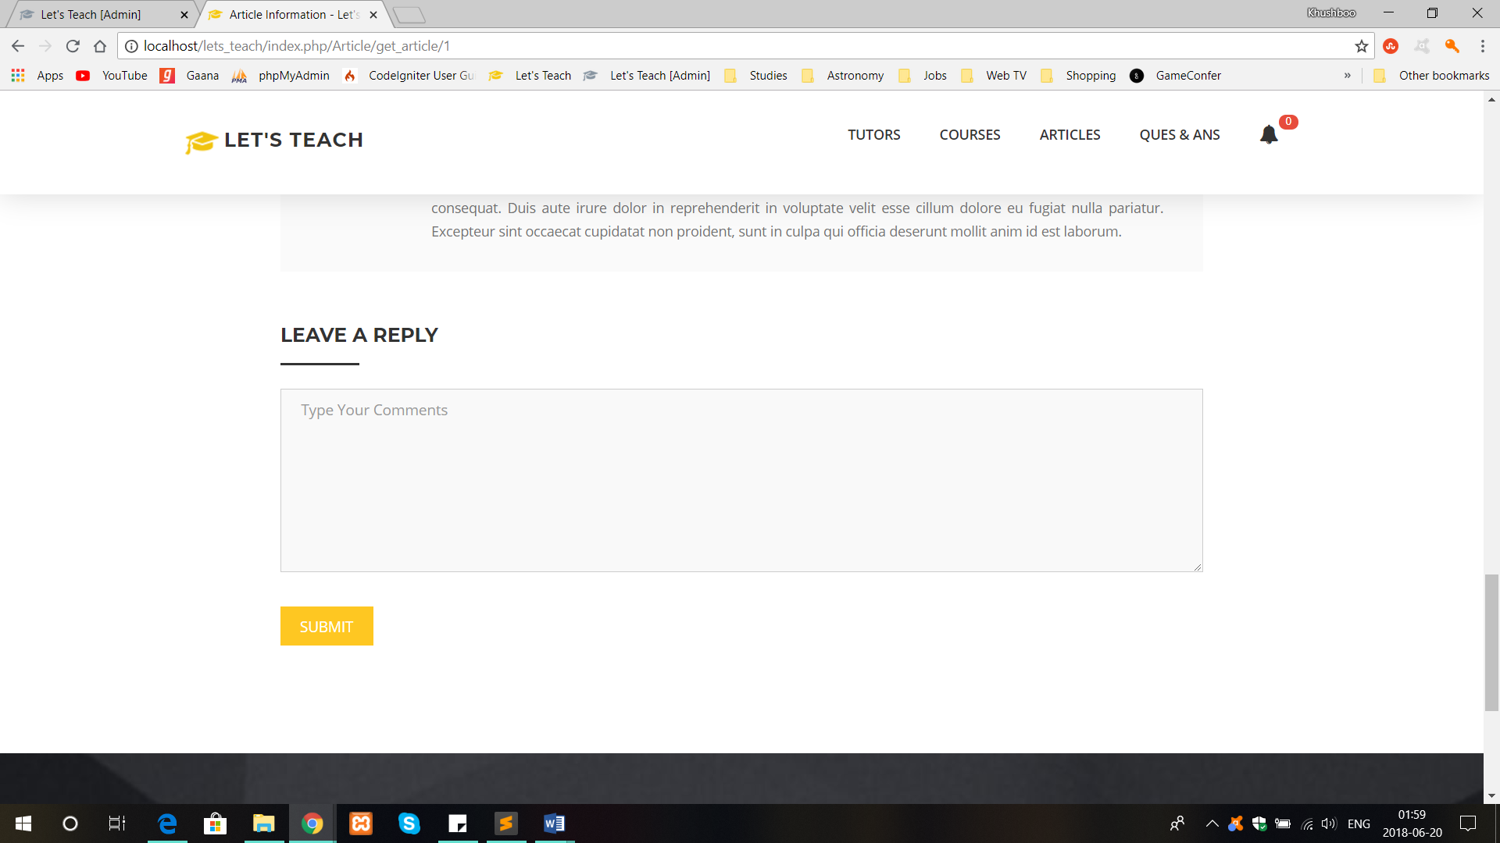

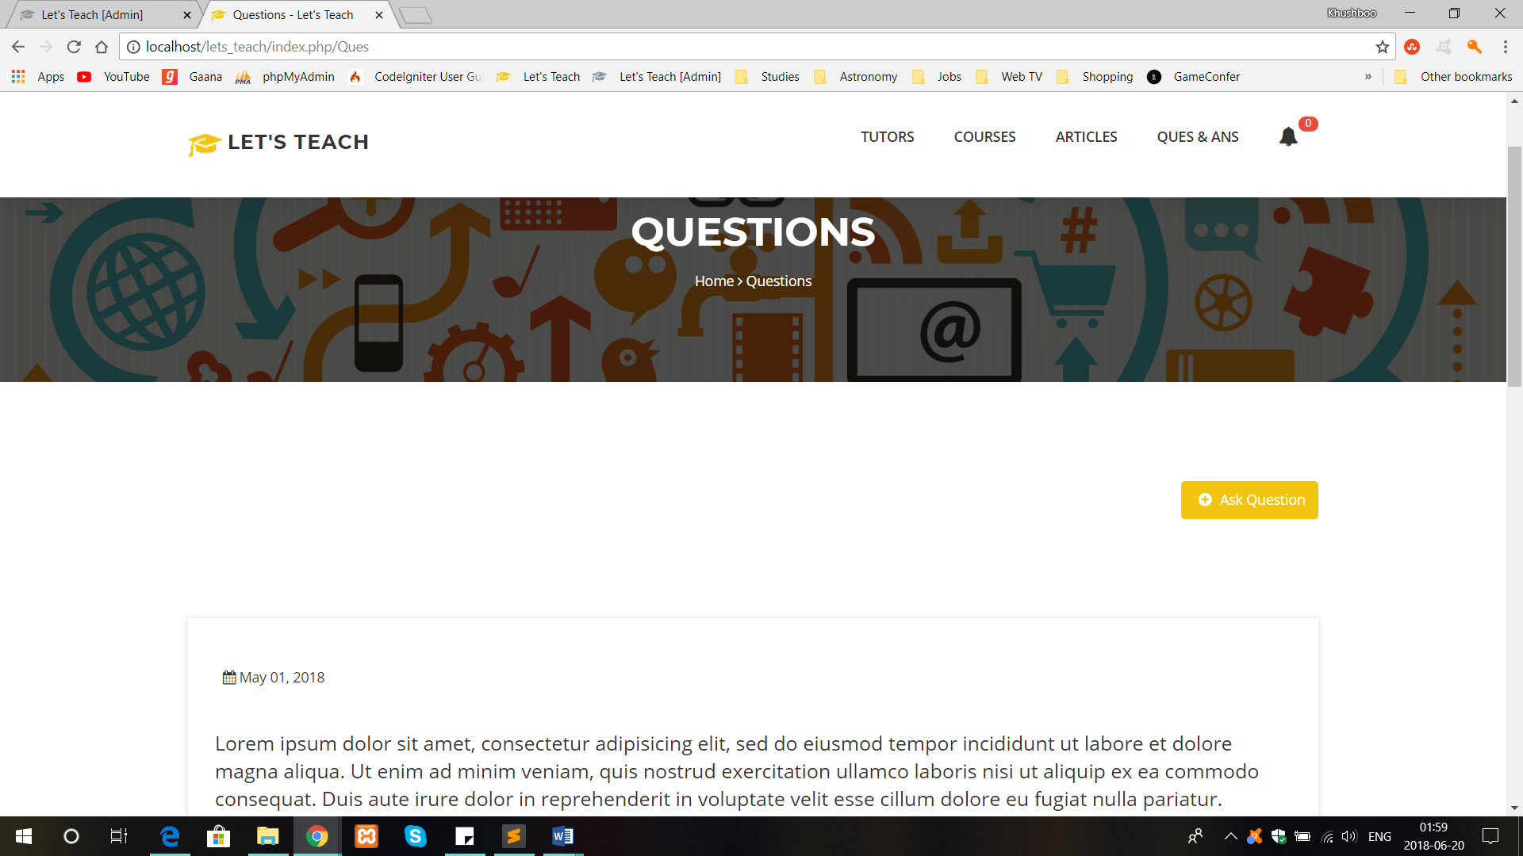

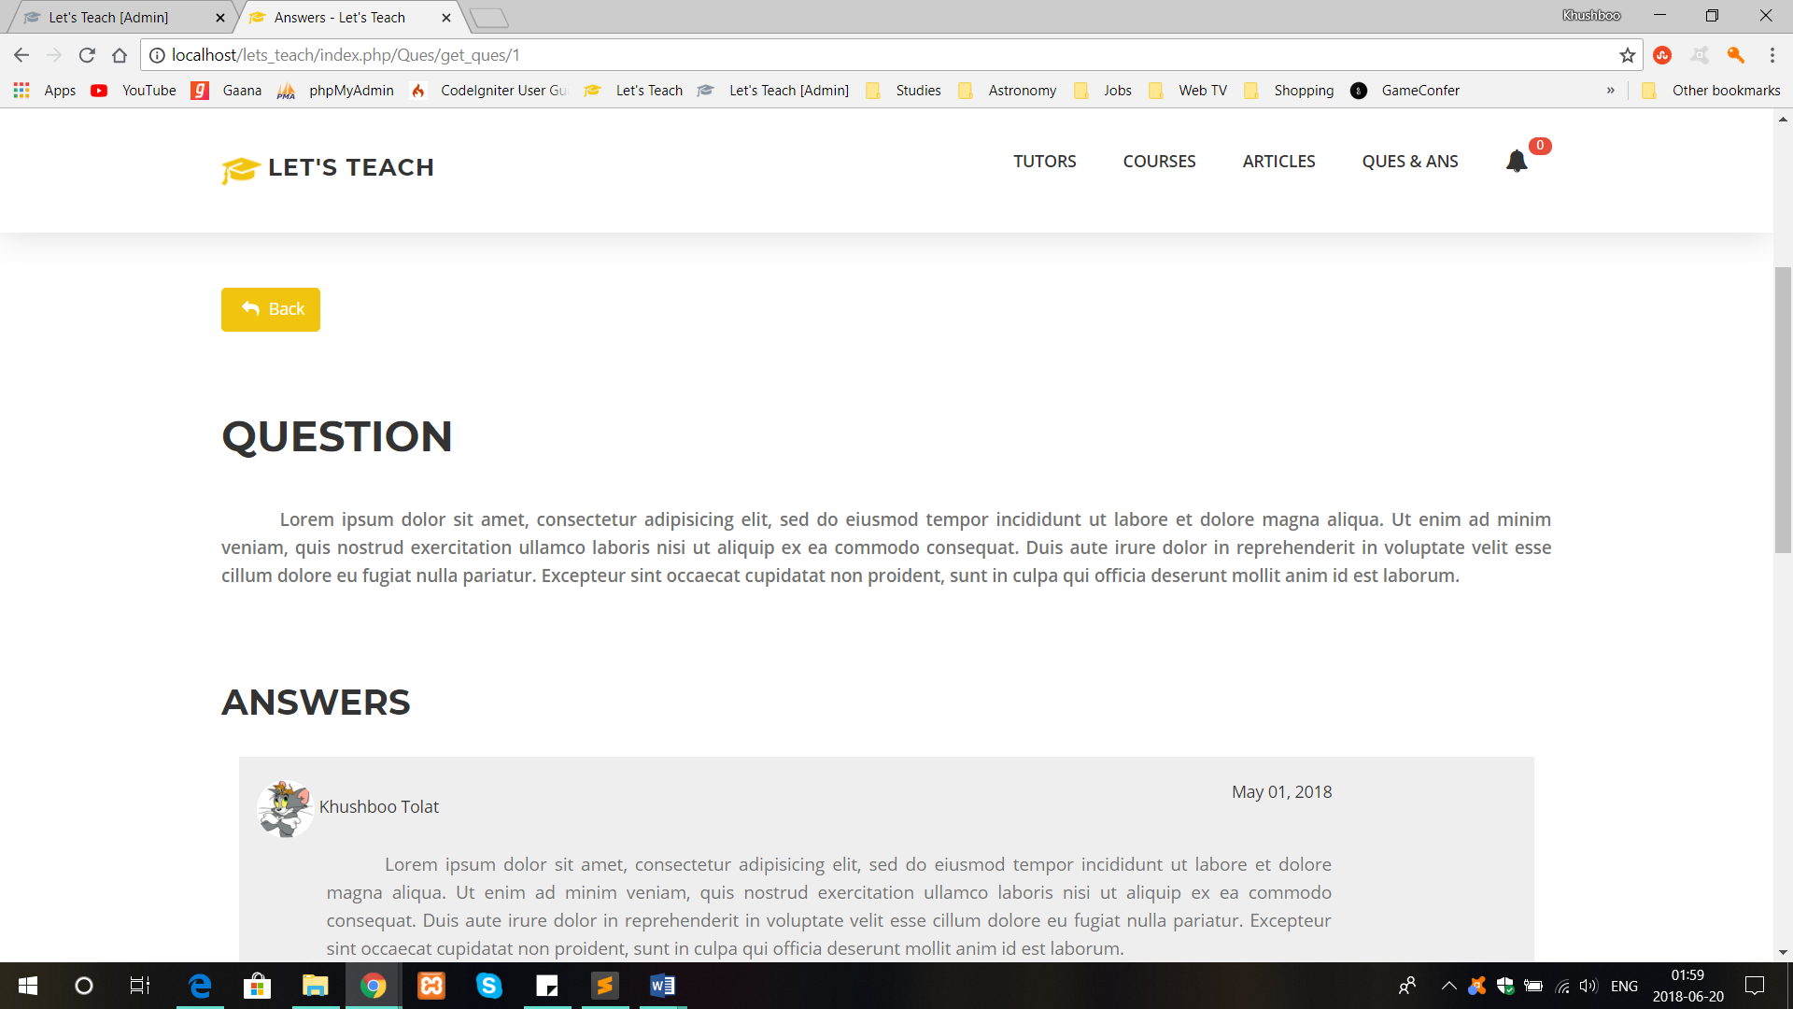

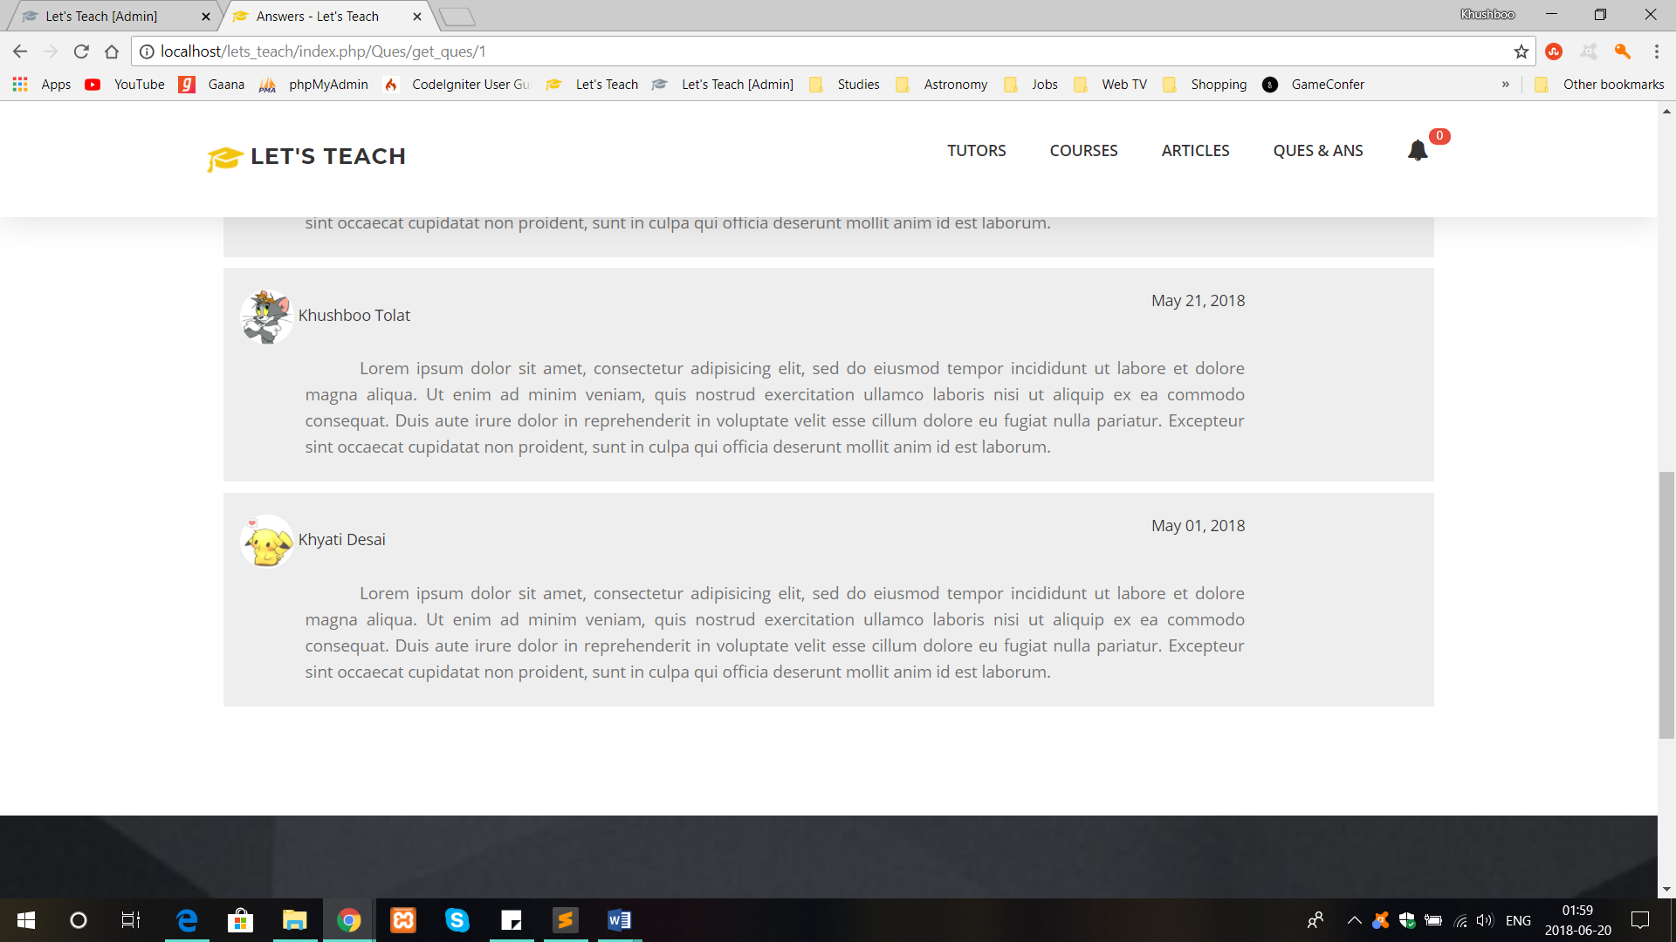

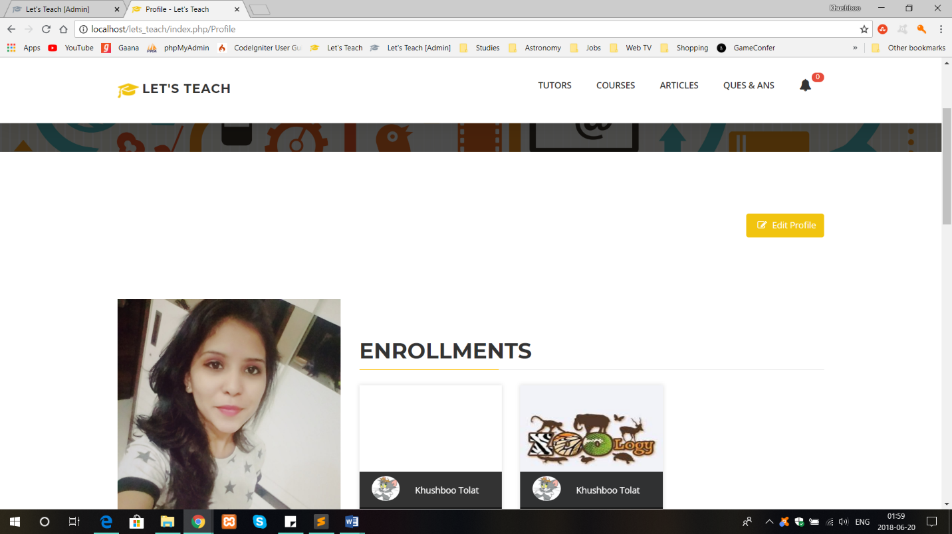

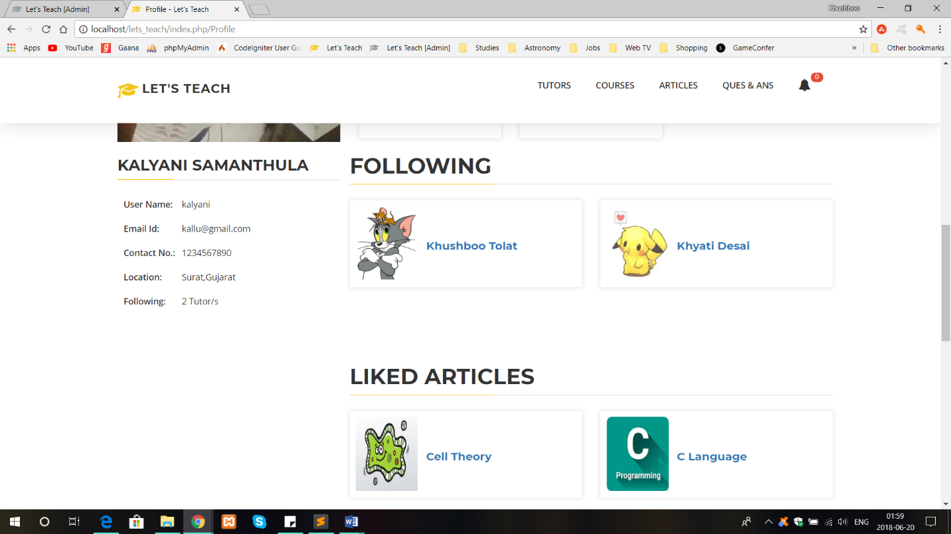

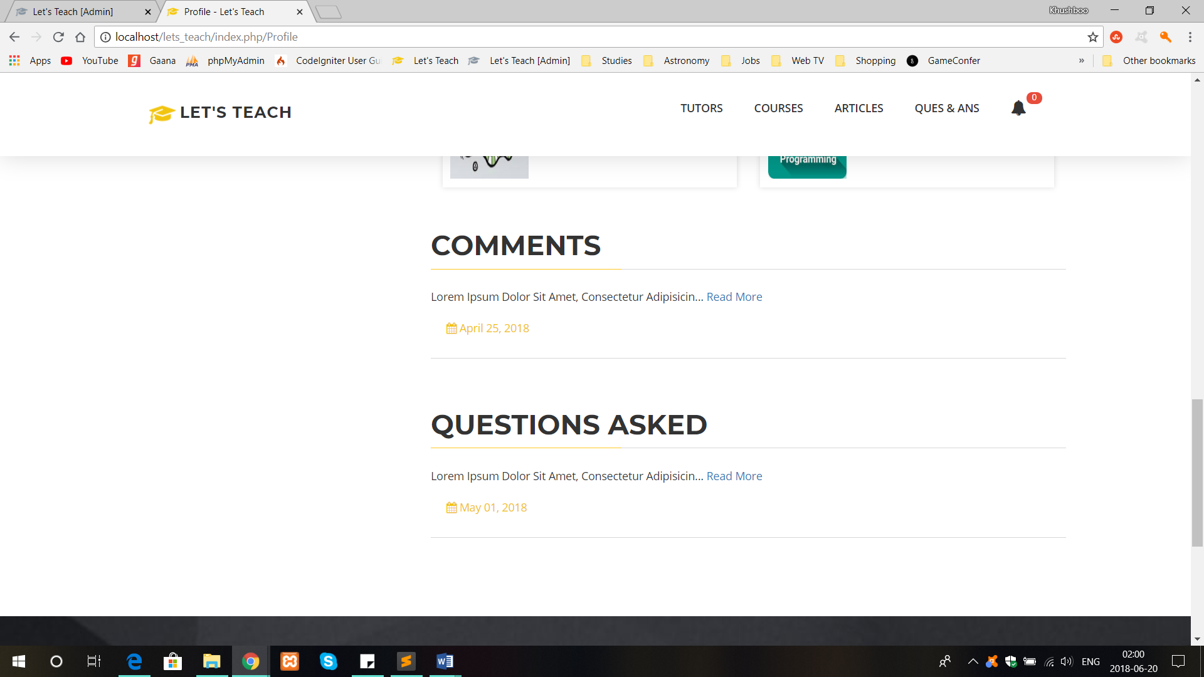

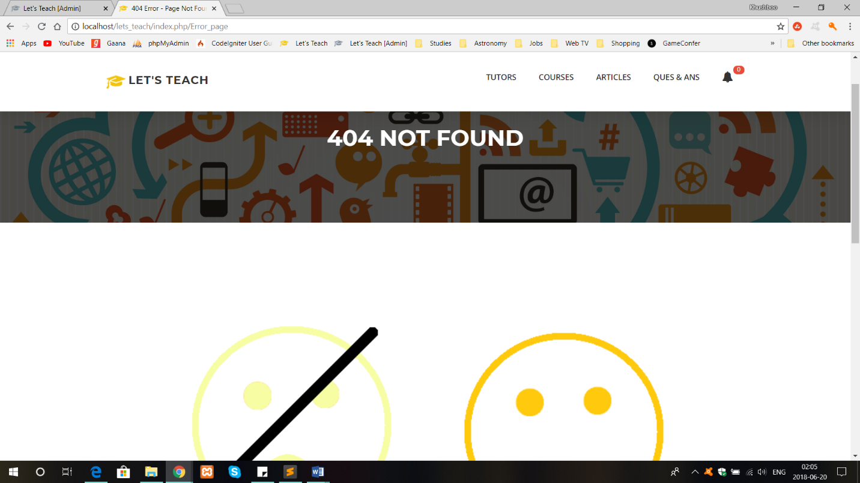

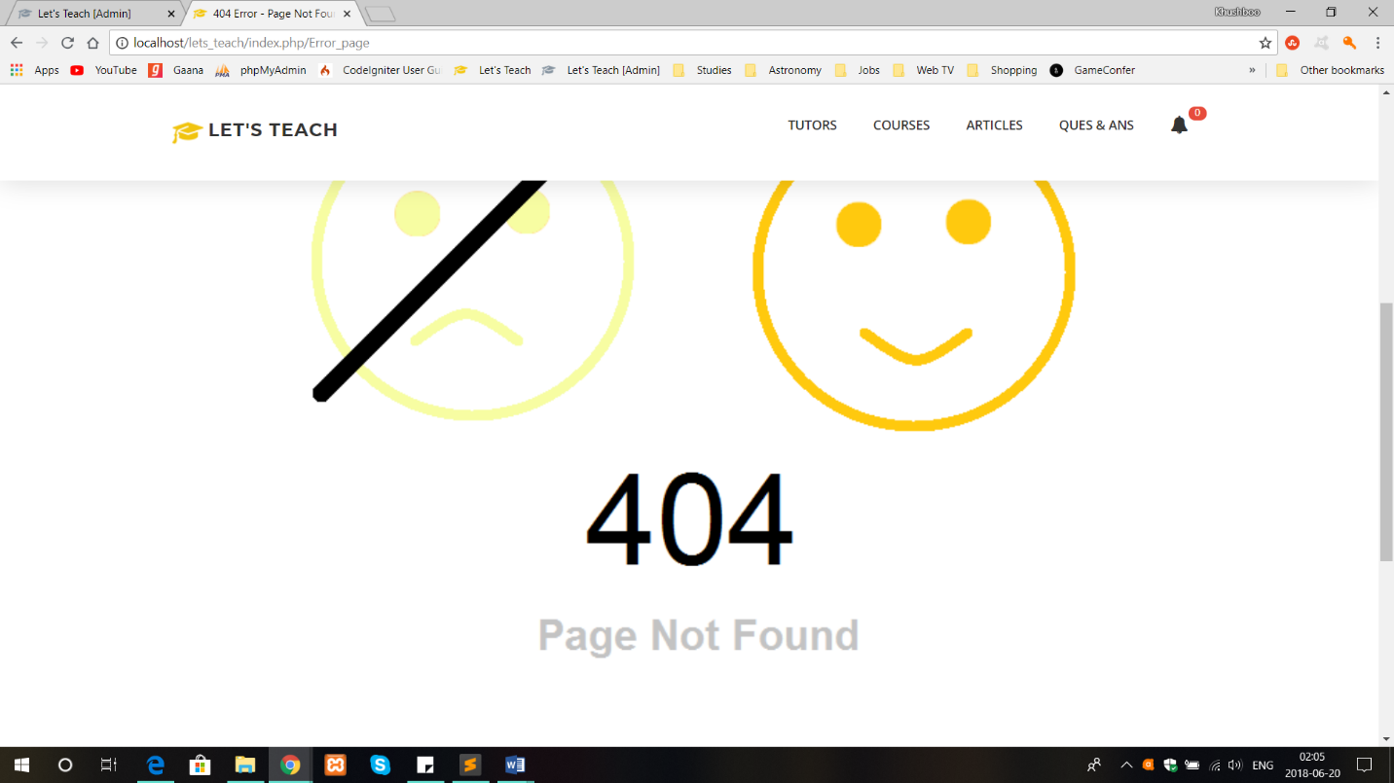

* **Admin Site:**

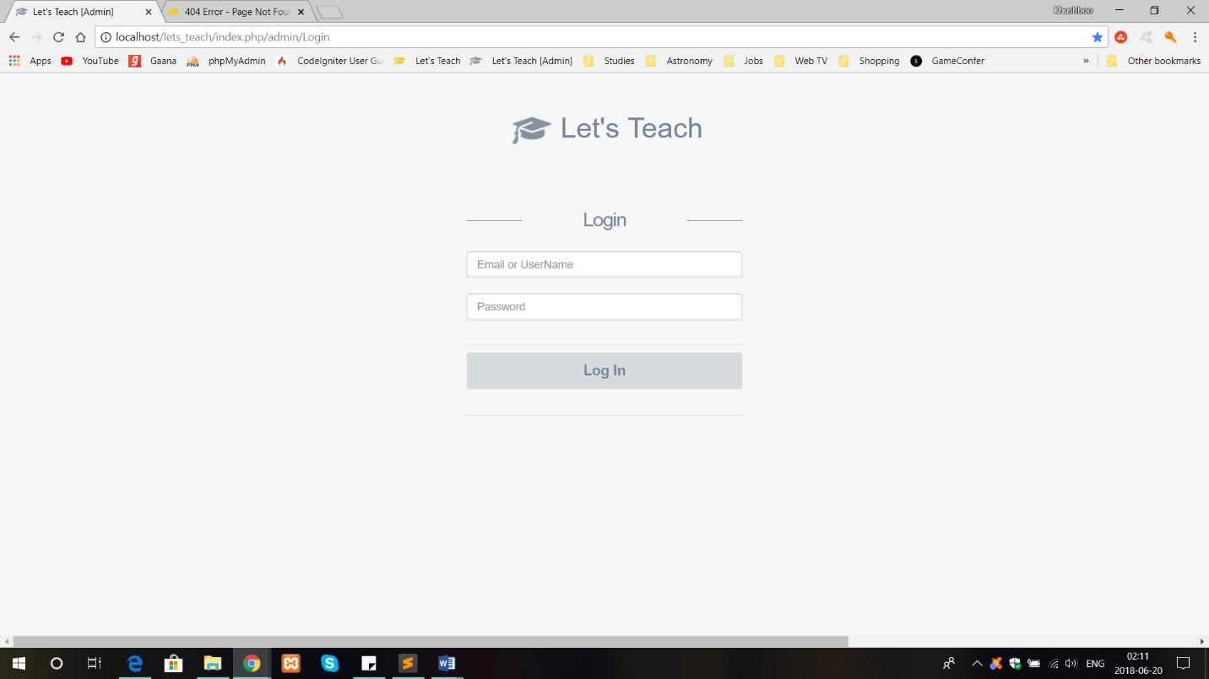

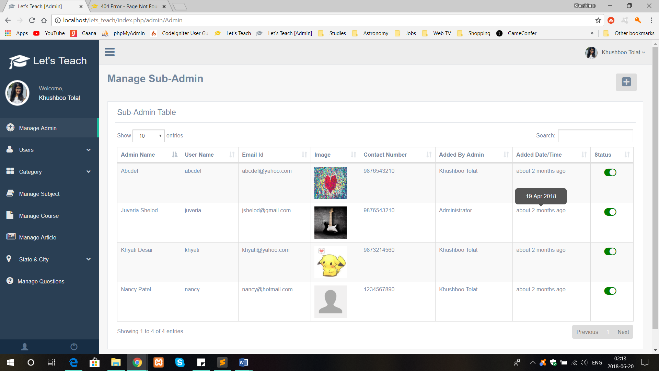

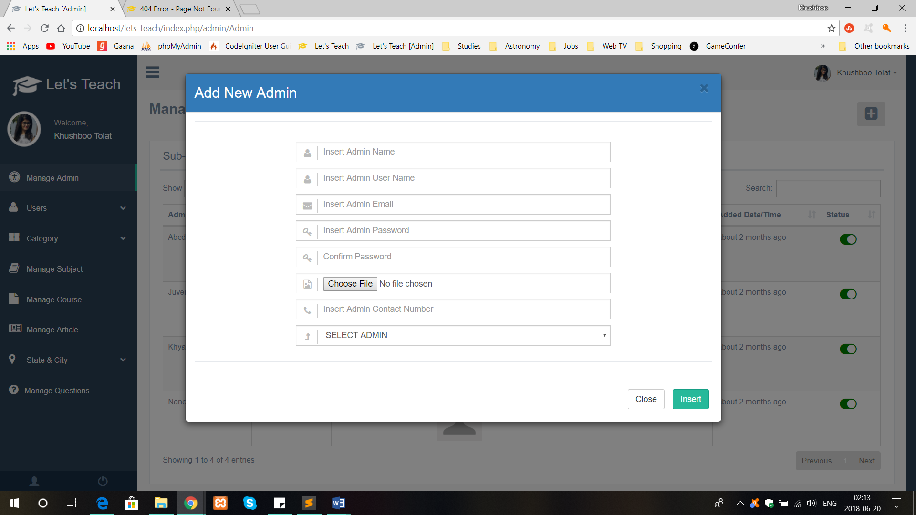

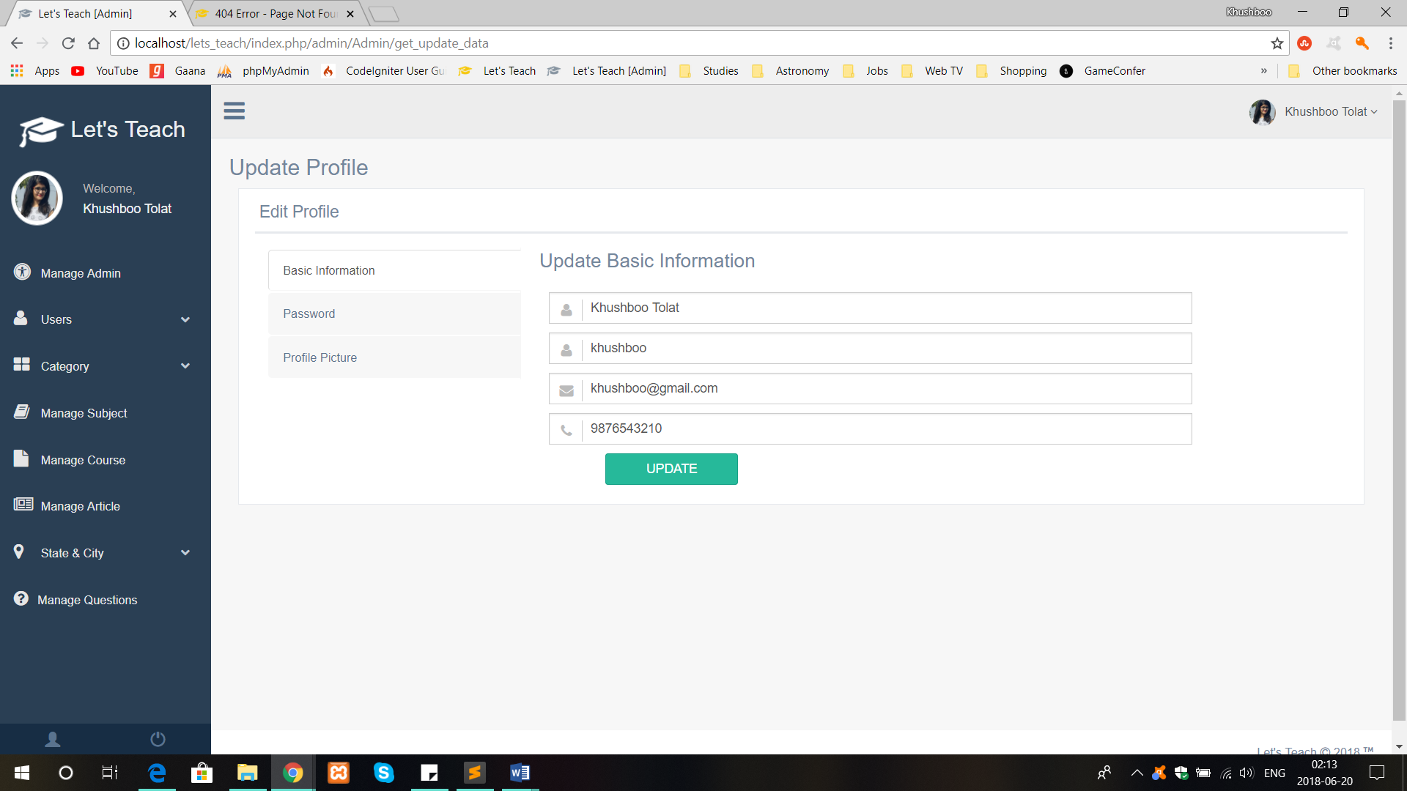

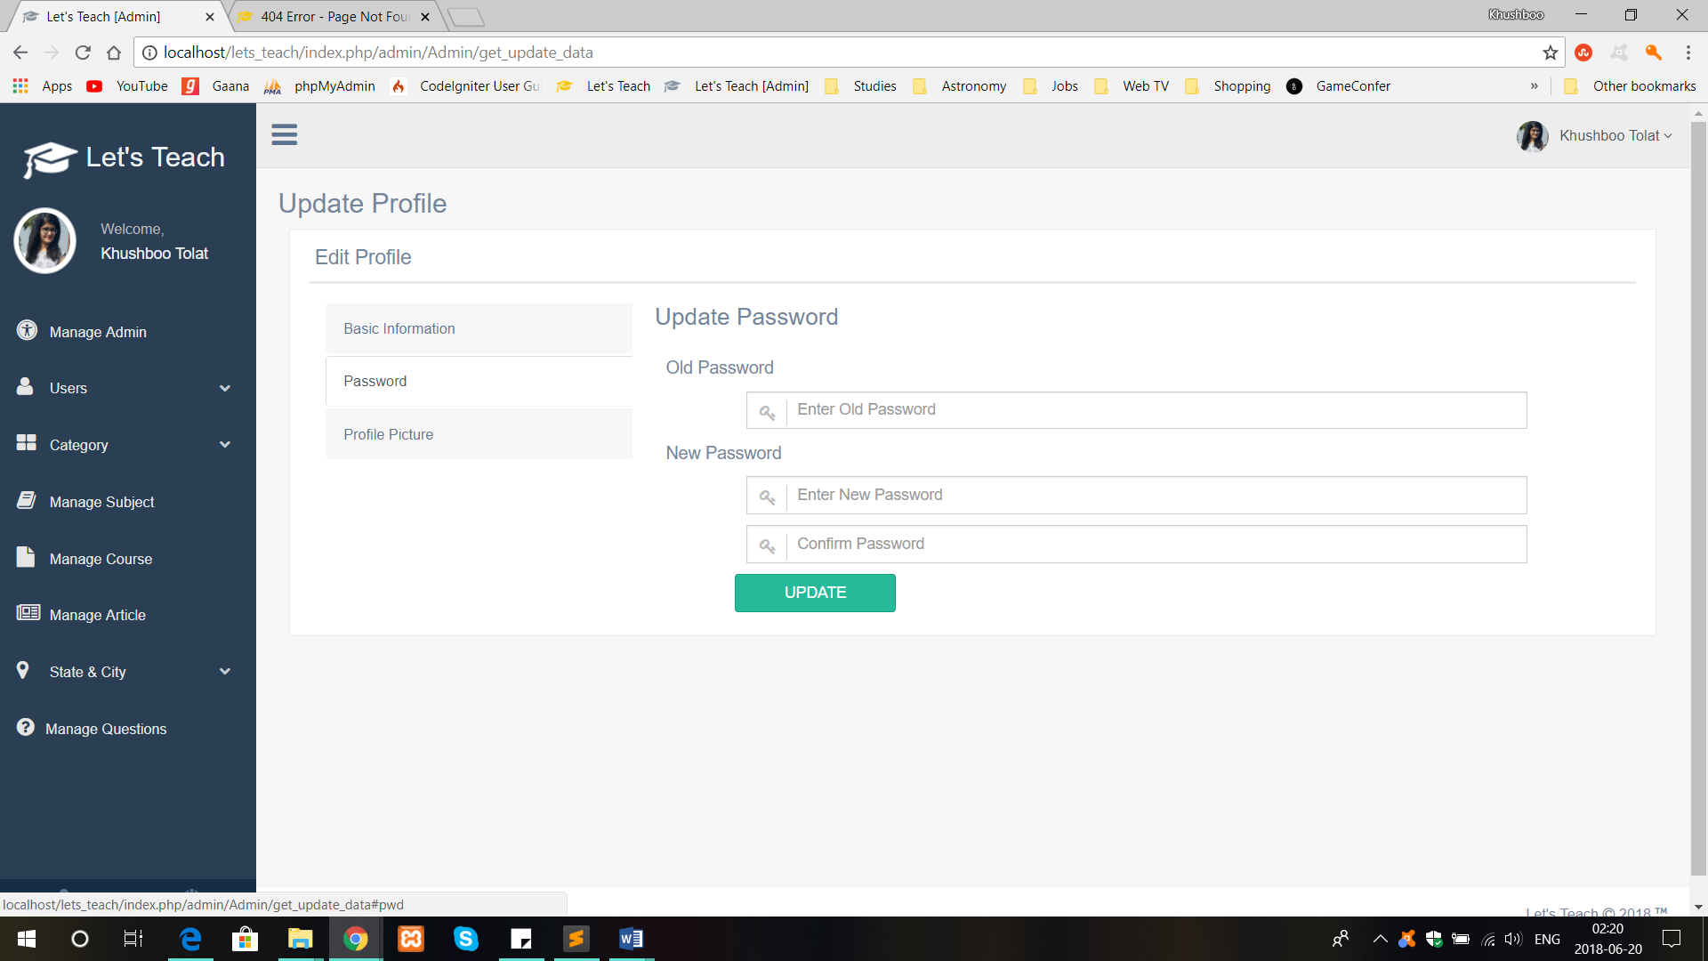

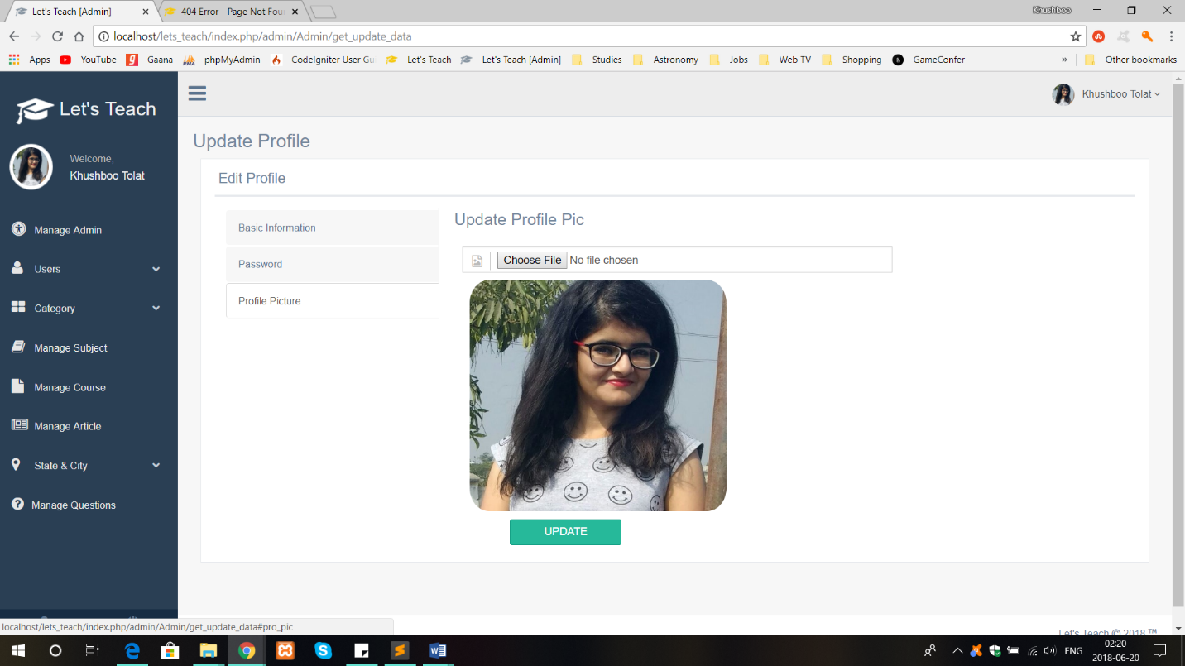

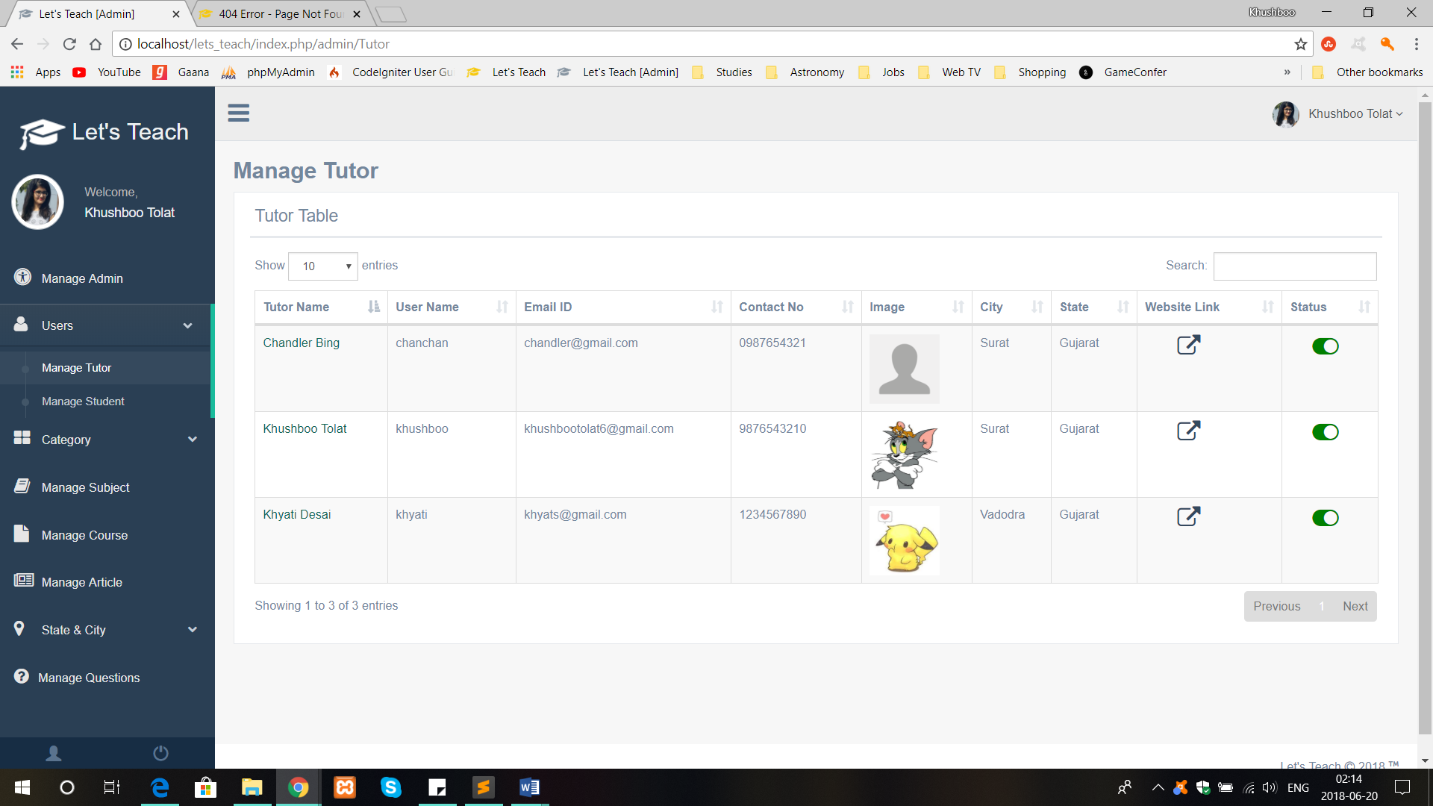

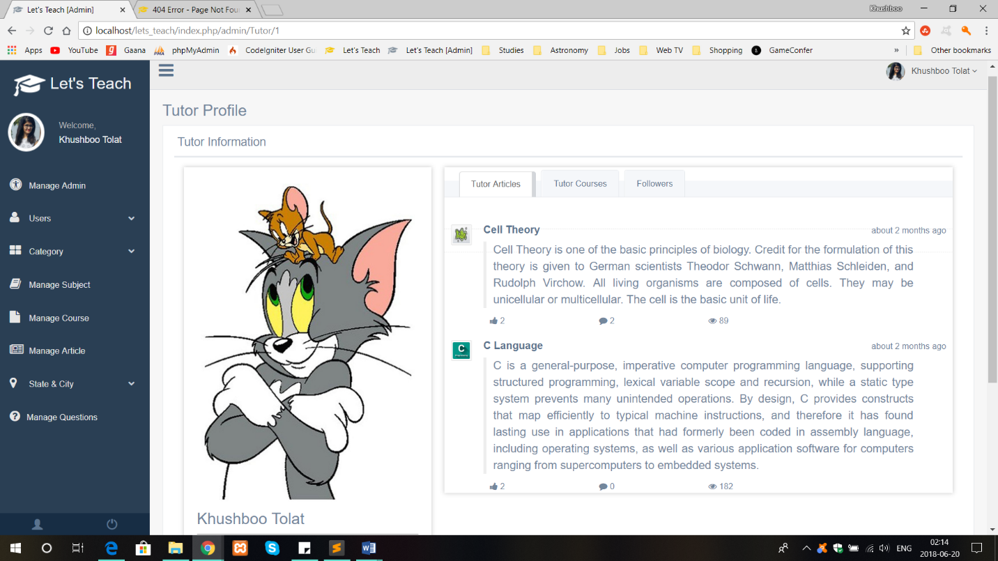

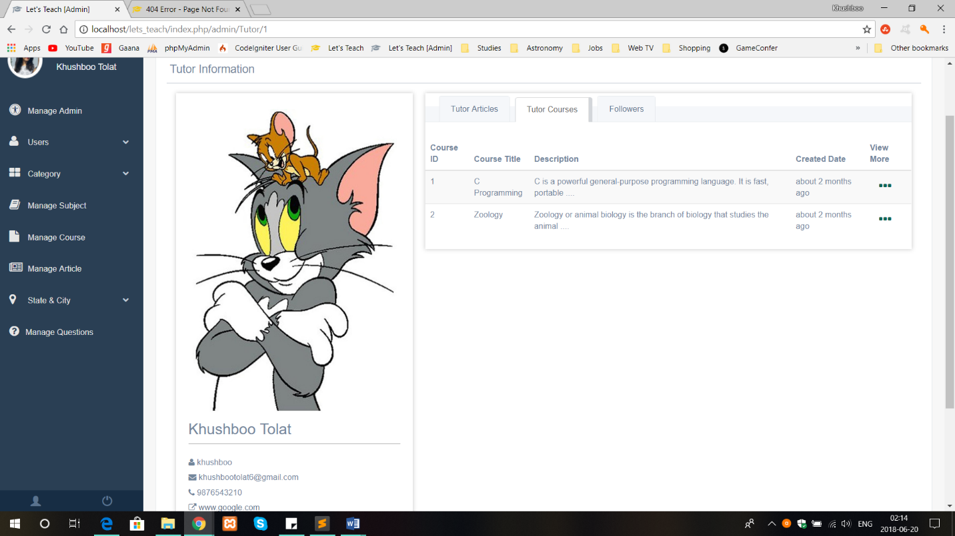

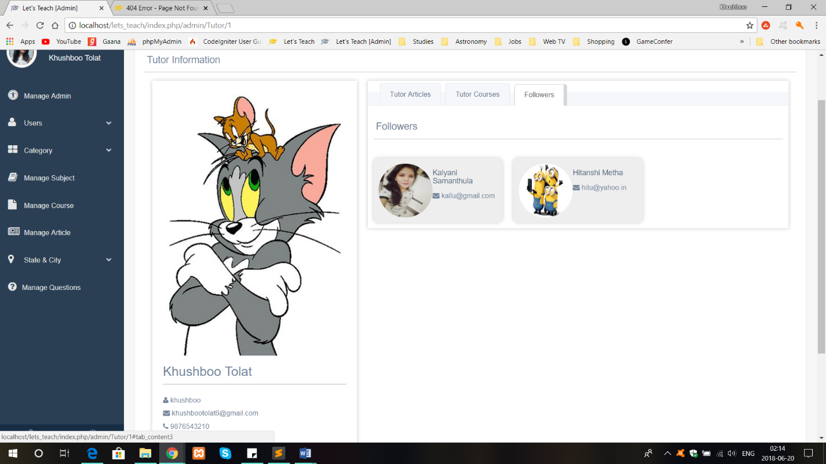

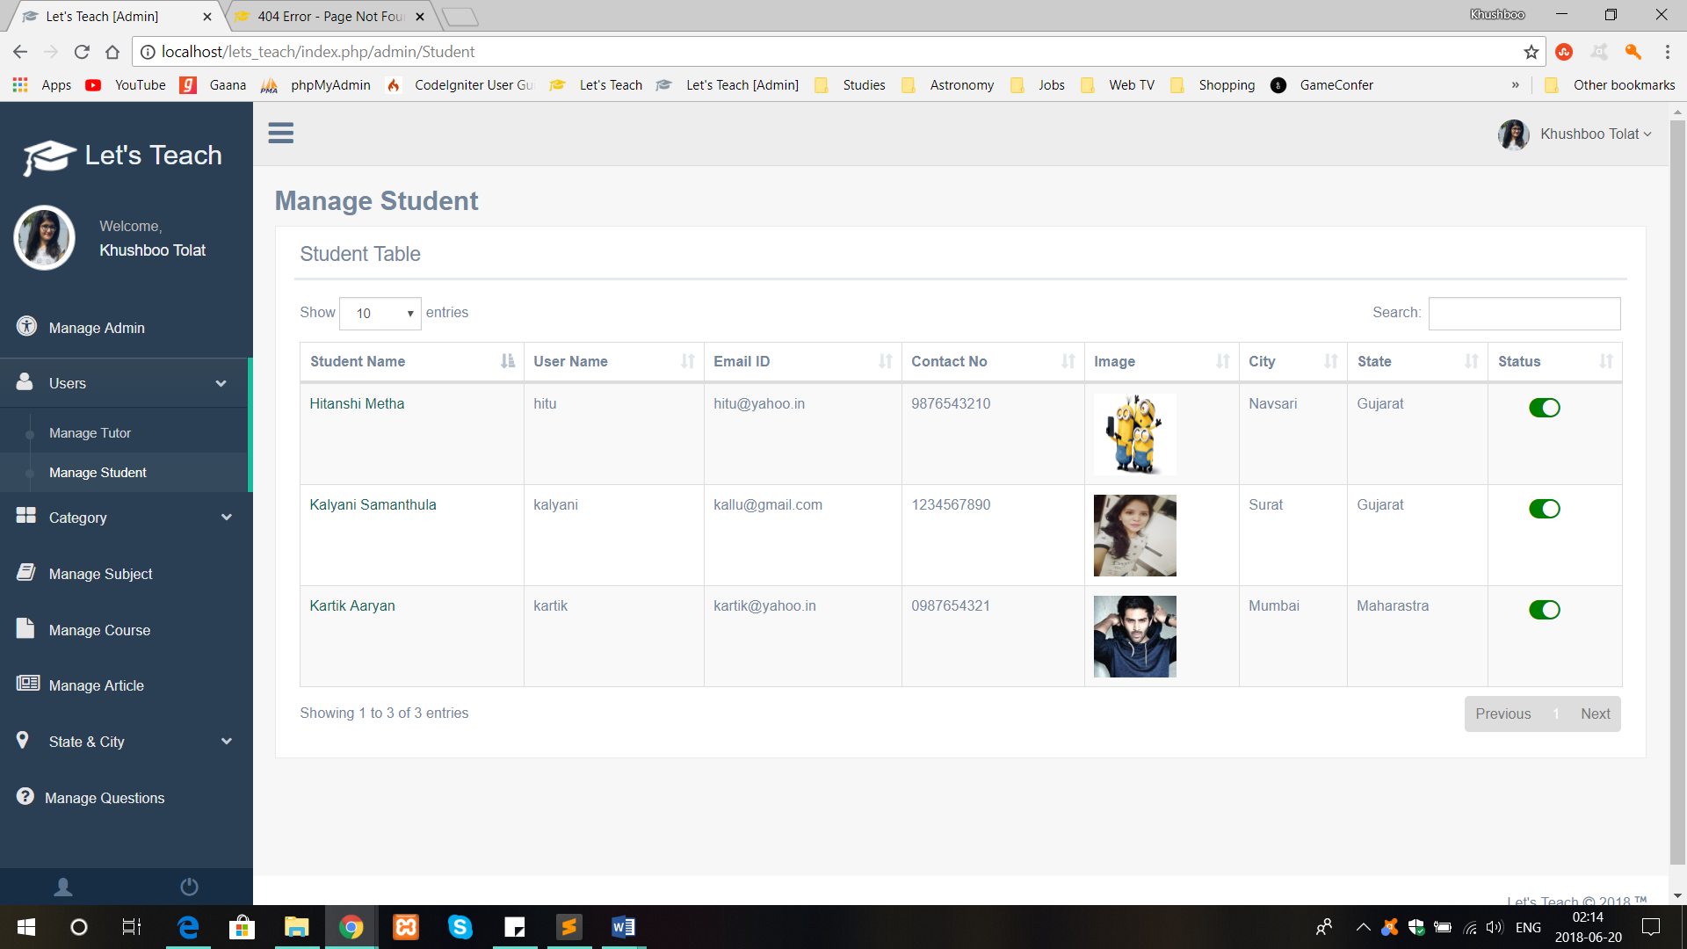

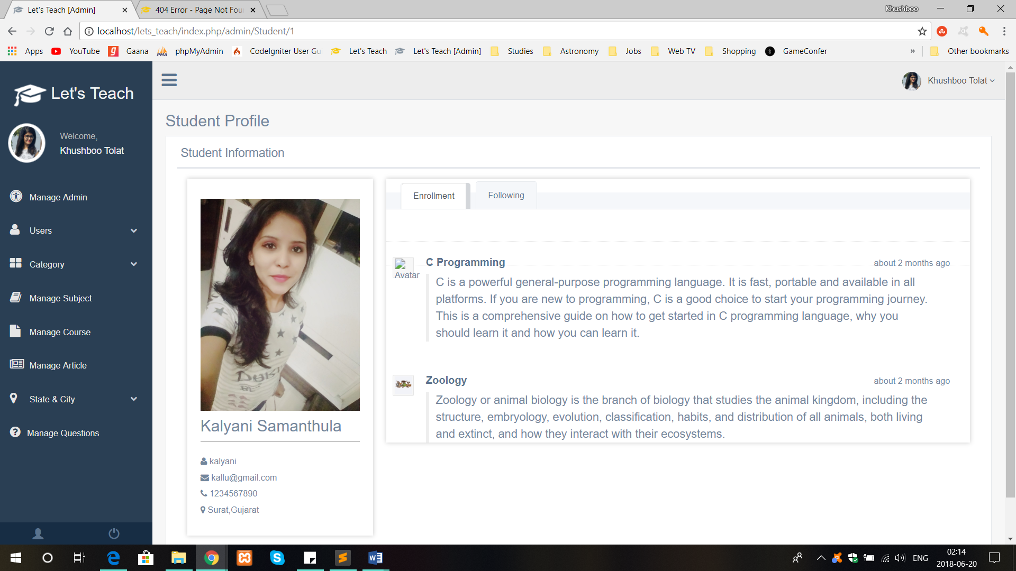

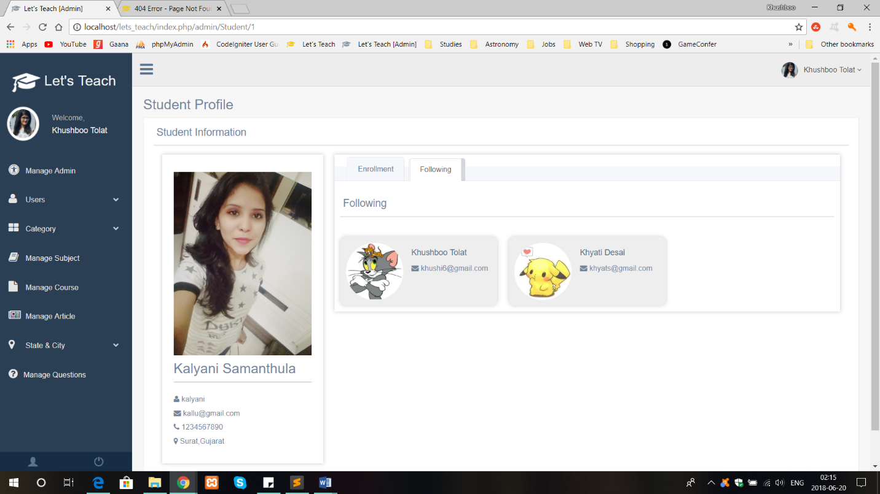

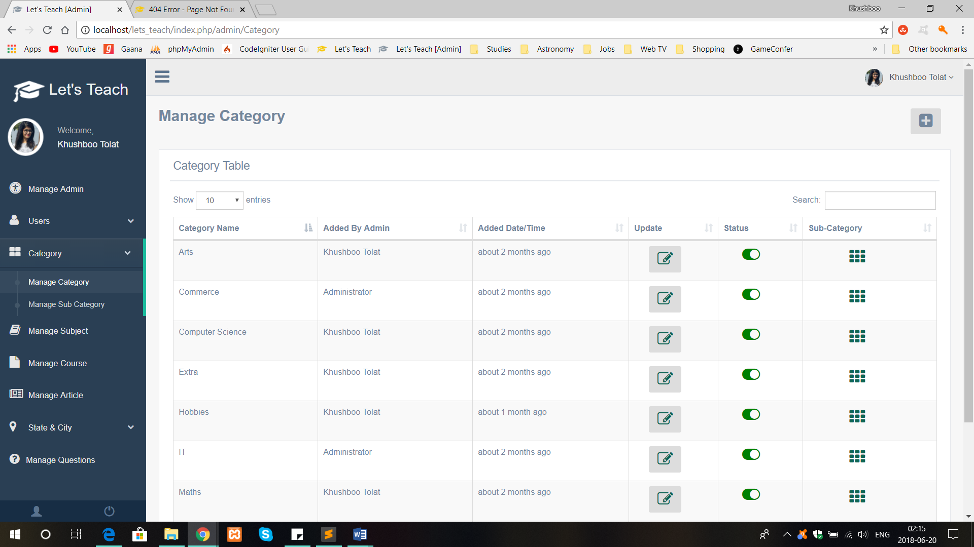

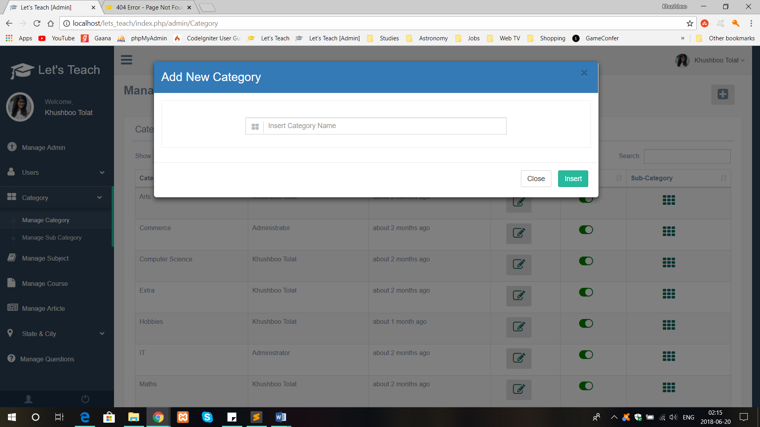

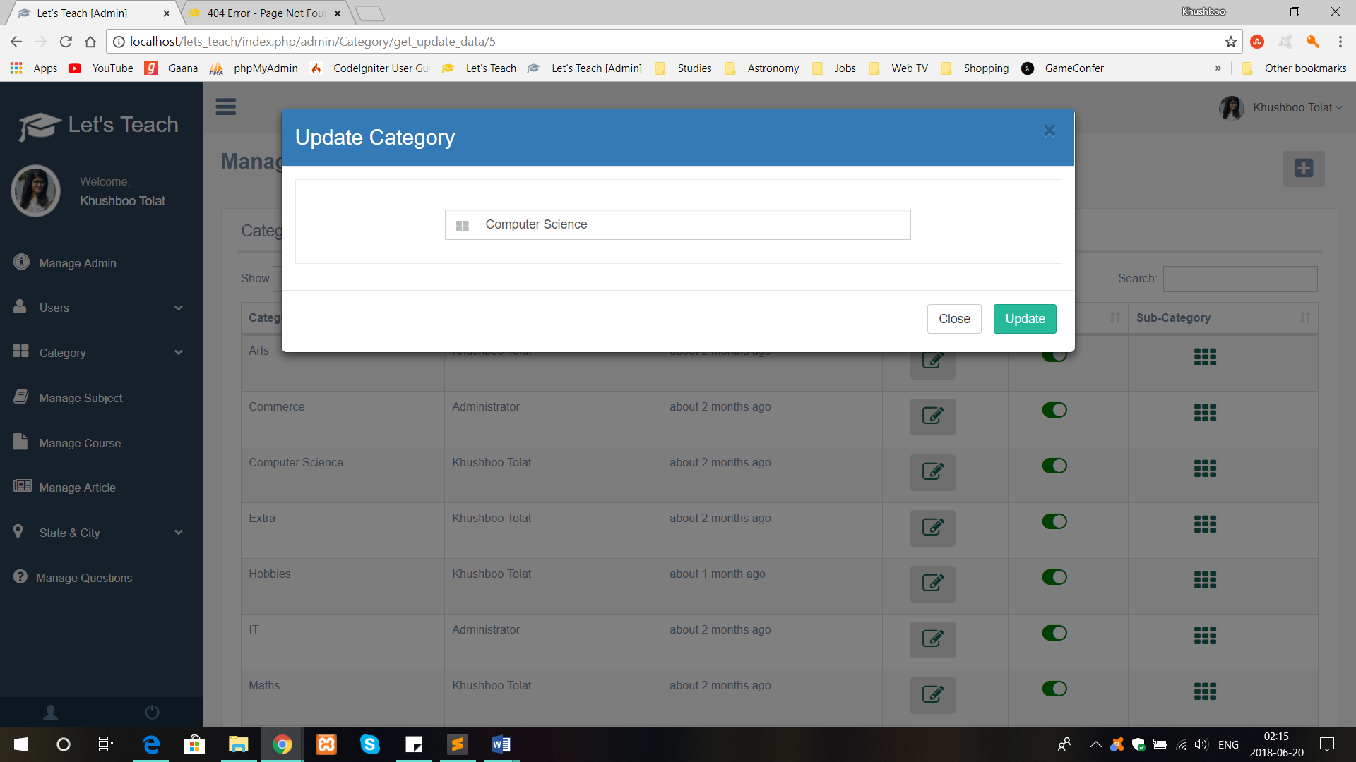

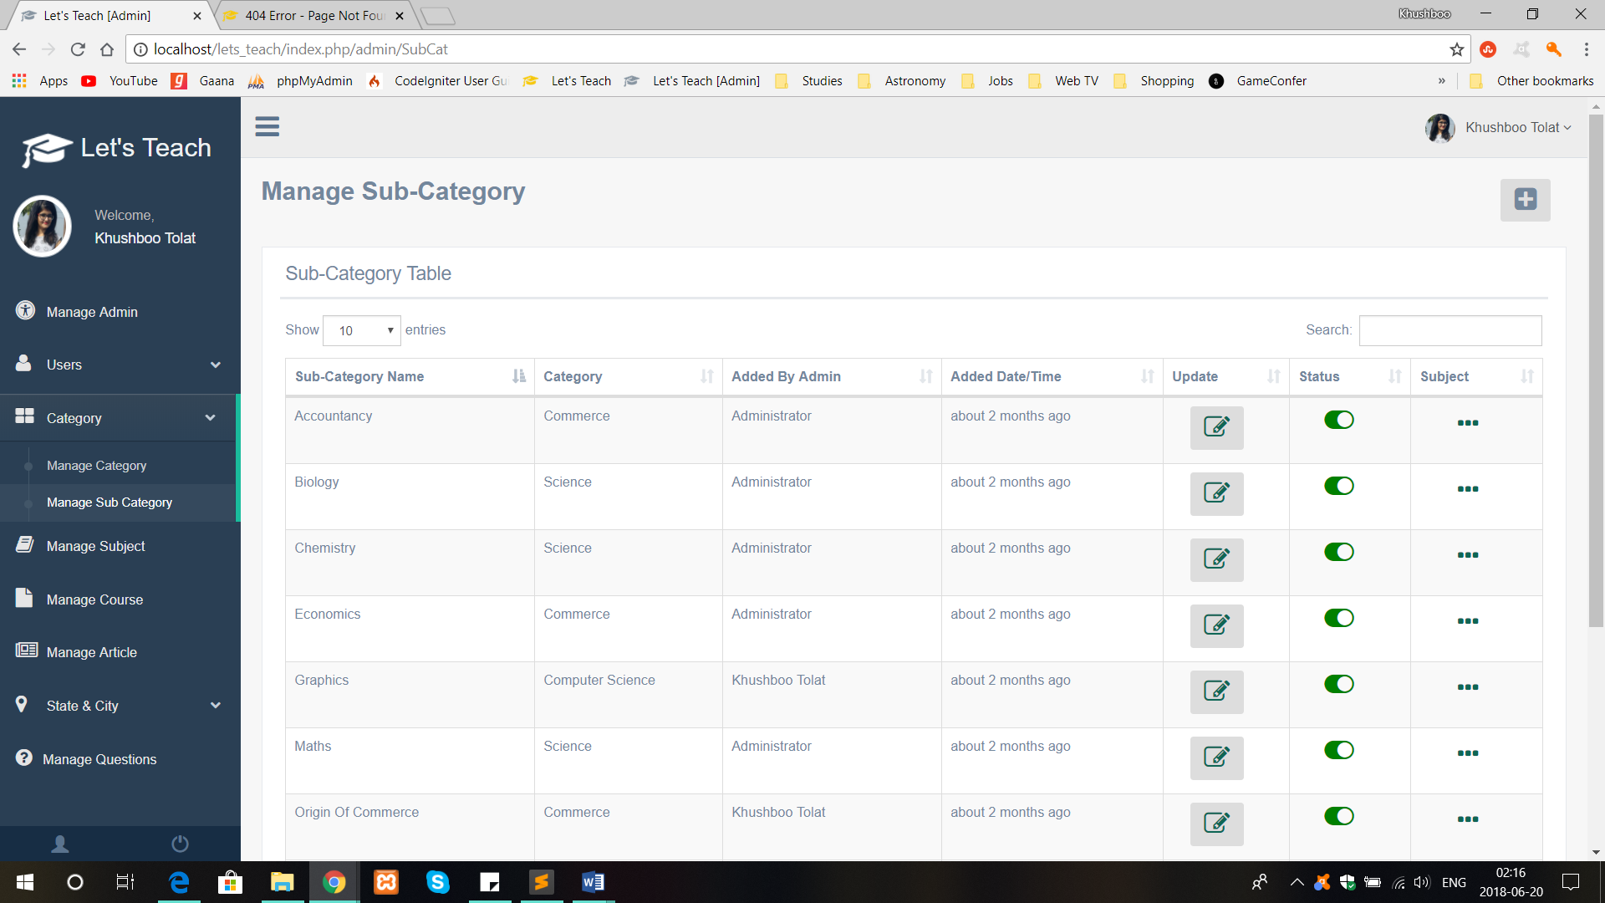

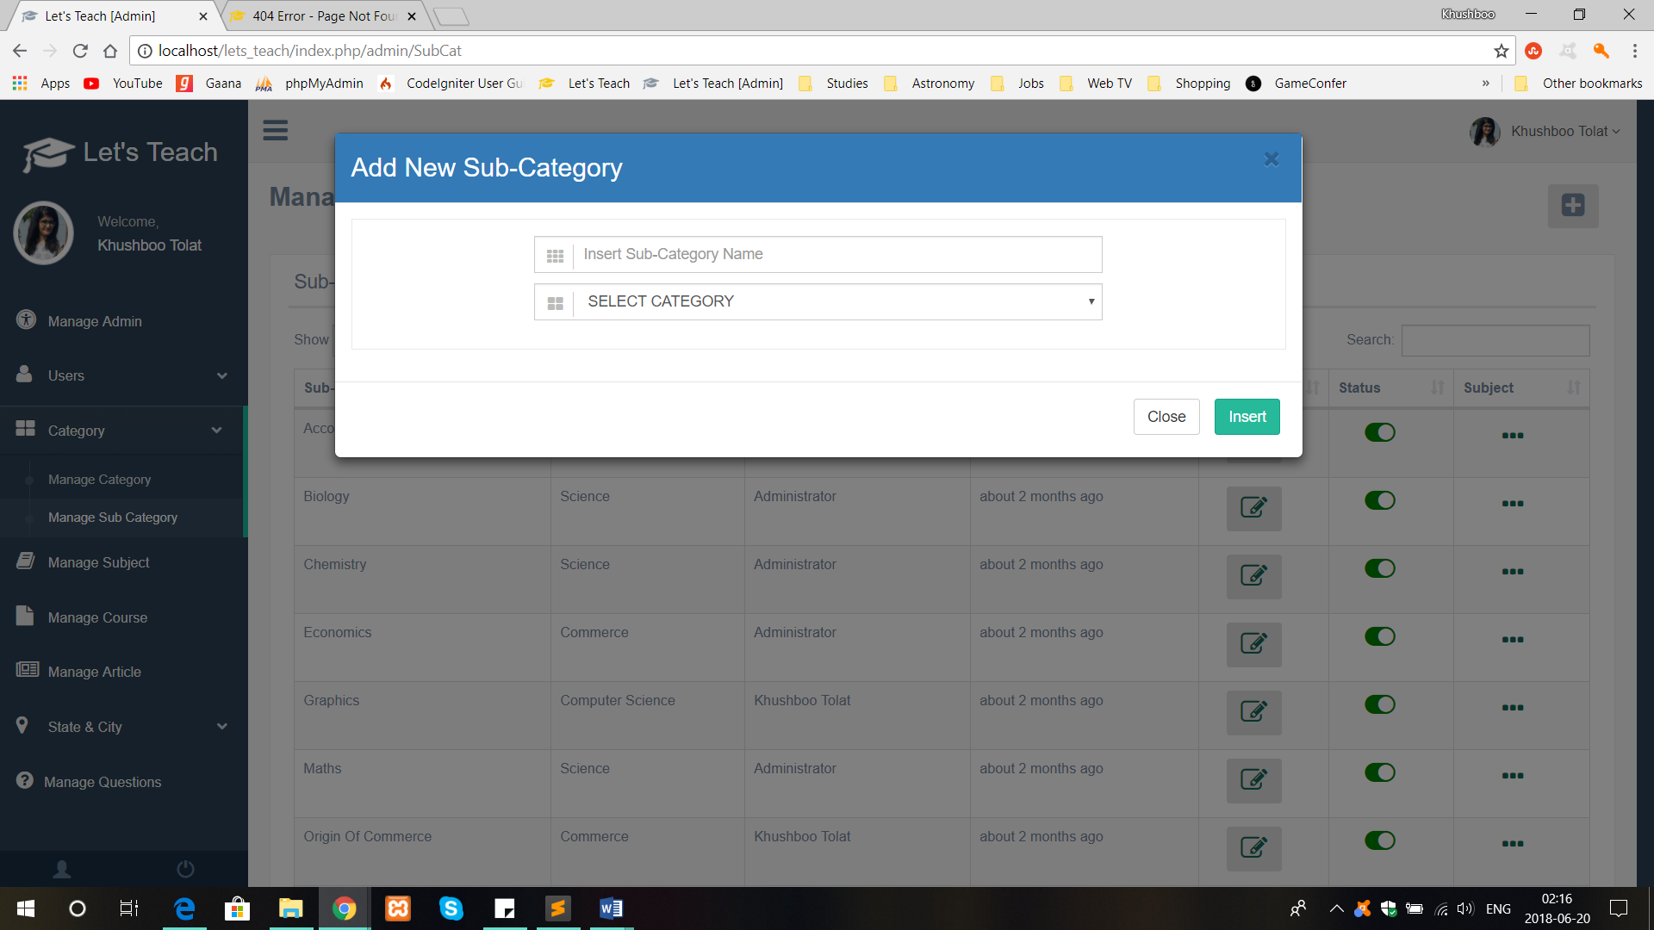

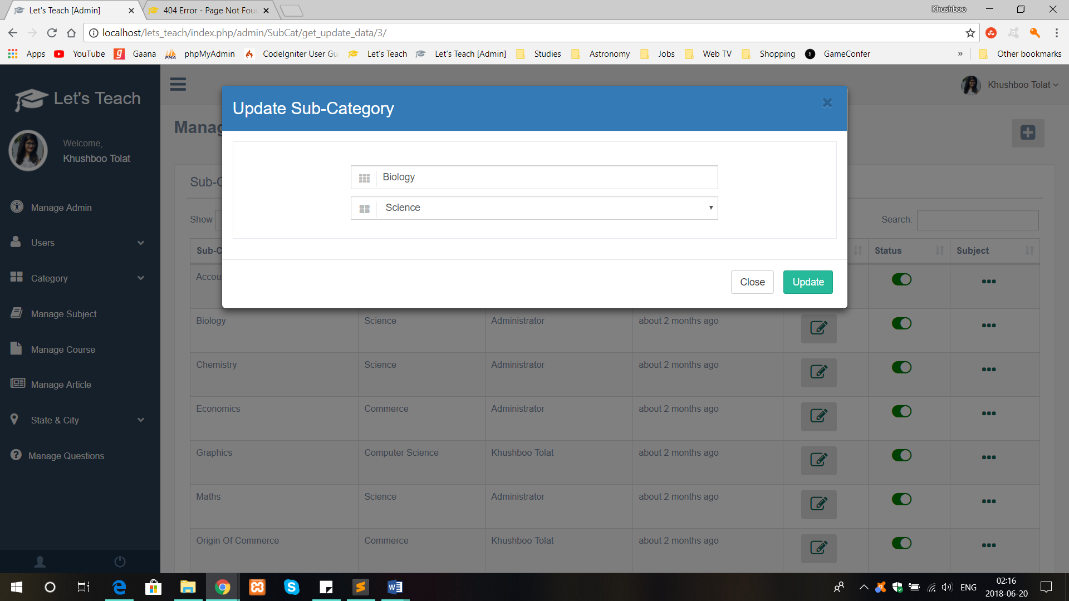

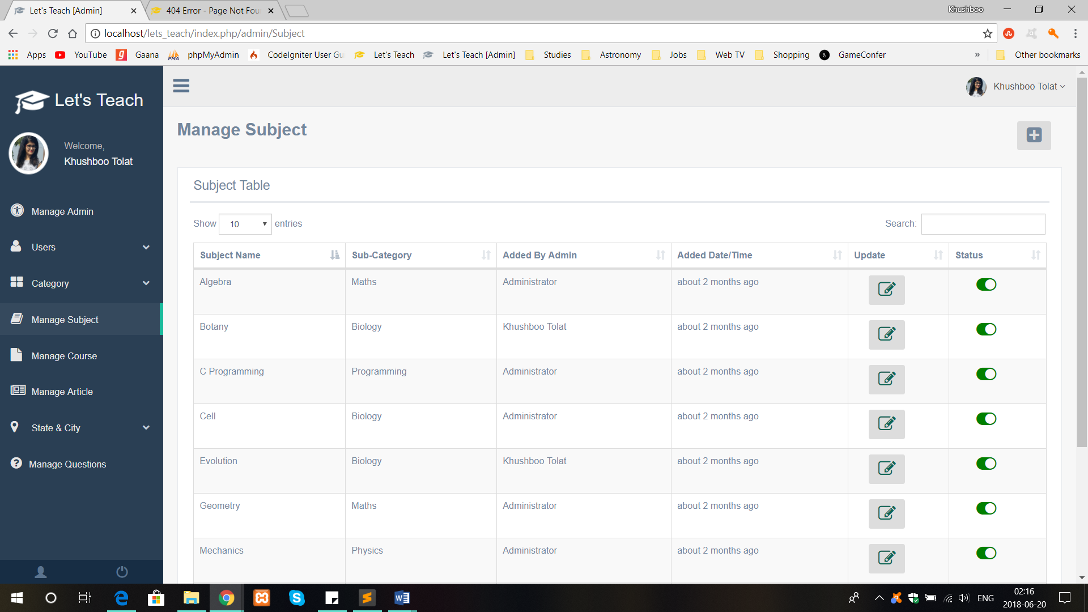

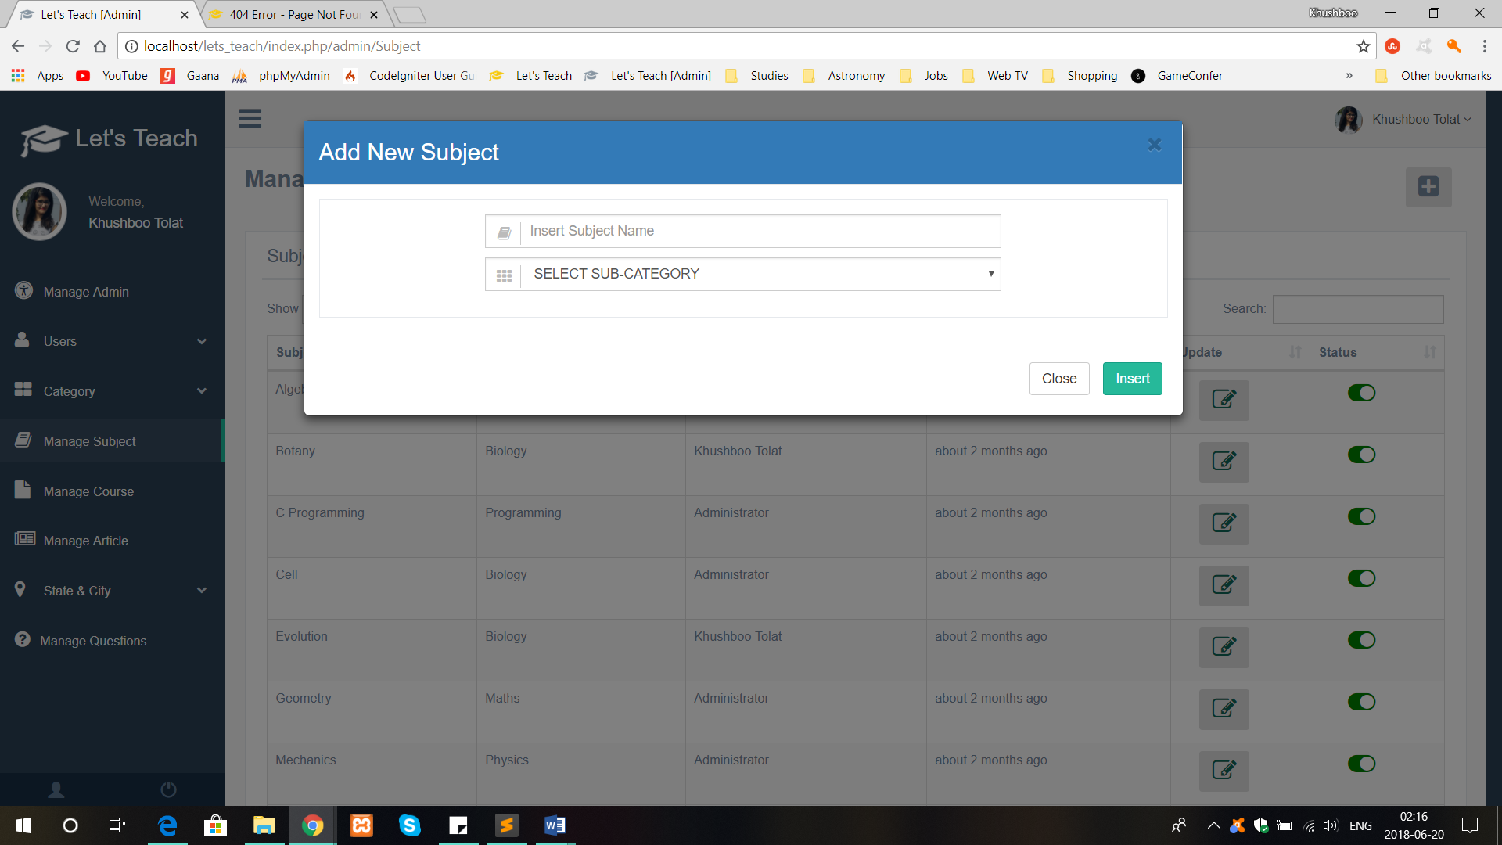

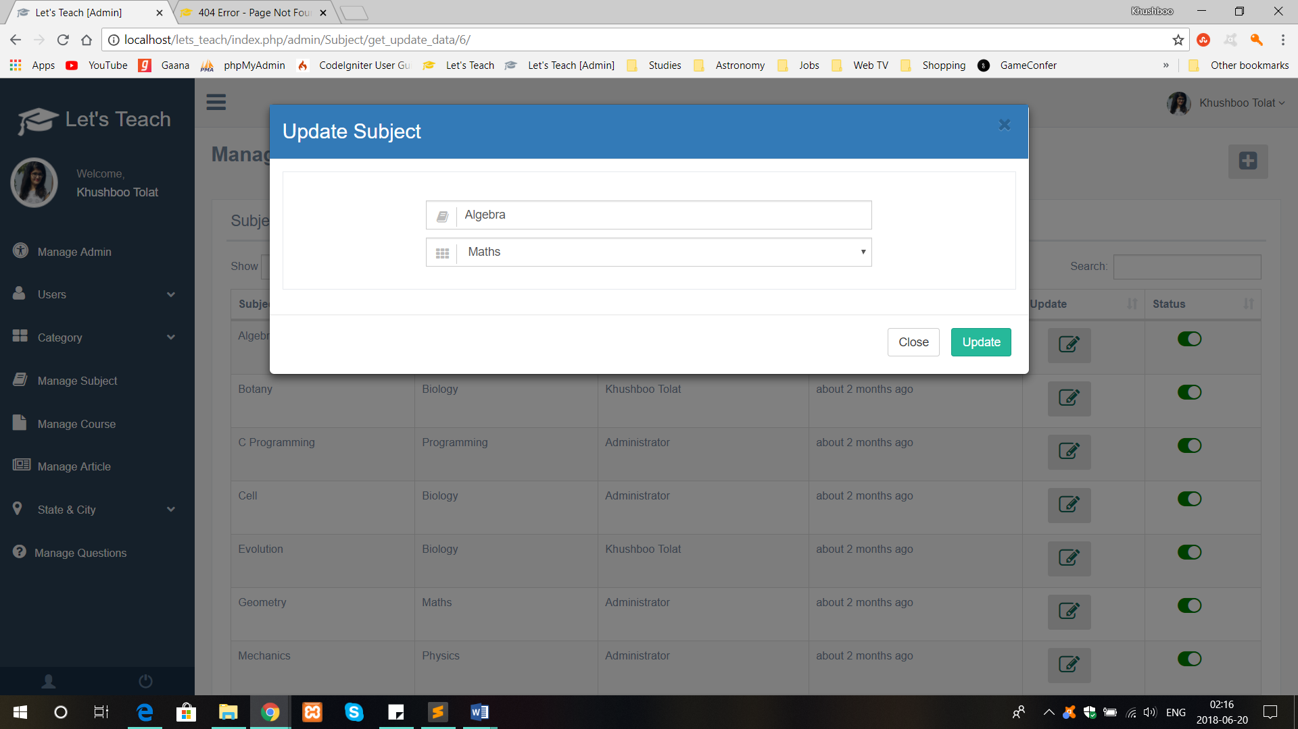

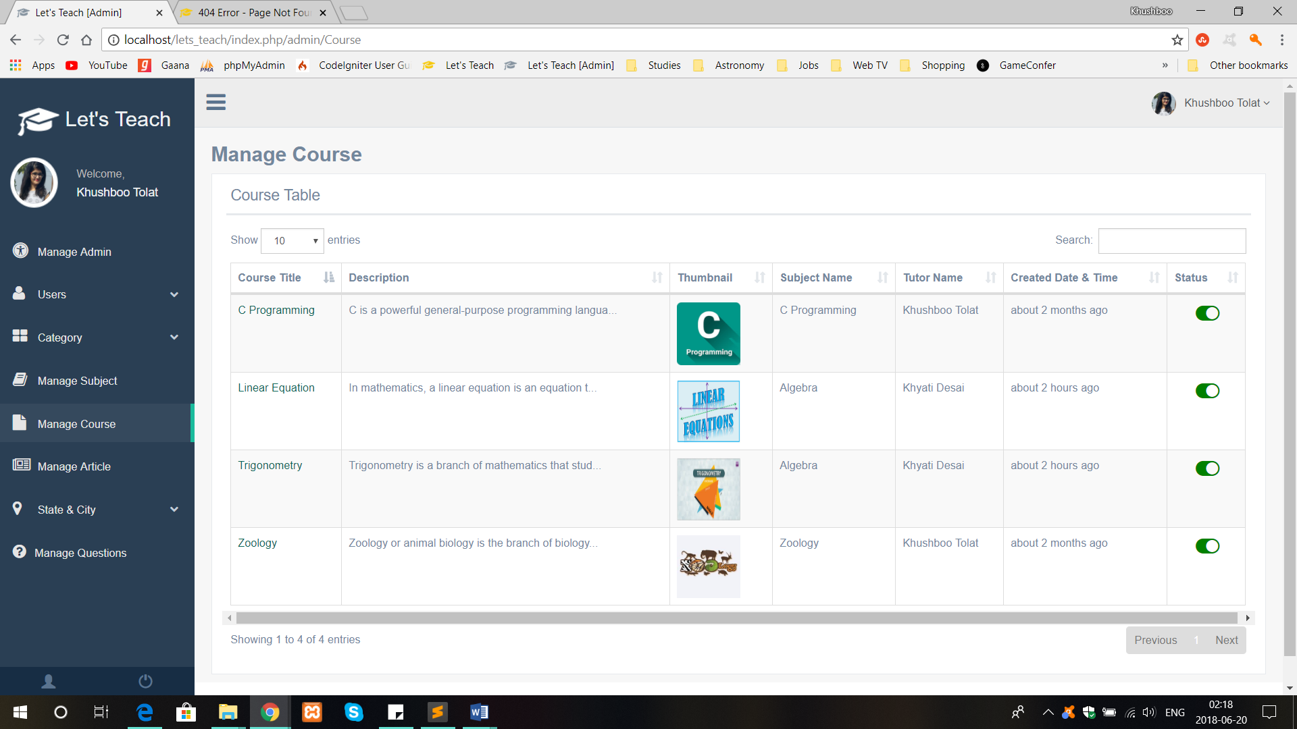

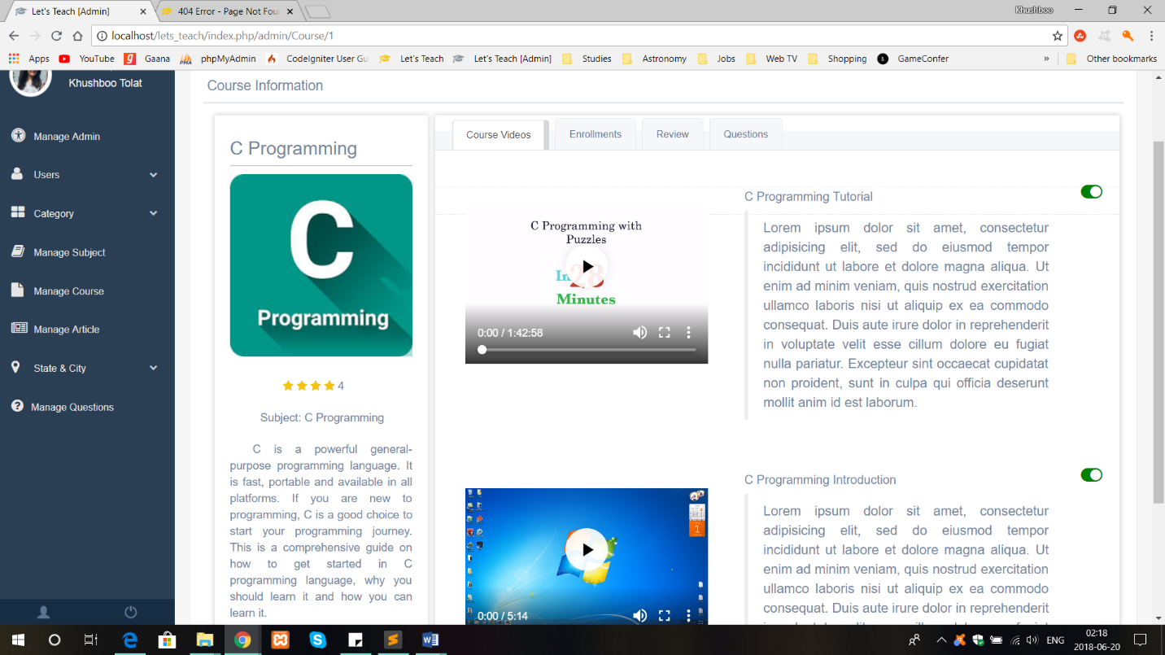

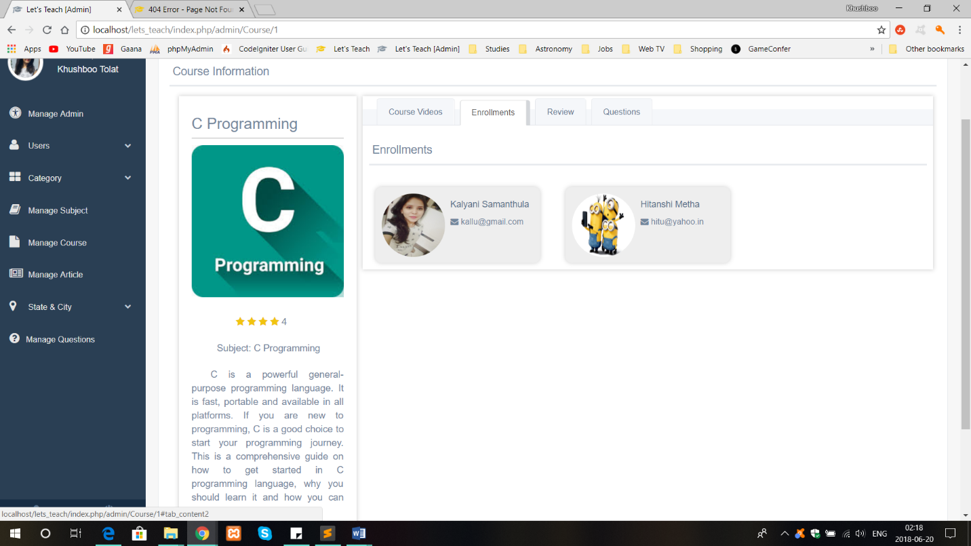

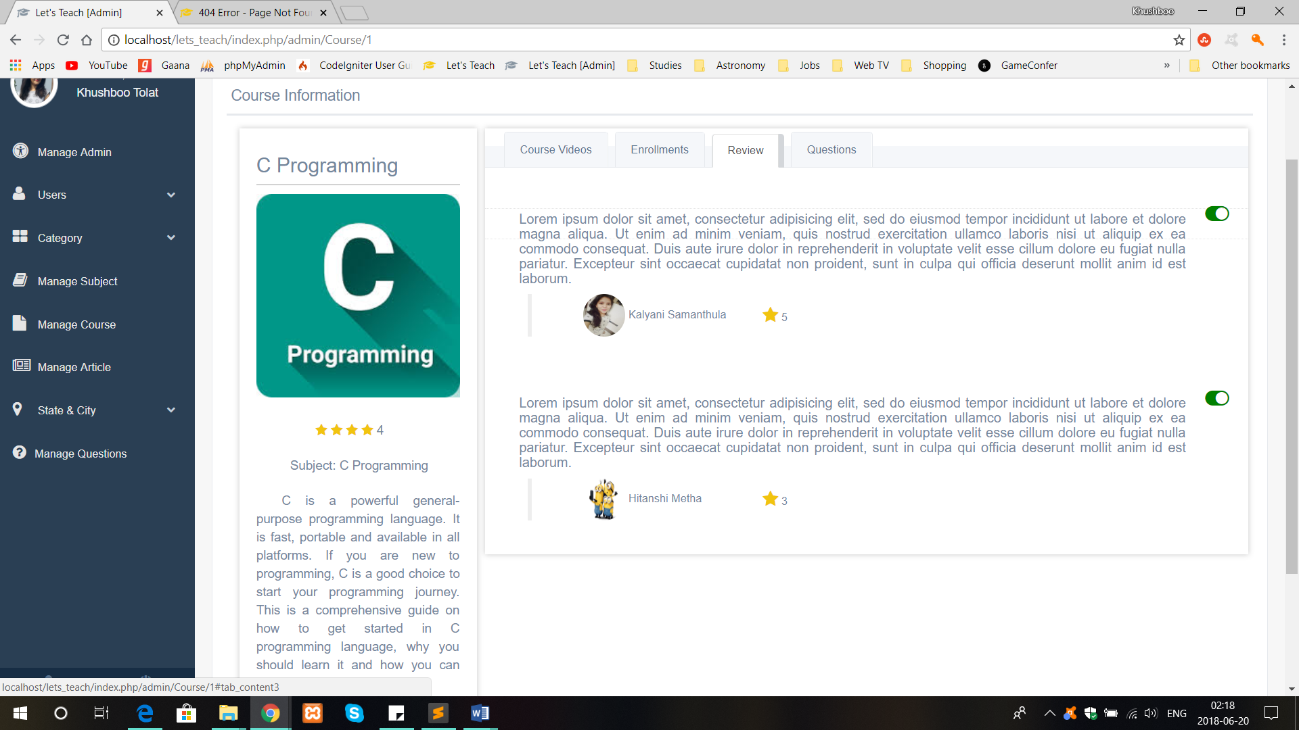

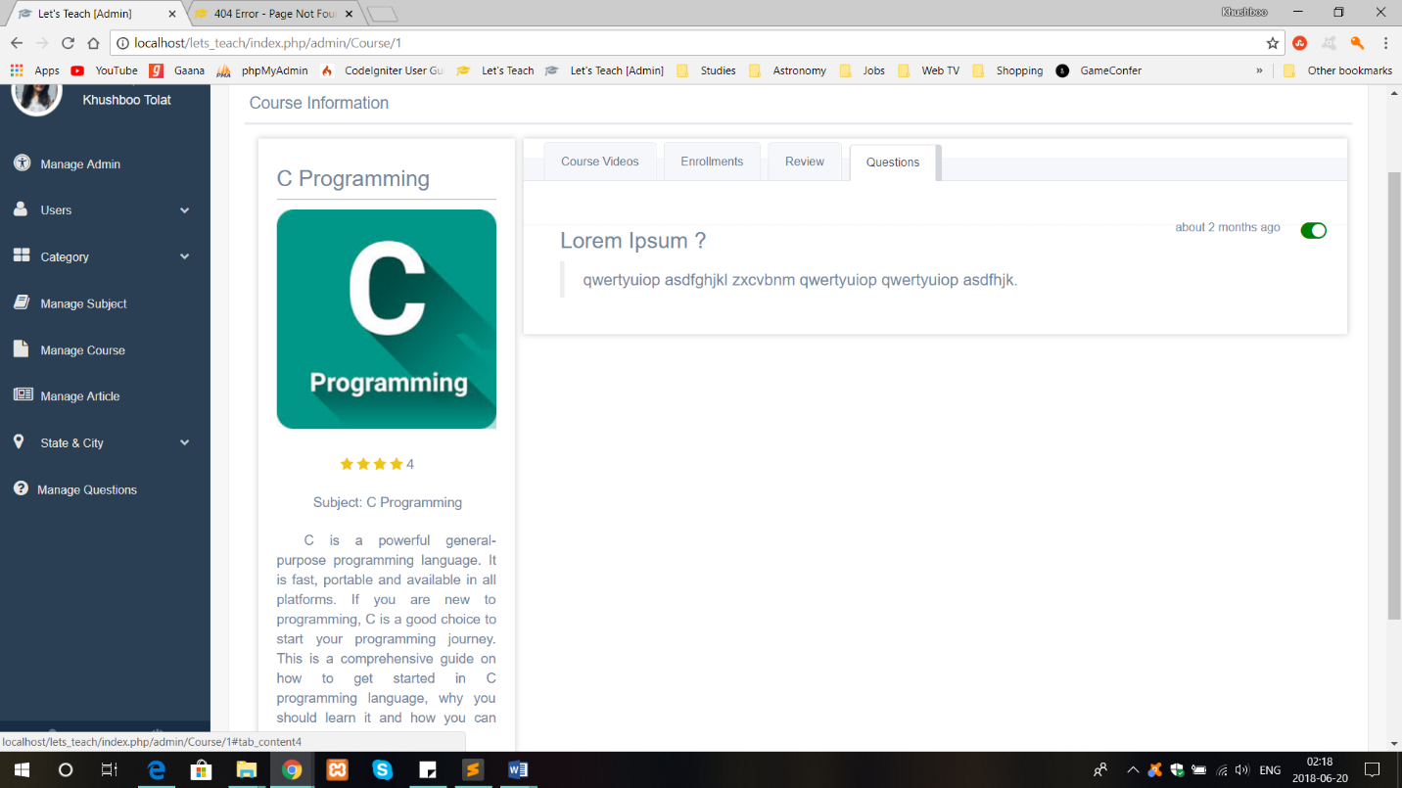

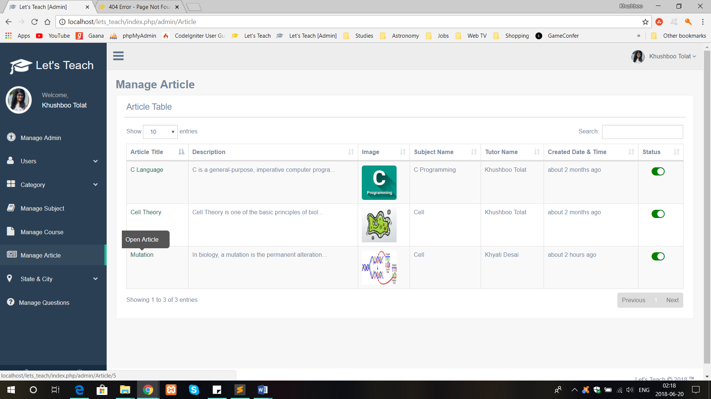

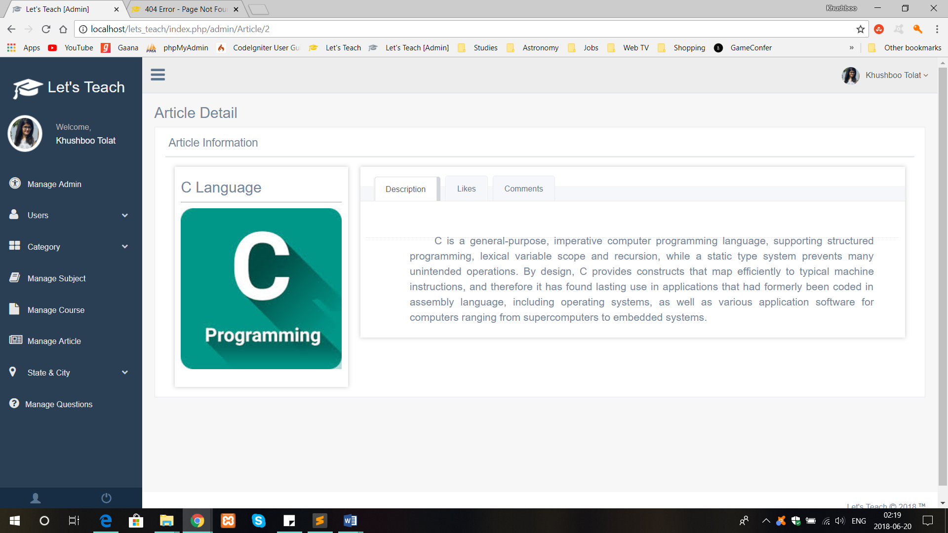

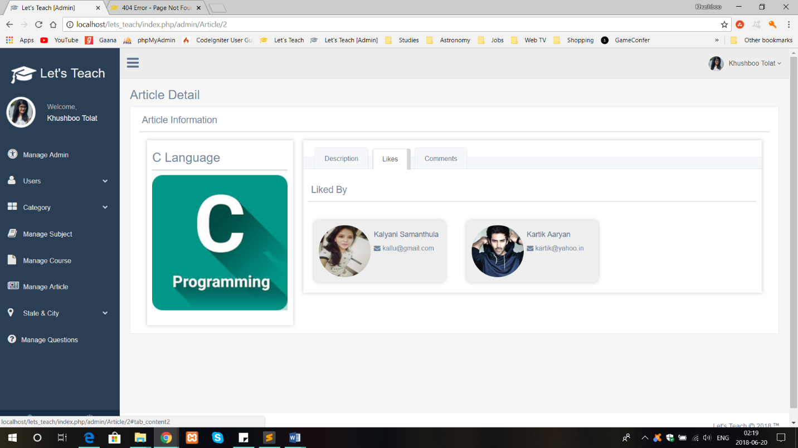

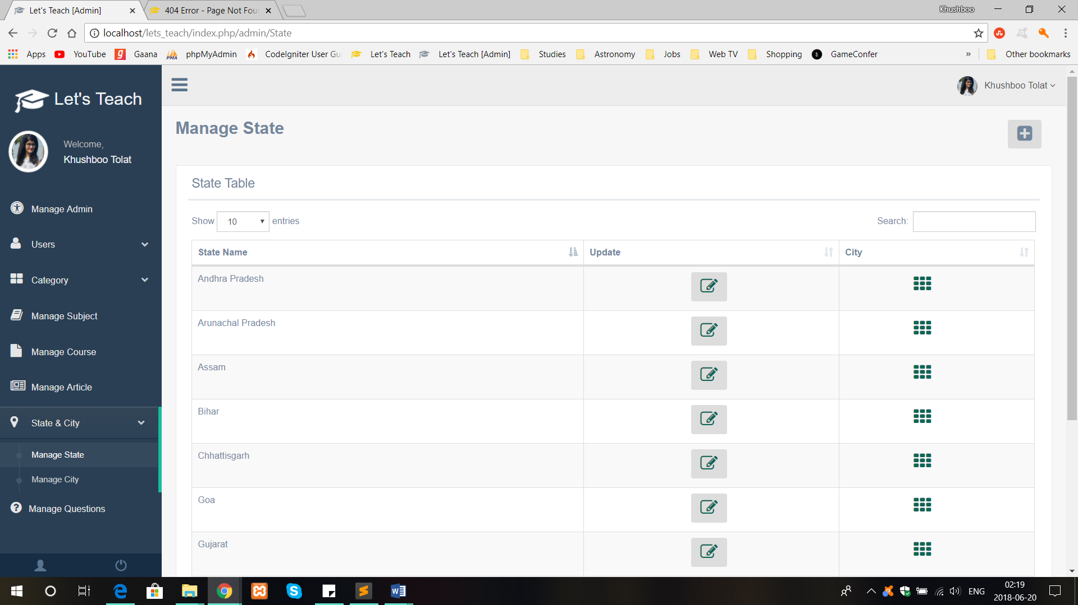

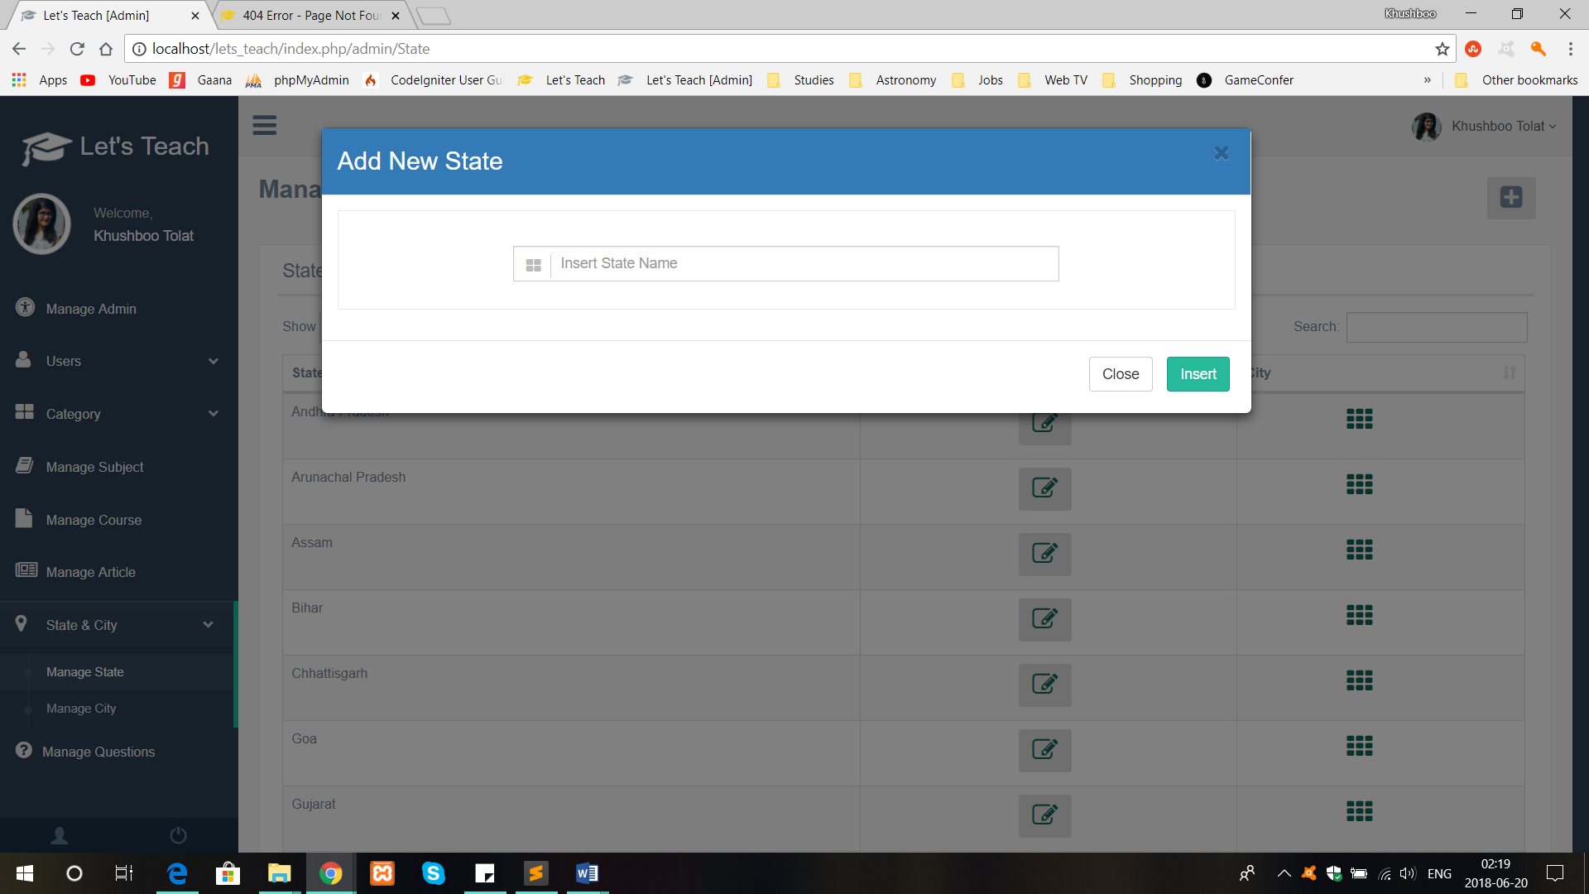

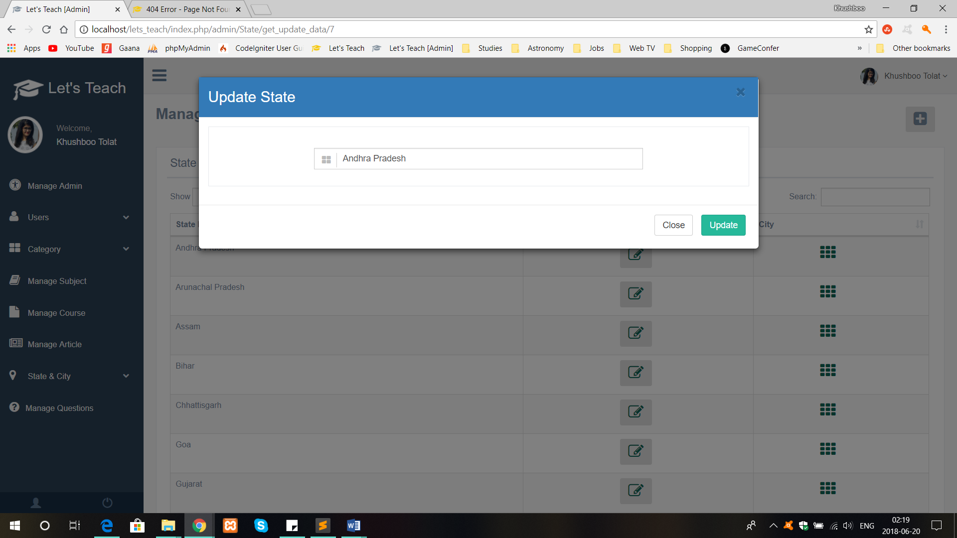

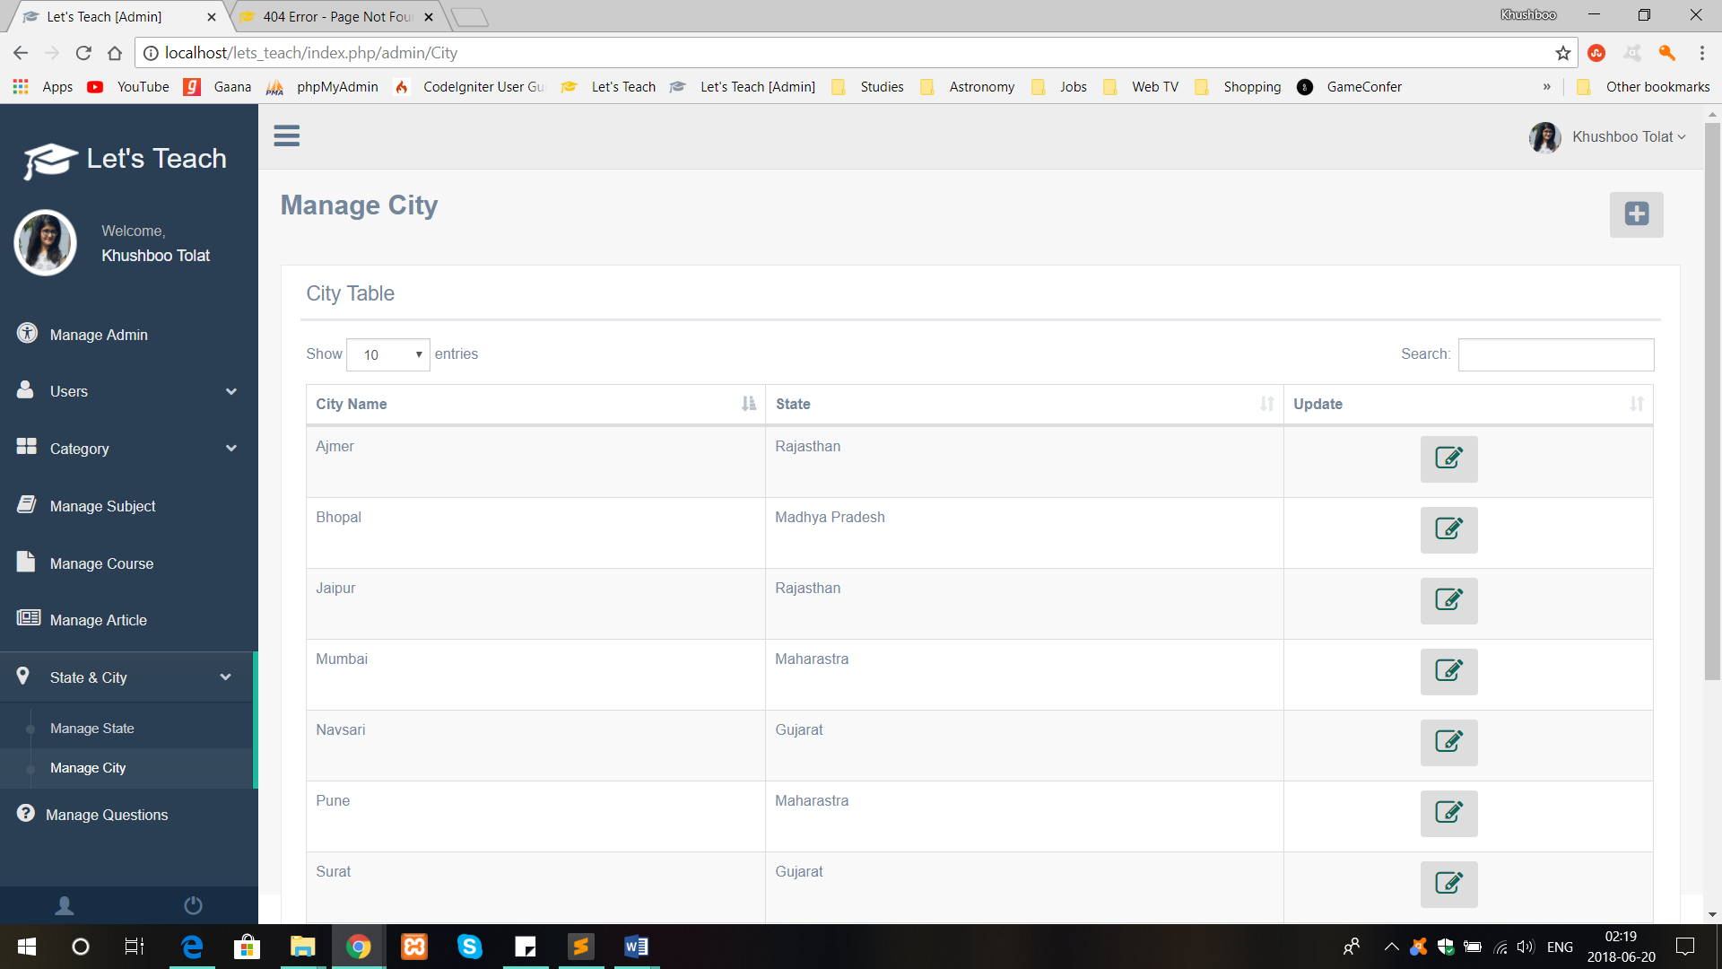

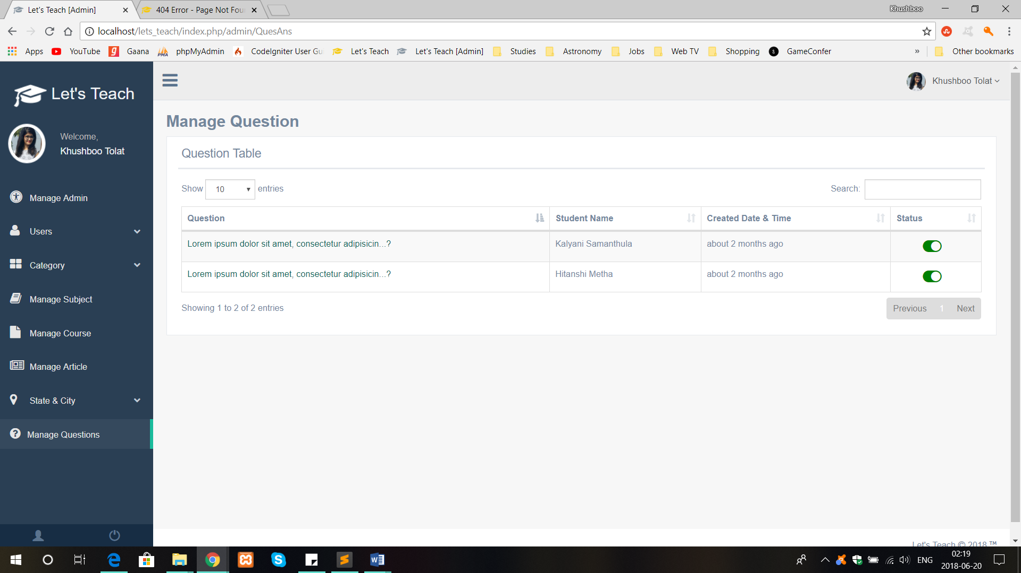

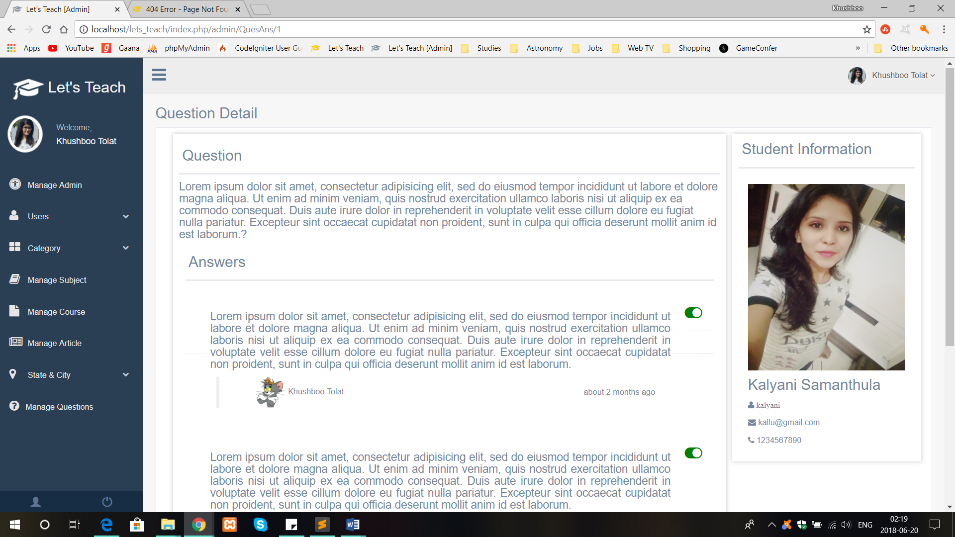

**Testing**

**7.1 Admin Side**

* **Login page**

|  |  |  |  |  |
| --- | --- | --- | --- | --- |
| **Sr.No** | **Field Name/Constraint** | **Input Value** | **Valid/Invalid** | **Error Message** |
| 1. | Admin Name/Contact No/EmailID | String | Valid: Any string input  Invalid: Null or non-string | Please fill out this field. |
| 2. | Password | String | Valid: Any string input  Invalid: Null or non-string | Please fill out this field. |

* **Add SubAdmin**

|  |  |  |  |  |
| --- | --- | --- | --- | --- |
| **Sr.No** | **Field Name/Constraint** | **Input Value** | **Valid/Invalid** | **Error Message** |
| 1. | User Name | String | Valid: Any string input  Invalid: Null or non-string | Name must contains alphabets and space only |
| 2. | Email ID | String | Valid: Any string input  Invalid: Null | Email Address must be valid |
| 3. | Password | String | Valid: Any string input | Enter proper password |
| 4. | Confirm password | String | Valid: Input must be matched with Password field  Invalid: Input doesn’t matches with password field | Confirm password must be matched with password field |
| 5. | Contact No. | String | Valid: Any valid phone number  Invalid: Any invalid phone number | Invalid Contact no. |

* **Add Category**

|  |  |  |  |  |
| --- | --- | --- | --- | --- |
| **Sr.No** | **Field Name/Constraint** | **Input Value** | **Valid/Invalid** | **Error Message** |
| 1. | Category name | String | Valid: Any string input  Invalid: Null or non-string | Category name must be valid |

* **Update Category**

|  |  |  |  |  |
| --- | --- | --- | --- | --- |
| **Sr.No** | **Field Name/Constraint** | **Input Value** | **Valid/Invalid** | **Error Message** |
| 1. | Category name | String | Valid: Any string input  Invalid: Null or non-string | This category name already exist |

* **Add State**

|  |  |  |  |  |
| --- | --- | --- | --- | --- |
| **Sr.No** | **Field Name/Constraint** | **Input Value** | **Valid/Invalid** | **Error Message** |
| 1. | State name | String | Valid: Any string input  Invalid: Null or non-string | State name must be valid |

* **Update State**

|  |  |  |  |  |
| --- | --- | --- | --- | --- |
| **Sr.No** | **Field Name/Constraint** | **Input Value** | **Valid/Invalid** | **Error Message** |
| 1. | State name | String | Valid: Any string input  Invalid: Null or non-string | State name already exist |

* **Add City**

|  |  |  |  |  |
| --- | --- | --- | --- | --- |
| **Sr.No** | **Field Name/Constraint** | **Input Value** | **Valid/Invalid** | **Error Message** |
| 1. | City name | String | Valid: Any string input  Invalid: Null or non-string | City name must be valid |

* **Update City**

|  |  |  |  |  |
| --- | --- | --- | --- | --- |
| **Sr.No** | **Field Name/Constraint** | **Input Value** | **Valid/Invalid** | **Error Message** |
| 1. | City name | String | Valid: Any string input  Invalid: Null or non-string | City name already exist |

**Tutor/Student Side:-**

* **Login Page**

|  |  |  |  |  |
| --- | --- | --- | --- | --- |
| **Sr.No** | **Field Name/Constraint** | **Input Value** | **Valid/Invalid** | **Error Message** |
| 1. | EmailID | String | Valid: Any string input  Invalid: Null or non-string | Please fill out this field. |
| 2. | Password | String | Valid: Any string input  Invalid: Null or non-string | Please fill out this field. |

* **Registration**

|  |  |  |  |  |
| --- | --- | --- | --- | --- |
| **Sr.No** | **Field Name/Constraint** | **Input Value** | **Valid/Invalid** | **Error Message** |
| 1. | User name | String | Valid: Any string input  Invalid: Null or non-string | Name must contains alphabets and space only |
| 2. | EmailID | String | Valid: Any string input  Invalid: Null or non-string | Please fill out this field. |
| 3. | Password | String | Valid: Any string input  Invalid: Null or non-string | Please fill out this field. |
| 4. | Confirm password | String | Valid: Input must be matched with Password field  Invalid: Input doesn’t matches with password field | Repeat password must be matched with password field |
| 5. | Contact No. | String | Valid: Any valid phone number  Invalid: Any invalid phone number | Invalid Contact no. |

* **Add article**

|  |  |  |  |  |
| --- | --- | --- | --- | --- |
| **Sr.No** | **Field Name/Constraint** | **Input Value** | **Valid/Invalid** | **Error Message** |
| 1. | Article Name | String | Valid: Any string input  Invalid: Null or non-string | Article name must be valid |

* **Add Course**

|  |  |  |  |  |
| --- | --- | --- | --- | --- |
| **Sr.No** | **Field Name/Constraint** | **Input Value** | **Valid/Invalid** | **Error Message** |
| 1. | Course Name | String | Valid: Any string input  Invalid: Null or non-string | Course name must be valid |

**Bibliography**

* [www.w3schools.com](http://www.w3schools.com)
* [www.javatpoint.com](http://www.javatpoint.com)
* [www.tutorialspoint.com](http://www.tutorialspoint.com)
* [www.stackoverflow.com](http://www.stackoverflow.com)